Long-term impacts of disturbance on plant and insect communities in forest ecosystems

Thesis

Presented in Partial Fulfillment of the Requirements for the Degree Master of Science in the Graduate School of The Ohio State University

By

Aaron Tayal

Graduate Program in Entomology

The Ohio State University

2025

Thesis Committee

Kayla I. Perry

Mary M. Gardiner

Wendy S. Klooster

Samuel F. Ward

Copyrighted by

Aaron Tayal

2025

# Abstract

Natural and anthropogenic disturbances including invasive insect outbreaks, windstorms, and tree harvesting impact forest ecosystems by changing abiotic and biotic conditions. These disturbances create forest gaps, which can stimulate the growth of tree regeneration and create islands of early-successional habitat. These gaps can harbor insect communities that differ in species and traits from those of the undisturbed forest. While short-term impacts of disturbance in forest ecosystems are more commonly studied, there are gaps in knowledge of long-term effects of disturbance, as well as effects of multiple disturbances in sequence. However, these questions are important because insects play important roles in sustaining food webs, decomposing waste, and pollinating crops. Understanding forest disturbances can help humans to make decisions that conserve biodiversity.

When emerald ash borer (EAB) populations swept through forests of southeast Michigan and killed overstory ash trees, there were surviving ash in the understory which were too small to be killed by EAB. This cohort of surviving ash represents a possibility for ash trees to reclaim a place in the canopy, but residual populations of EAB may affect this possibility. We studied long-term monitoring plots near Detroit, MI where EAB has been present for over 20 years, asking whether ash (*Fraxinus* spp.) regeneration has persisted and grown, and how EAB and its natural enemies are influencing ash regeneration. Each forest stand was previously classified into three categories, hydric, mesic, and xeric, based on hydrology and predominate ash species. We found that the size distribution and abundance of ash regeneration differs based on the hydrology of forest stands. In mesic and xeric forests, ash regeneration is surviving, but remains small, mostly below 2.5 cm diameter at breast height (DBH). Meanwhile, ash regeneration in some hydric stands has reached larger sizes (2.5-10 cm DBH) which are susceptible to EAB attack. While symptoms of EAB are common, some regeneration remains healthy. We also recovered three species of introduced parasitoid wasp which might help control EAB populations. Our results suggest that ash regeneration has, with few exceptions, not grown large enough to produce seeds, but may persist if parasitoid wasps can control EAB populations.

In addition to insect outbreaks, forest ecosystems are periodically affected by natural disturbance such as windthrow, which creates canopy gaps and changes abiotic conditions in the understory layer. Forest managers often harvest fallen trees affected by windthrow in a process called salvage logging, but this practice may have long-term effects on biodiversity. We studied the short- and longer-term impacts of a tornado disturbance and subsequent salvage-logging on ground beetles (Coleoptera: Carabidae). We hypothesized that both the windthrow and subsequent salvage-logging would increase alpha-diversity initially, but that salvage-logged plots would have lower diversity in the longer-term, due to alteration of biological legacies such as woody debris. The study site was Powdermill Nature Reserve in Westmoreland County, Pennsylvania, where a tornado occurred in 2012, and salvage-logging occurred on half of the windthrow site. We sampled ground beetles during the growing seasons of 2015 and 2022, identified ground beetles to species, and measured 10 functional traits of each species. Our results show that salvage-logged habitat differed in species and traits from undisturbed forest, while unsalvaged windthrow was similar to the undisturbed forest. Carabid species common in salvage-logged habitat tended to be smaller, and have larger eyes and longer rear trochanters, suggesting that environmental conditions are filtering species based on their traits. Differences between forest management treatments were still detectable nine years after salvage-logging, indicating that combined natural and anthropogenic disturbances have lasting impacts on biodiversity.

Combined, our research shows that forest disturbances play out over decades and have outcomes for biodiversity that depend on interactions between plants and animals. For example, whether ash persists in forests depends on tri-trophic interactions between trees, their pests, and the natural enemies of those pests. How forest disturbance impacts ground beetles depends on how the disturbance alters vegetation and woody debris resources that each species may depend on. Furthermore, examining functional traits, such as flood-tolerance of trees and sensory strategies of ground beetles, can help us understand and predict the long-term impacts of forest disturbance.

# Acknowledgments

I would like to thank my research advisor, Kayla Perry, for providing encouragement as I learned about forest entomology. She offered to lend books as well as gave excellent advice for setting up my hypotheses, deciding what I was going to record (both in the field and at the microscope), and gave helpful feedback on many presentations and these thesis chapters. I would like to thank all members of the Perry Lab for their support and advice on improving my research. And I would like to thank my committee members, the professors who taught my classes, and the graduate students in my classes. They have truly solidified my interest in entomology, and their dedication is evident.

Chapter 1 would not have been possible without the work of numerous people who set up the Michigan research plots between 2004-2008. I would like to thank Dianne Hartzler for support in relocating the research plots and being a vital resource for understanding how to prepare for the tree survey fieldwork. I would also like to thank Wendy Klooster for being a resource for how to do the tree survey. Tony Garro provided two summers of fieldwork assistance which involved dealing with the elements and the bugs for long hours. The teams at car rental companies and hotels also indirectly supported our fieldwork. Toby Petrice confirmed identifications of parasitoid wasps. Luciana Musetti provided advice on insect specimen collection. Jessi Raubenolt, Cesia Cerrato, and Kayla Perry provided additional fieldwork support. Kathleen Knight gave advice on prism traps and ash identification. The staff at the Huron-Clinton MetroParks and Michigan Department of Natural Resources kindly approved our research project.

Chapter 2 would not have been possible without the work of many people. Kayla Perry and Andrea Kautz designed the plot layout and coordinated and carried out the entirety of arthropod collections at Powdermill Nature Reserve in 2015 and 2022. Kayla Perry identified all the ground beetles collected in 2015. Andrea Kautz also provided links to relevant literature and feedback on my research posters. Without their work, this project would never have happened. Suranga Basnagala provided detailed assistance to me as I learned to identify ground beetles and spend multiple days working with me to learning the basics of identification and gave encouraging feedback on presentations. Trap collection support was done by Bryce Stouffer and Rachel Lloyd. The company which completed salvage-logging in 2013 created the forest management treatments for our study. Pitfall trap sorting, which enabled the investigation of ground beetles, was done by Carolyn Velazquez, Cassian Filbrun, Cesia Cerrato, Diane Hartzler, Haley Marcum, John Gallander, Lizzie Arnold, and Suranga Basnagala. Cesia Cerrato helped with measuring functional traits of beetles. Bob Davidson was instrumental in confirming 2015 species identifications and providing taxonomic expertise.

Funding for this project was provided by Ohio State University, including the CFAES Interval Grants Program – Faculty Grant

Lastly, I would like to thank my family for their consistent support throughout my degree, including my parents, siblings, grandparents, and aunts and uncles, who helped inspire me to study science.

# Vita

2017…………………………………………………Bishop Watterson High School

2021…………………………………………………B.S. Mathematics, The Ohio State

University

2023 to Present………………………………………Graduate Research Associate, Department of Entomology, The Ohio State University

Publications

Mattingly, K.Z., C.T.C. Day, E.S.J. Rauschert, **A. Tayal**, S.M. Hovick. 2022. Genetic and morphological comparisons of lesser celandine (*Ficaria verna*) invasions suggest regionally widespread clonal and sexual reproduction. Biol Invasions 25 (2023): 379-397. https://doi.org/10.1007/s10530-022-02921-4.

Palacio‐Lopez, K., S.M. Hovick, K.Z. Mattingly, L.M. Weston, N.P. Hofford, L. Finley, **A. Tayal**, and J.A. Reinartz. “Suppression of Reed Canarygrass by Assisted Succession: A Sixteen‐year Restoration Experiment.” Journal of Applied Ecology 61, no. 8 (August 2024): 1805–16. https://doi.org/10.1111/1365-2664.14705.

Fields of Study

Major Field: Entomology

# Table of Contents

Abstract ii

Acknowledgments v

Vita vii

Table of Contents viii

List of Tables ix

List of Figures xi

Chapter 1 . The long-term impacts of emerald ash borer on ash populations in forests near the epicenter of invasion 1

Abstract 1

Introduction 2

Methods 7

Results 16

Discussion 26

References 33

Chapter 2 . The effects of a tornado and salvage-logging on ground beetles 40

Abstract 40

Introduction 41

Methods 47

Results 59

Discussion 78

References 83

Full References 89

Appendix A 101

Appendix B 113

# List of Tables

**Table 1.1.** Density (± standard error) of living ash (*Fraxinus* spp.) regeneration in hydric (*n*=10), mesic (*n*=8), and xeric (*n*=19) transects in the Upper Huron River Watershed in southeast Michigan, USA. Data were collected during the growing season in 2024-2025. Table columns are size class (including short seedlings, tall seedlings, saplings, understory trees, and canopy trees), hydrology class (including hydric, mesic, xeric, and combined), and ash per hectare. 19

**Table 1.2.** Relative density (%) and relative dominance (%) of canopy (≥12.5 cm DBH) and understory (2.5-12.5 cm DBH) tree genera found in the 10 hydric transects (30 plots) in 2024-2025. Only living trees were counted. A total of 810 living canopy trees were counted in the main plots and 638 living understory trees were counted in the subplots. Shrub species were not counted. The first column lists the genus of tree. 23

**Table 1.3.** Average percentage cover (± SE) of understory cover types in the 30 hydric plots surveyed in 2025. Standard errors were calculated using n=30. The columns are cover type, scientific name, and mean percentage cover ± standard error. 26

**Table 2.1.** Measured morphological traits and literature-based traits used in this study, and their connections to habitat variables that could be impacted by disturbance. The columns are trait, connection to habitat, and references. 53

**Table 2.2.** Total trap catch of ground beetle species (Coleoptera: Carabidae) collected via pitfall traps at Powdermill Nature Reserve, Rector, Westmoreland County, Pennsylvania, USA. Sampling occurred from 27 May to 17 August, 2015, and from 1 June to 23 August, 2022. The columns of the table are tribe, species (including authority), code (referring to species codes in Figure B.2 and B.3), 2015 (counts), 2022 (counts), and total (counts). Nomenclature follows Bousquet (2012). 62

**Table 2.3.** Main effects of forest management treatments (windthrow, salvaged, undisturbed forest) and year (2015, 2022) on activity-abundance, species richness, species diversity, community-weighted means (CWM) for individual traits, and functional diversity for ground beetles collected at Powdermill Nature Reserve, Rector, Westmoreland County, Pennsylvania, USA. The model type column indicates if the model was a standard linear model (LM), a linear mixed-effects model with transect included as a random effect (LMM), or a generalized linear model with Poisson errors (GLM). Dashes indicate that the p-value is above 0.10. Patterns with a p-value below 0.05 are bolded. Beetles were collected between 27 May to 17 August, 2015, and from 1 June to 23 August, 2022. 68

**Table 2.4.** Means (± standard errors) of the response variables for ground beetle biodiversity. The columns list the response variable, the unit, the year, and then columns for the group means for windthrow, salvaged, and forest. 71

**Table 2.5.** Means (± standard errors) of the environmental variables in the understory. The columns list the environmental variable, followed by the unit, then the year, and then there are columns for the group means for windthrow, salvaged, and forest. 77

**Table A.1.** Plot locations for the 111 plots visited in this study. Each set of three plots makes up a transect. Each transect was given a hydrological class of xeric (19 transects), mesic (8 transects), or hydric (10 transects). The plot numbers go up to 114 because they skip 46-48, because transect K (Smith 2006) was not visited. The columns are plot number, plot name, park, transect, hydrological class, latitude, and longitude. 104

**Table A.2.** Trap locations for the 2024 purple-prism and multi-funnel traps installed to assess EAB presence. The columns are trap number, park, plot number of nearest plot, trap type, tree species trap is hung in, DBH of nearest ash, and canopy condition of nearest ash. 110

**Table A.3.** Yellow pan trap information for 2024 parasitoid sampling effort. All traps were within ~30 meters of the center tree for Plot 53 at Pontiac Lake Recreation Area. The columns are trap number, DBH of ash, canopy condition, EAB exit holes, woodpecker marks, ash bark splitting, epicormic sprouts, and basal sprouts. 111

**Table A.4.** Waterlogging and shade tolerance (± SE) from (Niinemets and Valladares 2006) for the common tree species found in the 30 hydric plots. Species were included if three or more individual trees were found. Values range from 1 to 5, with 5 being the most tolerant to waterlogging or shade. 112

**Table B.1.** Voucher specimens used for trait measurements in this study. Vouchers were deposited at the Triplehorn Insect Collection at Ohio State University. The “Newly deposited?” column indicates whether the specimen was vouchered in 2025 as part of this thesis (y), or whether an existing specimen at the museum was used for trait measurement (n). 116

**Table B.2.** Loading values for the first four principal components of eight numerical traits. Percentages underneath each PC column indicate the percentage of variance explained by each axis. The word “standard” after a variable name indicates that it has previously been divided by body length. 123

**Table B.3.** Comparison of the principal component analyses (PCA) run with and without *Notiophilus aeneus*, a species with unusual traits. Traits were listed under “Top loading values” if their loading value was ≥ 0.4. The word “standard” after each trait indicates that these values have been divided by body length prior to running the PCA. 124

**Table B.4.** Specific definitions of the traits measured for ground beetles in this study. Literature-based traits were assigned based on species descriptions in (Larochelle and Larivière 2003). Morphological traits were measured using an ocular micrometer. Sometimes multiple measurements were added to obtain a morphological trait. For example, body length was defined as elytron length + pronotum length + head length. 125

# List of Figures

**Figure 1.1.** Map of southeastern Michigan showing the locations of the seven Huron-Clinton Metroparks (Indian Springs, Kensington, and Hudson Mills) and Michigan State Recreation Areas (Pontiac, Highland, Proud Lake, and Island Lake) where forest stands were surveyed (A). Plot design, showing the 18 m radius main plot, the 8 m radius nested subplot, and the four 4 m2 area microplots located in cardinal directions (B). Forest transects were comprised of three replicate plots. 9

**Figure 1.2.** Ash occurrence in 37 transects in the Upper Huron River Watershed in southeast Michigan. The x-axis represents the soil hydrological class of the transect. Each data point represents a transect. Lowercase letters above bars indicate statistically significant differences at α=0.05. A) Mean density of ash seedlings (all ash with height < 1.37 m; short and tall seedling categories were combined for the graph), B) mean density of ash saplings (height ≥ 1.37 m and DBH < 2.5 cm), C) mean density of living understory ash trees (2.5 cm ≤ DBH < 10 cm), D) mean basal area of all living ash trees (DBH ≥ 2.5 cm). The basal area of living ash trees was not statistically investigated due to low occurrence. 18

**Figure 1.3.** The presence or absence of symptoms of EAB plotted against tree diameter at breast height (DBH) for 283 ash trees. Trees were included in the analysis if they belonged to a forest plot containing at least 10 trees. Grey circles are individual trees, which are plotted as y=1 for presence or y=0 for absence (points were vertically jittered slightly). Black line shows the overall fitted model, disregarding each specific random intercept for each plot. See Figure A.4 for plots including each random intercept. Asterisk next to the lines for woodpecker predation marks, epicormic sprouts, and canopy decline indicate a slope significantly different from zero. Red triangles show the proportion of trees that have the symptom within a DBH bin. For E, tree death is defined as having a canopy condition of 5. For F, canopy decline is defined as having a canopy condition between 2-5 (minor to complete defoliation). 21

**Figure 1.4.** Basal area of living trees in the 30 hydric plots surveyed in 2025. Each dot represents a single plot. A) Canopy trees (≥ 12.5 cm DBH); B) understory trees (2.5-12.5 cm DBH). Tree genera were only included in the graph if their mean basal area was in the top seven. Note the difference in y-axis scale between the two graphs. Boxplot boundaries represent the 25th and 75th percentiles, while center line within the box is the median. Genera were arranged in the order of decreasing mean basal area. 24

**Figure 1.5.** Nonmetric multidimensional scaling (NMDS) of the tree species composition among the 30 hydric plots visited in 2025. Each point is a plot. Data used to generate the NMDS was the basal area per hectare of each tree species, counting all trees ≥ 2.5 cm DBH. The final stress value was 0.149. Species were pooled within each of the red oak group (*Quercus* section *Lobatae*), the white oak group (*Quercus* section *Quercus*), *Ulmus,* and *Populus* for the analysis. 25

**Figure 2.1.** Map of the study area. The study was located at Powdermill Nature Reserve in Rector, Westmoreland County, Pennsylvania. Red shading represents forest affected by the tornado but left unsalvaged, whereas yellow shading represents forest affected by the tornado and subsequently salvage-logged. Colored dots are drawn in the plot locations where pitfall traps were installed. Locations of plots have been slightly adjusted on this map to coincide with shapefiles of the shaded areas. White lines connecting the plots indicate the transects, which span the disturbances and extend into the undisturbed forest. 48

**Figure 2.2.** Total species richness (A) and activity-abundance (B) of ground beetles collected in windthrow, salvaged, and undisturbed forest in 2015 and 2022 at Powdermill Nature Reserve, Rector, Westmoreland County, Pennsylvania, USA. Bar height is the group mean, and whiskers indicate the standard error of the mean. Statistical results are provided in Table 2.3. 61

**Figure 2.3**. Activity-abundance of open-habitat and habitat-generalist ground beetle species (A) and forest-specialist species (B) collected in windthrow, salvaged, and undisturbed forest in 2015 and 2022 at Powdermill Nature Reserve, Rector, Westmoreland County, Pennsylvania, USA. The habitat affinity information was collected from Larochelle and Larivière (2003). Bar height is the group mean, and whiskers indicate the standard error of the mean. Statistical results are provided in Table 2.3 61

**Figure 2.4.** Community-weighted mean (CWM) traits of ground beetles collected in windthrow, salvaged, and undisturbed forest plots in 2015 and 2022. Circular points are observations from 2015, while triangles are observations from 2022. (A) CWM body length, measured as the sum of head length, pronotum length, and elytron length. (B) CWM flight capability, as indicated in the literature (Larochelle and Larivière 2003). Values closer to 1 indicate that a higher proportion of individuals collected were identified as flight-capable species. (C) CWM eye length (posterior to anterior edge of eye) standardized to body length. (D) CWM meta-trochanter length standardized to body length. (E) CWM antenna length standardized to body length. (F) CWM water affinity, as indicated in the literature (Larochelle and Larivière 2003). Values closer to 1 indicate that a higher proportion of individuals collected belonged to species which prefer wet soil or live near water. Statistical results are provided in Table 2.3. 66

**Figure 2.5.** Nonmetric multidimensional scaling (NMDS) ordinations of ground beetle communities in taxonomic space (A) and functional trait space (B). Each point is a plot in a given year; shape of the point indicates the year the community was sampled, while color indicates the forest management treatment. Ellipses are drawn at the 95% level. The NMDS ordinations resulted in stress values of 0.224 for taxonomic beta-diversity and 0.181 for functional beta-diversity. 75

**Figure A.1.** The total number of understory ash trees (2.5 – 10 cm DBH) found in 37 transects in the Upper Huron River Watershed. Understory ash of all canopy conditions are counted. Bars are shaded based on the proportion of each ash species that was found in a transect. Green represents green, white, and/or pumpkin ash; black represents black ash; light blue represents unknown ash species. 101

**Figure A.2.** Yellow pan trap design using nested yellow bowls attached to a wooden stand and strapped to an ash tree. 102

**Figure A.3.** Captures of EAB adults from Prism traps in 2024. Collection interval 1 corresponds to June, while collection interval 2 corresponds to July. 102

**Figure A.4.** Same as Figure 1.3, but here the regression lines are graphed separately for each random intercept. The presence or absence of symptoms of EAB plotted against tree diameter at breast height (DBH) for 283 trees in the 10 forest plots containing at least 10 trees. Colored points are individual trees, which are plotted as y=1 for presence or y=0 for absence (points were vertically jittered slightly). Points are colored based on the plot they belong to. Colored lines show the models for each estimated random intercept corresponding to each plot. 103

**Figure B.1.** Species accumulation curves for ground beetle communities sampled in A) 2015 and B) 2022. The x-axis shows the number of sampled plots, while the y-axis shows the species richness. The main line is the mean species richness at a given number of sampled plots, while the error bars are standard deviations based on random permutations of the order of sampling. 113

**Figure B.2.** Biplot of the first two principal component axes of the principal components analysis (PCA) of the eight numerical traits measured for 47 ground beetle species. Blue arrows with labels are the eight trait variables, which are explained in Table 1. Black text in the graph indicates the locations of each species in trait space, following the abbreviations in Table 2.2. The word “standard” after a variable name indicates that it has previously been divided by body length. The species *Notiophilus aeneus* was omitted from the PCA. 114

**Figure B.3.** Biplot of the third principal component axis (y-axis) against the first principal component axis (x-axis) of the principal components analysis (PCA) of the eight numerical traits measured for 47 ground beetle species. Blue arrows with labels are the eight trait variables, which are explained in Table 1. Black text in the graph indicates the locations of each species in trait space, following the abbreviations in Table 2. The word “standard” after a variable name indicates that it has previously been divided by body length to address high correlations with body length. The species *Notiophilus aeneus* was omitted from the PCA. 115

# . The long-term impacts of emerald ash borer on ash populations in forests near the epicenter of invasion

## Abstract

Emerald ash borer (EAB) has been present in forests of southeast Michigan for more than 20 years, creating economic and ecological consequences. Ash (*Fraxinus* spp.) regeneration in the understory survived the initial EAB outbreak and may be growing to larger sizes which are now susceptible to EAB attack. Introduced natural enemies have been widely released for more than 15 years (Duan et al. 2023), which could help protect ash saplings as they continue to grow. The persistence or extirpation of ash trees will depend on interactions between regeneration and populations of EAB, natural enemies of EAB, competition with other plants, and site conditions. We surveyed for the occurrence and health of ash regeneration in 37 forested transects in the outskirts of Detroit, MI. These transects were classified based on their hydrology, and included xeric upland, mesic, and hydric swamp forest. We found that as of 2024-2025, ash remained present in 36 of the transects, but the size distribution and abundance of regeneration varied. Specifically, ash regeneration in mesic and xeric forest remained in the seedling and sapling sizes (mostly under 137 cm tall). Conversely, regeneration in hydric swamp forest reached the size of ash trees (2.5-10 cm diameter at breast height, DBH) which are susceptible to EAB attack. Symptoms of EAB are common on these growing trees, but many remain healthy, with 57% of ash larger than 5 cm DBH having healthy canopies. Furthermore, we recovered three species of introduced natural enemies, suggesting that parasitoids may be playing a role in regulating populations of EAB. We also completed a survey of all tree species in hydric forests, which indicated that black ash (*Fraxinus nigra* Marshall) regeneration tends to occur in stands containing tamarack (*Larix laricina* (Du Roi) K. Koch), and does not occur as often in stands with silver maple (*Acer saccharinum* L.). Our results suggest that ash in hydric swamps are closer to reaching the sizes required to produce seeds than ash in mesic or xeric forests. However, their success will depend on interactions between tree resistance to EAB, population fluctuations of EAB, and parasitoid natural enemies.

## Introduction

Forests are increasingly impacted by anthropogenic stressors, including the establishment and spread of nonnative species (Lovett et al. 2006). Nonnative tree-feeding insects have been especially significant, causing economic and ecological impacts (Gandhi and Herms 2010, Van Driesche and Reardon 2016). These pests can undergo exponential population growth because top-down and bottom-up processes are reduced in the invaded range. Insects introduced to a new region can escape their specialist natural enemies which might otherwise control their populations (Roy et al. 2011, Duan et al. 2023). Furthermore, native tree species do not share a coevolutionary history with nonnative insects and may lack the necessary physical or chemical defenses (Villari et al. 2016, Mech et al. 2019). Release from these top-down and bottom-up controls can lead to rapid and widespread mortality of host trees, which has short- and long-term impacts on forest structure and function. In the short term, tree mortality forms canopy gaps that increase light availability and temperature and alter soil moisture on the forest floor (Perry and Herms 2019). Multiple size classes of trees can respond to the available resources, including canopy trees and/or advanced regeneration in the understory (Oliver and Larson 1996, Hoven et al. 2020). If the host tree species has surviving seedlings, saplings, or root sprouts, this regeneration may compete to reclaim the space. However, regeneration of the host tree species can be hindered by the continual presence of the nonnative insect (Olatinwo et al. 2021). Eventually, host tree species may be functionally eliminated from forests, or they may continue to be important components of the community (McCormick and Platt 1980). If they do survive, they may do so in a different size range, or only within certain forest types (Barnes 1976).

Emerald ash borer (EAB, *Agrilus planipennis* Fairmaire) is an introduced woodboring beetle (Coleoptera: Buprestidae) that has had substantial direct and indirect ecological impacts in forests (Klooster et al. 2018). First identified near Detroit, Michigan in 2002, EAB has since spread throughout the eastern United States, in parts of eastern Canada, and into Colorado and Oregon (Ward et al. 2020, Canadian Food Inspection Agency 2025, USDA–APHIS 2025). Extensive mortality of North American ash (*Fraxinus* spp.) has occurred in regions where EAB has become established. For example, mixed deciduous forests near the epicenter of the EAB invasion experienced more than 99% mortality of canopy ash by 2009 (Klooster et al. 2013). Ash trees with EAB larvae tunneling in their vascular system exhibit symptoms like bark splitting, epicormic sprouting, canopy foliage dieback, and death (Knight et al. 2014). Concurrent with the death of mature ash, viable seed production declined precipitously, which threatens to eliminate the ash from forests (Klooster et al. 2013). To attempt control of EAB populations, several biological control agents native to east Asia have been widely released in eastern North America. Three parasitoid wasp species have established and are impacting EAB populations (Duan et al. 2015, 2023, Aker et al. 2022, Quinn et al. 2023).

Although the majority of mature ash have died, ash seedlings and saplings that were too small to be colonized by EAB during the initial wave of mortality are abundant in many forest understories (Aubin et al. 2015, Ward et al. 2021). If this regeneration grows large enough to reproduce and generate viable seeds, then ash could remain a long-term component of eastern North American forests. However, EAB populations persist in post-outbreak forests, albeit at low densities (Duan et al. 2015). As ash saplings grow to larger sizes, they become susceptible, increasing the likelihood that persisting populations of EAB will kill them (Duan et al. 2017). Recent evidence suggests that the introduced parasitoids could provide enough EAB-population control to protect regenerating ash in post-outbreak forests (Duan et al. 2015, McCullough 2019). *Tetrastichus planipennisi* Yang (Hymenoptera: Eulophidae) parasitizes EAB larvae through the thinner bark of young ash trees (<12 cm in diameter) (Abell et al. 2012, Duan et al. 2023), while the longer ovipositor of *Spathius galinae* Belokobylskij (Hymenoptera: Braconidae) may allow it to parasitize EAB larvae within ash trees up to about 39 cm in diameter (Murphy et al. 2017). Meanwhile, the tiny *Oobius agrili* Zhang & Huang (Hymenoptera: Encyrtidae) parasitizes EAB eggs in bark crevices (Quinn et al. 2023). The long-term persistence of ash populations in natural forests of North America will depend on the dynamic interactions among the cohort of immature ash in the forest understory, competing plants, low-density EAB populations, and introduced parasitoids.

Species of ash currently grow in many forest types across North America, including different hydrological conditions (Wagner and Todd 2015). Long-term patterns of ash regeneration and persistence may vary among forest types due to local abiotic and biotic conditions. Ash is found in early-successional old-fields (Morris et al. 2023), mixed hardwood forests on slopes (Royo and Knight 2012), riparian areas along streams (Engelken et al. 2020), river floodplains (Siegert et al. 2021), swamps formed from glacial lake plains (Abella et al. 2019), and depressional areas fed by ground or surface water (Golet et al. 1993). These forests can be classified using a variety of abiotic characteristics, but hydrology is one of the most impactful because of its effect on tree survival and species composition (Megonigal et al. 1997, Niinemets and Valladares 2006). Based on hydrology, forest stands may be classified as xeric, mesic, or hydric. Ash species vary in their hydrological niches, with white ash (*Fraxinus americana* L.) preferring xeric or mesic sites, green ash (*Fraxinus pennsylvanica* Marsh) preferring mesic or hydric sites, and black ash (*Fraxinus nigra* Marsh) preferring hydric sites (Burns and Honkala 1990, Wagner and Todd 2015). Hydric, mesic, and xeric stands also vary in baseline levels of canopy openness, as well as in the size and shape of canopy gaps formed by EAB-induced ash mortality (Smith 2006, Klooster 2012). These differences in light availability, as well as abiotic stressors like flooding and drought, create different understory plant communities depending on hydrology (Engelken et al. 2020). Hydric forests are unique because ash species, particularly black ash, were often dominant. Black ash has adaptations that allow it to transpire even when the ground is flooded, which helps draw down the water table in seasonally flooded areas (Telander et al. 2015, Kolka et al. 2018). The importance of black ash in regulating abiotic conditions, coupled with black ash’s high susceptibility to EAB, make these ecosystems particularly important to study in the aftermath of EAB (Siegert et al. 2023).

Given the uncertain future of ash in eastern North American forests, it is important to understand the potential for ash survival and regeneration in invaded forests with low-density EAB populations and a history of biological control releases. We resurveyed long-term forest research sites established during the early stages of ash mortality near the epicenter of invasion to investigate the occurrence and health of ash populations more than two decades after the detection of EAB. Our first objective was to quantify the abundance and health of ash regeneration in hydric, mesic, and xeric forests. We predicted that newly germinated seedlings would be absent due to a lack of seed-producing ash trees, and that the incidence of signs and symptoms of EAB would increase with increasing ash tree diameter (Klooster et al. 2013, Duan et al. 2017, Ward et al. 2021) due to the continued presence of EAB in these forests (Duan et al. 2015). Furthermore, we predicted that occurrence of ash regeneration would depend on soil hydrology of the forest, due to the associations between hydrology and ash species, canopy gap size, abiotic stressors, and understory vegetation dynamics. Our second objective was to evaluate whether introduced parasitoid natural enemies of EAB could be recovered at our sites following a history of releases in the region. To further explore the responses in hydric forests, our third objective was to characterize tree species composition in these post-outbreak forests.

## Methods

Study area

This study was conducted in 37 transects previously established in 2004-2008 in mixed hardwood stands on public land within the Upper Huron River Watershed in southeast Michigan (Table A.1) (Smith 2006; Klooster et al. 2014; Smith et al. 2015). Forest transects were established in the Huron-Clinton Metroparks (Indian Springs, Kensington, and Hudson Mills) and Michigan State Recreation Areas (Pontiac, Highland, Proud Lake, and Island Lake) (Fig. 1.1A). Transects were initially characterized by the dominant ash species present (*F. americana*, *F. pennsylvanica*, or *F. nigra*) and hydrologic conditions (xeric, mesic, or hydric soils) (Smith 2006). Transects in well-drained upland forests with white ash were classified as xeric (*n*=19). Transects with moderately well-drained soils with mostly green ash were classified as mesic (*n*=8). Transects in floodplains with water-saturated soils, standing water for part of the year, and black ash and/or green ash were classified as hydric (*n=*10). Transects were located 24-45 km from the epicenter of EAB invasion in Canton, Michigan (Siegert et al. 2014) and have a long history of EAB. EAB was present in most transects in 2004-2005, and >99% of ash above 2.5 cm diameter were killed by 2009 (Klooster et al. 2013). Aside from hydrology, transects also varied in total tree basal area and density, tree species diversity, and ash basal area and density (Smith et al. 2015). Other than ash, common tree genera included maple (*Acer*), oak (*Quercus*), cherry (*Prunus*), hickory (*Carya*), tuliptree (*Liriodendron*), aspen and cottonwood (*Populus*), elm (*Ulmus*), basswood (*Tilia*), hophornbeam (*Ostrya*), and musclewood (*Carpinus*) (Smith et al. 2015). The region is a post-glaciated landscape, with moraines forming the upland areas. In some cases, precipitation seeps through the moraines and fills lowland areas with mineral rich water (Kost and O’Connor 2003).

Within each transect, three replicate 18 m radius circular plots (0.1 ha) were previously established with a multiscale sampling design to facilitate vegetation surveys (Fig. 1.1B). Each plot was composed of an 18 m radius main plot, a nested 8 m radius subplot, and four 4.06 m2 microplots, one in each cardinal direction. When established in 2004-2008, all plots contained at least two mature ash trees. Additional details on plot establishment and characterization are provided in Smith (2006). In the main plot, subplot, and microplots, we resurveyed ash trees, saplings, and seedlings during the growing seasons in 2024 and 2025.

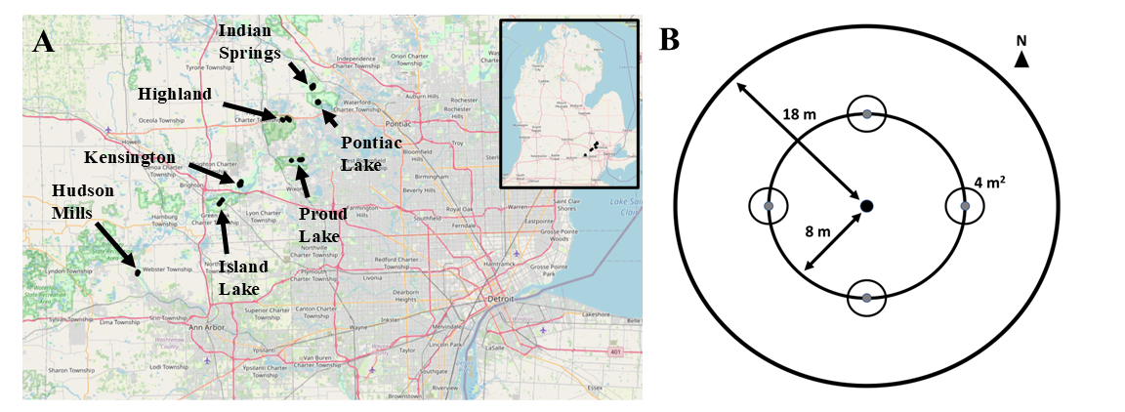

**Figure 1.1.** Map of southeastern Michigan showing the locations of the seven Huron-Clinton Metroparks (Indian Springs, Kensington, and Hudson Mills) and Michigan State Recreation Areas (Pontiac, Highland, Proud Lake, and Island Lake) where forest stands were surveyed (A). Plot design, showing the 18 m radius main plot, the 8 m radius nested subplot, and the four 4 m2 area microplots located in cardinal directions (B). Forest transects were comprised of three replicate plots.

Ash abundance and health

To assess the abundance and health of ash, canopy ash trees (≥10 cm diameter at breast height, DBH) were surveyed within the entire 18 m radius main plots, understory ash trees (2.5-10 cm DBH) and living ash saplings (≥137 cm in height but <2.5 cm DBH) were surveyed within the central 8 m radius subplots, and living ash seedlings (<137 cm in height) were surveyed within the 4 m2 microplots. All seedlings were checked for the presence of cotyledons which would indicate they were newly germinated (Klooster et al. 2013). Ash seedlings were counted in two height categories, <25 cm and >25 cm, and the percentage cover of ash seedlings in microplots was estimated (Klooster et al. 2013).

When present, canopy and understory ash (>2.5 cm DBH) were assessed individually for DBH, species, and health. All DBH measurements were taken at a height of 137 cm (Ward et al. 2021). Due to difficulties in distinguishing green and white ash, species designations were grouped into three categories: 1) black ash; 2) all other species of ash, including white ash, green ash, and potentially pumpkin ash (*Fraxinus profunda* Bush); and 3) unknown ash species because the tree was dead. After recording ash species, the tree was checked for signs and symptoms of EAB, including the presence of D-shaped emergence holes, woodpecker predation marks, bark splitting, epicormic sprouts, and basal sprouts. Furthermore, the canopy condition was rated using a 1 to 5 scale, where 1 represented a healthy canopy, 5 represented complete defoliation of the canopy (possibly still with living epicormic sprouts), and 2-4 represented increasing stages of decline (Smith 2006, Klooster et al. 2013, Knight et al. 2014). For statistical analyses, we simplified the canopy condition variable into two binary variables, *ash tree decline* and *ash tree death*. *Ash tree decline* was coded as 1 if the canopy condition showed any signs of decline (i.e. if canopy condition ≥ 2) and 0 if the canopy condition = 1. *Ash tree death* was coded as 1 if canopy condition = 5, and 0 otherwise (adapted from Hoven et al. 2020).

EAB trapping

In 2024, we used purple-prism traps and multi-funnel traps to assess EAB presence at six of the seven study parks (all except Hudson Mills Metropark, Table A.2). Two purple-prism traps were installed at each park, for a total of 12 prism traps. Additionally, three multi-funnel (Lindgren) traps were installed at one park, Pontiac Lake Recreation Area. Traps were hung on or near the biggest ash trees that could be found during preliminary site visits. Traps were installed between May 29 and June 5, 2024 (627-734 GDD, base 50 °F, single sine method), and removed between July 23 and July 25, 2024 (1733-1770 GDD) (Oregon State University 2022). Purple prism traps used standard purple (“Coroplast purple”) colored board coated with glue (TAD Insect Trap Coating, Great Lakes IPM). Multi-funnel traps consisted of 12 stacked funnels above a collection container, which was filled with a 20% propylene glycol solution. Traps were hung at varying heights on or near ash of varying size classes, depending on what was found at a park (Table A.2). All traps were baited with Manuka oil (Scentry Biologicals Inc., Billings, MT) and a fresh lure was installed halfway through the summer, between June 25 and July 3 (1146-1283 GDD). All buprestid beetles were removed from purple prism traps monthly, and from multi-funnel traps weekly, and EAB were counted and sexed (Parsons 2008).

Parasitoid sampling

In 2024, yellow pan traps were used to determine whether the introduced biological control agents had established in the area. Traps were installed at Pontiac Lake Recreation Area at plot 53 due to a high abundance of ash saplings and seedlings in the understory. Yellow pan traps were composed of two nested yellow plastic bowls attached to the trunk of an ash tree and filled with 20% propylene glycol (Duda Energy LLC, Decatur AL) solution and a drop of unscented dish soap (USDA–APHIS/ARS/FS 2021). The USDA design was modified by using polypropylene webbing straps instead of nails to attach to the tree (Figure A.2). On June 4, 2024, 15 traps were attached at a height of 5-6 feet to green or white ash trees (3.2-9.6 cm DBH) (Table A.3). Traps were collected weekly until August 8, 2024, by pouring the collection liquid through a fine mesh paint filter (TCP Global, San Diego CA, listed as 190 μm, actually ~300 μm = 0.3 mm) and rinsing with distilled water. Since the smallest introduced parasitoid, *Oobius agrili*, averages 0.95 mm long (Zhang et al. 2005), a 0.3 mm mesh size was sufficient to collect all three parasitoid species. Paint filters were cooled on ice within 30 minutes and frozen within 24 hours (USDA–APHIS/ARS/FS 2021). To sort trap contents, a paint filter was placed into a petri dish and 70% isopropanol in distilled water was added. The introduced biological control agents of EAB were identified using USDA guidelines (USDA–APHIS/ARS/FS 2021) and determinations were verified (Toby Petrice, personal communication).

Vegetation survey in hydric transects

In 2025, non-ash canopy trees (≥12.5 cm DBH) and understory trees (2.5-12.5 cm DBH) were characterized in the 18 m radius main plot and the 8 m radius subplot, respectively, to investigate plant composition in hydric forests following the loss of ash. All trees within hydric plots were identified to species if possible and rated as living or dead (dead trees could still have living epicormic sprouts). Trees that divided into two or more branches below breast height (137 cm) were considered as the same tree and were counted if their sum of diameters was greater than the threshold (i.e., 12.5 cm for the main plot or 2.5 cm for the subplot). Stems were considered as separate trees if they remained separate down to ground level, even if they likely connected belowground (Abella et al. 2019).

In addition to tree surveys, percentage cover was estimated for woody shrubs, graminoids (grasses, cattails, and sedges), skunk cabbage (*Symplocarpus foetidus* (L.) Salisb.), ferns, and standing water. The percentage cover of the shrubs poison sumac (*Toxicodendron vernix* (L.) Kuntze), spicebush (*Lindera benzoin* L.), winterberry (*Ilex verticillata* (L.) A.Gray), and glossy buckthorn (*Frangula alnus* Mill.) were scored individually. Percentage cover was visually estimated for each of these categories by standing at 8 m in the NE, SE, SW, and NW quadrants of the 18 m radius plot. The four estimates for each cover type were averaged for a plot-level estimate.

Statistical analysis

All analyses were conducted in R version 4.4.1. All code and development history that support these findings can be found in the GitHub repository: https://github.com/KPerryLab/EAB_Michigan_2024_2025.

For the first objective, the unit of replication was the transect, and counts of ash canopy and understory trees, ash saplings, and ash seedlings were each summed across the three plots in a transect. Densities were calculated in units of stems per hectare. For canopy and understory trees, density of standing dead trees (canopy condition = 5) was calculated separately from density of living trees (canopy condition < 5). Basal area was calculated for living canopy and understory trees using the formula Σ(π*(d/2)2), where d is the DBH of each individual tree stem (Hoven et al. 2020). Multiple stems of a single tree were considered individually for basal area calculations but were considered as the same tree for tree counts.

To test for differences in ash populations among hydrological classes, we used generalized linear mixed-effects models (GLMMs). The response variables were number of short ash seedlings (count), number of tall ash seedlings (count), mean percentage cover of ash seedlings (continuous), number of ash saplings (count), and number of living understory ash trees (count). Due to a low number of observations, the number of canopy ash (≥10 cm DBH) was not tested statistically. A separate model was created for each response variable. Hydrological class (xeric, mesic, or hydric) was treated as the fixed effect predictor and park was included as a random intercept. For each count response variable, a Poisson GLMM with a log link function was implemented using the package ‘lme4’ (Bates et al. 2015) in R (R Core Team 2024). The package ‘DHARMa’ was used to determine if the observed data were adequately modelled by the GLMM (Hartig 2024). If residuals were determined to be overdispersed, a negative binomial error structure was implemented using the ‘lme4’ (Bates et al. 2015) and ‘MASS’ (Venables et al. 2002) packages in R. The residuals of the negative binomial GLMM were similarly examined to verify model fit. Furthermore, the Akaike Information Criterion (AIC) was compared between the Poisson and negative binomial models to verify improvement in fit. The models for number of saplings and number of understory trees were singular fits, so the random intercept term for park was dropped. For the mean percentage cover of ash seedlings, a linear mixed effects model with a Gaussian error structure was used. The mean percentage cover was transformed using the function f(x)=ln(x+1) to satisfy the assumption of homogeneity of variances. For all models, the ‘Anova’ function in the R package ‘car’ (Fox and Weisberg 2019) was used to test for overall differences among hydrological classes, and Tukey contrasts were calculated using the R package ‘emmeans’ (Lenth 2024).

To test the hypothesis that ash tree diameter would be positively correlated with signs and symptoms of EAB attack, generalized linear mixed-effects models with binomial error structure and logit link functions were implemented using the package ‘lme4’ (Bates et al. 2015). The binary (y/n) response variables tested were woodpecker predation marks, bark splitting, epicormic sprouts, basal sprouts, ash tree decline, and ash tree death. The fixed effect predictor variable was tree DBH. Plot was included as a random intercept to account for non-independence of trees in a plot. A Z-test was used to test the null hypothesis of no relationship between DBH and the EAB symptom. For our analysis, understory and overstory ash trees were pooled, and any tree was excluded if it belonged to a plot where less than 10 trees were found, which yielded a sample size of 283 trees. This was so that we could account for differences in frequency of EAB symptoms based on site conditions (which might vary by plot). A cutoff of 5 trees in a plot was also tested and did not change the direction or significance of the results. To assess the accuracy of the models, trees were binned into increments of 1 cm diameter, and the proportion of trees in each bin showing the EAB symptom was calculated. A model was judged as a good fit if the model trendline passed through the proportions for each bin.

To understand differences in plant communities in hydric forests, we characterized tree species composition in each plot separately, rather than combining plots into transects. This was because some transects had variation between plots in tree species composition. Tree species composition was visually assessed using nonmetric multidimensional scaling (NMDS) with the function ‘metaMDS’ in the ‘vegan’ package (Oksanen et al. 2024). The Bray-Curtis dissimilarity between each of the 30 plots was calculated using the basal area (≥ 2.5 cm DBH) of each tree species. Tree species were included in the analysis if they had ≥ 10 trees observed. The white oaks (*Quercus alba*, *Q. bicolor*, and *Q. macrocarpa*), red oaks (*Q. rubra* and *Q. palustris*), poplars (*Populus deltoides* and *P. grandidentata*), and elms (*Ulmus* sp.) were not identified to species level for the NMDS analysis.

## Results

In our survey of the 37 transects, we found 2981 ash seedlings, 1037 ash saplings, 276 living and 54 dead standing understory ash trees, and 7 living and 2 dead standing canopy (>10 cm DBH) ash trees. The basal area of living ash trees (≥ 2.5 cm DBH) at the transect level ranged between 0 and 2.60 m2/ha but averaged only 0.24 m2/ha. Ash seedlings were observed in 36 of the transects, but none had cotyledons. Only four ash trees were found producing seeds in the 18 m radius plots, including a 2.9 cm DBH green ash and three black ash trees ranging from 6.6 to 11.5 cm DBH. EAB adults were trapped at most parks, but in low densities (Fig. A.3). Three introduced biological control agents were recovered, *Spathius galinae* (3 individuals collected), *Oobius agrili* (2 individuals), and *Tetrastichus planipennisi* (2 individuals), but in low abundance. Parasitoids introduced for EAB biocontrol comprised 0.46% (7/1537) of the Hymenoptera caught in pan traps.

Abundance of ash among forest types

The average density of ash seedlings ranged from 0-54,000 stems/ha (0-5.4 stems/m2), with an average of 16,500 stems/ha (1.7 stems/m2). Of these ash seedlings, approximately half were in the shorter size class (0-25 cm tall) while the other half were in the taller size class (25-137 cm tall) (Table 1.1). Percentage cover of ash seedlings averaged 10.7% of the forest floor across all 37 transects. Ash seedling densities and percentage cover were lowest in hydric transects, relative to mesic and xeric transects (Fig. 1.2A; short seedlings model: χ2=12.63, 2 df, p=0.002; tall seedlings model: χ2=19.12, p<0.001, percentage cover model: χ2=17.72, p<0.001). The density of ash saplings (>137 cm tall and <2.5 cm DBH) was similar among hydrological classes (χ2=0.26, p=0.88) (Fig. 1.2B). A total of 330 understory (2.5-10 cm DBH) ash trees were found, and of these, 276 were living (canopy condition 1-4), while 54 were dead and standing. Hydric transects had more understory ash trees than xeric transects and marginally more understory ash trees than mesic transects (Fig. 1.2C; χ2=14.63, p=0.001). Of the 330 understory ash trees, 131 were identified as being green, white, or pumpkin ash, while 178 were identified as black ash, and 21 were unidentified *Fraxinus* (Figure A.1). Only 9 canopy ash trees (≥ 10 cm DBH) were found across all plots, of which 7 trees were living. Living canopy ash trees within the plots ranged in diameter from 10.3-12.4 cm DBH.

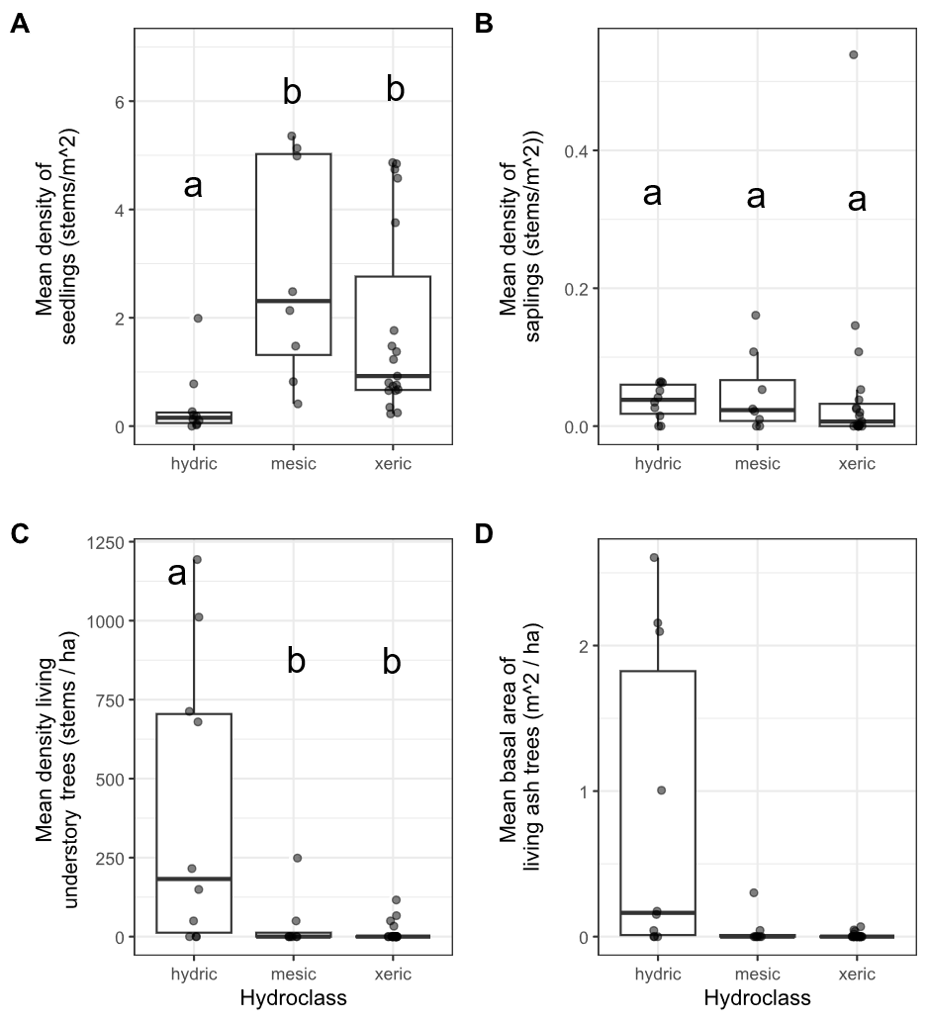

**Figure 1.2.** Ash occurrence in 37 transects in the Upper Huron River Watershed in southeast Michigan. The x-axis represents the soil hydrological class of the transect. Each data point represents a transect. Lowercase letters above bars indicate statistically significant differences at α=0.05. A) Mean density of ash seedlings (all ash with height < 1.37 m; short and tall seedling categories were combined for the graph), B) mean density of ash saplings (height ≥ 1.37 m and DBH < 2.5 cm), C) mean density of living understory ash trees (2.5 cm ≤ DBH < 10 cm), D) mean basal area of all living ash trees (DBH ≥ 2.5 cm). The basal area of living ash trees was not statistically investigated due to low occurrence.

**Table 1.1.** Density (± standard error) of living ash (*Fraxinus* spp.) regeneration in hydric (*n*=10), mesic (*n*=8), and xeric (*n*=19) transects in the Upper Huron River Watershed in southeast Michigan, USA. Data were collected during the growing season in 2024-2025. Table columns are size class (including short seedlings, tall seedlings, saplings, understory trees, and canopy trees), hydrology class (including hydric, mesic, xeric, and combined), and ash per hectare.

|  |  |  |
| --- | --- | --- |
| Size class | Hydrology class | Ash ha-1 |
| Short seedlings (<25 cm tall) | Hydric | 1,334 ± 952 |
|  | Mesic | 15,420 ± 4,920 |
|  | Xeric | 9,895 ± 2,458 |
|  | Combined | 8,776 ± 1,824 |
|  |  |  |
| Tall seedlings (25-137 cm tall) | Hydric | 2,381 ± 994 |
|  | Mesic | 13,085 ± 2,563 |
|  | Xeric | 8,351 ± 1,625 |
|  | Combined | 7,761 ± 1,189 |
|  |  |  |
| Saplings (>137 cm tall and <2.5 cm DBH) | Hydric | 360 ± 79 |
|  | Mesic | 472 ± 205 |
|  | Xeric | 517 ± 286 |
|  | Combined | 465 ± 152 |
|  |  |  |
| Understory trees (2.5 – 10 cm DBH) | Hydric | 401 ± 145 |
|  | Mesic | 37 ± 31 |
|  | Xeric | 14 ± 7 |
|  | Combined | 124 ± 48 |
|  |  |  |
| Canopy trees (>10 cm DBH) | Hydric | 2 ± 2 |
|  | Mesic | 0 |
|  | Xeric | 0 |
|  | Combined | 0 |

Signs and symptoms of EAB

Of the symptoms of EAB, bark splitting was the most common and was found on 193 (57%) ash trees (DBH ≥ 2.5 cm). Epicormic sprouts were found on 122 (36%) ash trees. Basal sprouts were found on 54 (16%) ash trees, while woodpecker predation marks were found on 46 (14%) ash trees. Out of a total of 338 trees, 229 (68%) were classified as canopy condition 1, 33 (10%) had canopy condition 2, 13 (4%) had canopy condition 3, 7 (2%) had canopy condition 4, and 55 (16%) had canopy condition 5. The D-shaped emergence holes from EAB were observed rarely, with only 8 trees (2%) recorded with visible exit holes.

The presence of woodpecker predation marks was positively correlated with tree diameter (DBH), with a 1 cm increase in DBH increasing the odds of woodpecker marks by a factor of 1.24 (Z=2.46, p=0.013) (Fig. 1.3A). Similarly, presence of epicormic sprouts was positively correlated with DBH, with a 1 cm increase in DBH increasing the odds of epicormic sprouts by a factor of 1.31 (Z=3.49, p<0.001) (Figure 1.3C). The presence of canopy decline was positively correlated with DBH, such that a 1 cm increase in DBH increased the odds of canopy decline by a factor of 1.22 (Z=2.89, p=0.004) (Figure 1.3F). Even though canopy decline was positively correlated with DBH, 57% of ash larger than 5 cm DBH had healthy canopies (i.e., canopy condition 1). No relationships were observed between DBH and bark splitting (Z=1.64, p=0.102), presence of basal sprouts (Z=1.16, p=0.245), and tree death (Z=0.21, p=0.831) (Figure 1.3B, D, and E).

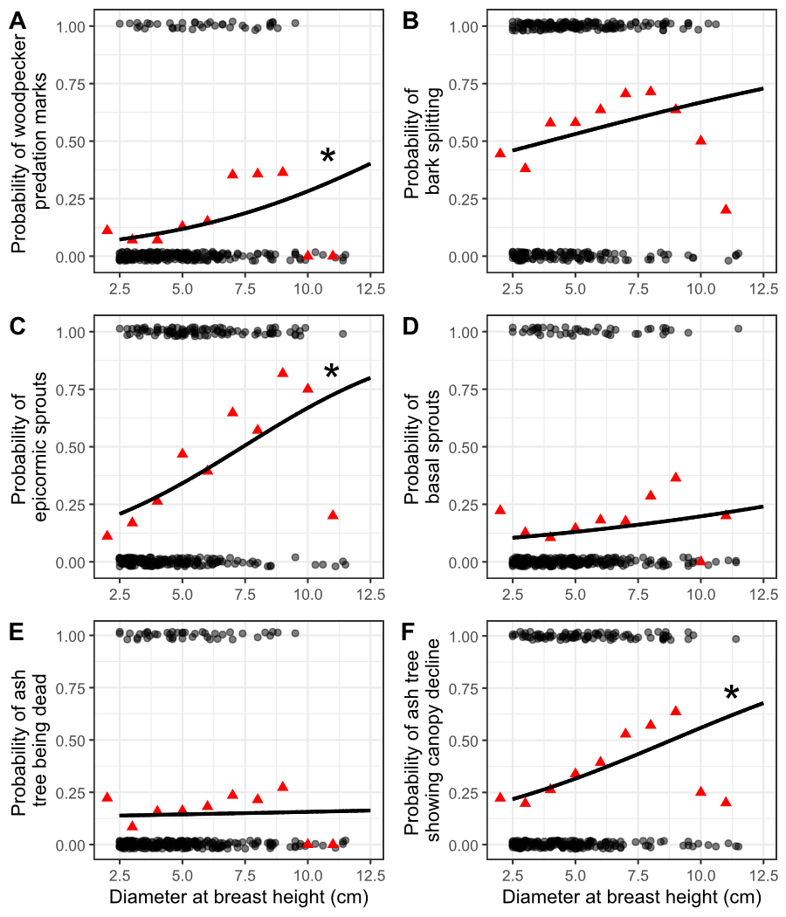

**Figure 1.3.** The presence or absence of symptoms of EAB plotted against tree diameter at breast height (DBH) for 283 ash trees. Trees were included in the analysis if they belonged to a forest plot containing at least 10 trees. Grey circles are individual trees, which are plotted as y=1 for presence or y=0 for absence (points were vertically jittered slightly). Black line shows the overall fitted model, disregarding each specific random intercept for each plot. See Figure A.4 for plots including each random intercept. Asterisk next to the lines for woodpecker predation marks, epicormic sprouts, and canopy decline indicate a slope significantly different from zero. Red triangles show the proportion of trees that have the symptom within a DBH bin. For E, tree death is defined as having a canopy condition of 5. For F, canopy decline is defined as having a canopy condition between 2-5 (minor to complete defoliation).

Plant communities in hydric stands

We identified 810 living canopy trees comprising 18 genera across the 10 hydric transects (Table 1.2). The most common species in the canopy (≥ 12.5 cm DBH) was silver maple (*Acer saccharinum* L.), followed by elm (*Ulmus* sp.), and basswood (*Tilia americana* L.). In the understory (2.5 ≤ DBH < 12.5 cm), 638 living trees were found, of which the most common species were musclewood (*Carpinus caroliniana* Walter), black ash (*Fraxinus nigra*), and green ash (*Fraxinus pennsylvanica*, possibly with some *F. americana* and *F. profunda*). The basal area of living trees in the canopy and understory averaged 21.1 m2/ha and 2.8 m2/ha, respectively, not counting shrub species. Of the ground-level cover types estimated in hydric plots, graminoids and skunk cabbage had the highest percentage cover (Table 1.3). The invasive shrubs glossy buckthorn (*Frangula alnus* Miller) and autumn olive (*Elaeagnus umbellata* Thunb.) were present, but with lower percentage cover than the native shrubs spicebush and winterberry. The NMDS ordination (Fig. 1.5) indicated a grouping of sample plots with high basal area of silver maple on the left side of the graph. Meanwhile, the upper center of the graph contained plots with species such as sugar maple (*Acer saccharum* Marshall). On the lower right side of the graph are plots with high basal area of yellow birch (*Betula alleghaniensis* Britt.) and/or tamarack (*Larix laricina* (Du Roi) K. Koch). The plots with high basal area of green ash tended to be in the forests with silver maple, whereas the plots with high basal area of black ash tended to be in forests with tamarack and/or yellow birch, although black and green ash also co-occurred in some plots.

**Table 1.2.** Relative density (%) and relative dominance (%) of canopy (≥12.5 cm DBH) and understory (2.5-12.5 cm DBH) tree genera found in the 10 hydric transects (30 plots) in 2024-2025. Only living trees were counted. A total of 810 living canopy trees were counted in the main plots and 638 living understory trees were counted in the subplots. Shrub species were not counted. The first column lists the genus of tree.

|  |  |  |  |  |
| --- | --- | --- | --- | --- |
|  | Relative density, % | | Relative dominance, % | |
| Genus | Understory | Canopy | Understory | Canopy |
| *Acer* | 10.5 | 42.3 | 18.7 | 63.5 |
| *Betula* | 0.3 | 3.8 | 0.7 | 2.3 |
| *Carpinus* | 19.5 | 2.7 | 12.1 | 0.3 |
| *Carya* | 0.5 | 0.6 | 0.4 | 0.4 |
| *Cornus* | 0.5 | 0 | 0.2 | 0 |
| *Fagus* | 0.3 | 0.5 | 0.6 | 0.7 |
| *Frangula* | 7.5 | 0.1 | 3.7 | 0 |
| *Fraxinus* | 38.1 | 0 | 28.8 | 0 |
| *Juniperus* | 0 | 0.1 | 0 | 0 |
| *Larix* | 0.9 | 5.8 | 0.8 | 2.3 |
| *Ostrya* | 0.9 | 0.4 | 0.7 | 0.1 |
| *Populus* | 0 | 1.2 | 0 | 4.6 |
| *Prunus* | 0.3 | 0.5 | 0.3 | 0.4 |
| *Quercus* | 3.3 | 10 | 3.3 | 12.8 |
| *Rhamnus* | 0.2 | 0.1 | 0 | 0 |
| *Tilia* | 3.3 | 15.1 | 4.5 | 7 |
| *Ulmus* | 13.3 | 16.2 | 24.7 | 5.5 |
| *Viburnum* | 0.5 | 0.1 | 0.5 | 0 |

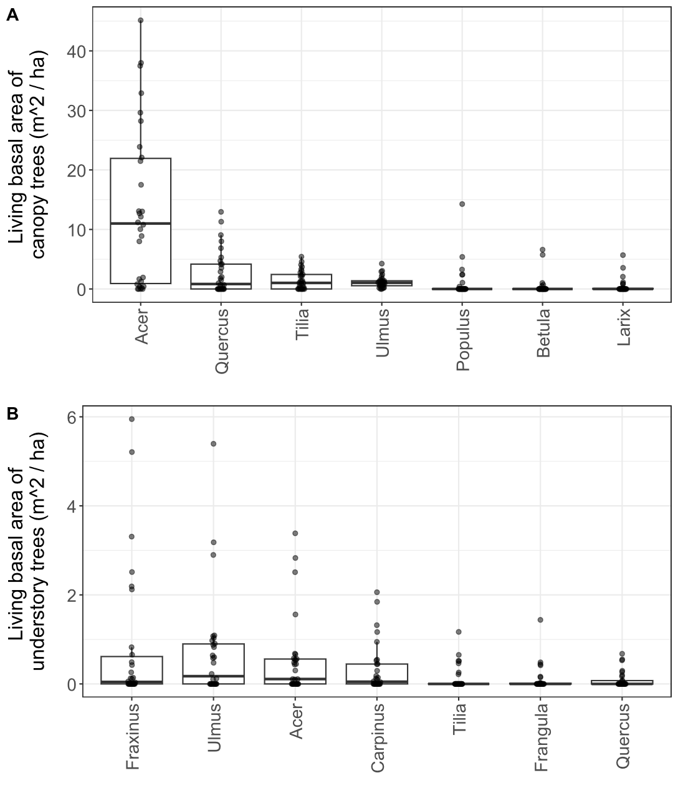

**Figure 1.4.** Basal area of living trees in the 30 hydric plots surveyed in 2025. Each dot represents a single plot. A) Canopy trees (≥ 12.5 cm DBH); B) understory trees (2.5-12.5 cm DBH). Tree genera were only included in the graph if their mean basal area was in the top seven. Note the difference in y-axis scale between the two graphs. Boxplot boundaries represent the 25th and 75th percentiles, while center line within the box is the median. Genera were arranged in the order of decreasing mean basal area.

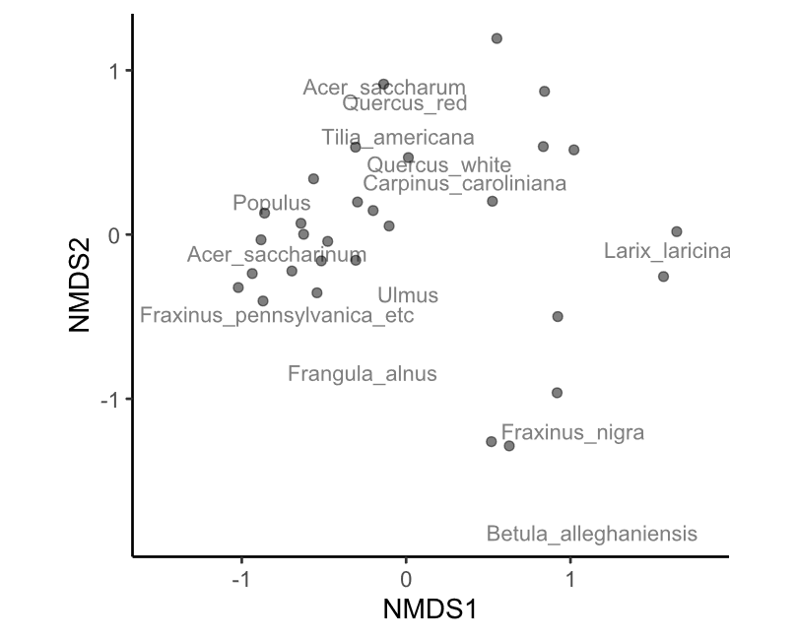

**Figure 1.5.** Nonmetric multidimensional scaling (NMDS) of the tree species composition among the 30 hydric plots visited in 2025. Each point is a plot. Data used to generate the NMDS was the basal area per hectare of each tree species, counting all trees ≥ 2.5 cm DBH. The final stress value was 0.149. Species were pooled within each of the red oak group (*Quercus* section *Lobatae*), the white oak group (*Quercus* section *Quercus*), *Ulmus,* and *Populus* for the analysis.

**Table 1.3.** Average percentage cover (± SE) of understory cover types in the 30 hydric plots surveyed in 2025. Standard errors were calculated using n=30. The columns are cover type, scientific name, and mean percentage cover ± standard error.

|  |  |  |  |  |
| --- | --- | --- | --- | --- |
| Cover type | Scientific name | Mean percentage cover (%) ± SE | | |
| Water |  | 9.8 | ± | 2.6 |
| Graminoids | Poales | 52.7 | ± | 5.0 |
| Skunk cabbage | *Symplocarpus foetidus* | 37.6 | ± | 5.0 |
| Ferns |  | 16.5 | ± | 2.9 |
| Spicebush | *Lindera benzoin* | 19.2 | ± | 4.4 |
| Winterberry | *Ilex verticillata* | 5.7 | ± | 1.9 |
| Glossy buckthorn | *Frangula alnus* | 3.6 | ± | 1.2 |
| Poison sumac | *Toxicodendron vernix* | 2.1 | ± | 0.9 |
| Other woody shrubs | *Elaeagnus umbellata, Cornus* spp.*, Rosa* spp.*, Vaccinium* spp.*, Corylus* spp., etc. | 5.0 | ± | 0.8 |

## Discussion

Over two decades since EAB was first detected in North America, we characterized ash survival and regeneration in forests that have experienced the longest history of EAB impacts. We found that ash regeneration was still present in these post-outbreak forests, although EAB continues to impact populations of ash. Ash regeneration remained at the seedling or sapling stages in mesic and xeric forests, but in hydric forests, ash regeneration consisted of trees in size classes susceptible to EAB. Parasitoids introduced to control EAB populations have established in the region, and we recovered three species, albeit in low numbers.

Stages of ash regeneration varied based on forest soil hydrology. In dry xeric and riparian mesic forests, ash seedlings were a prominent component of the understory layer, but ash trees >2.5 cm DBH were mostly absent. In hydric swamp forests, we found low numbers of seedlings, but higher densities of ash in the 2.5-10 cm DBH range. This suggests a difference in growth rate and/or regeneration stage, whereby ash regeneration tended to be more advanced in hydric forests. In our study locations, the hydric transects previously had a higher density of ash in the canopy than mesic or xeric transects, which may have resulted in larger canopy gaps following widespread ash mortality (Klooster 2012). Furthermore, overall canopy tree cover was lower in hydric forests than mesic or xeric forests even before significant ash loss (Smith 2006, Klooster 2012). Multi-tree gaps and high light availability likely allowed surviving ash regeneration to grow quickly as EAB populations declined following a reduction in host material in the landscape. Furthermore, black and green ash, which are highly tolerant of flooding, likely had an advantage in hydric forests over other co-occurring plant species, such as *C. caroliniana*, which are less flood tolerant (Table A.4) (Niinemets and Valladares 2006). In contrast, mesic and xeric forests may have developed mostly single-tree gaps from isolated ash canopy trees, allowing neighboring non-ash canopy trees to fill the gaps before saplings could grow substantially. In fact, saplings underneath mature canopy trees may require more than one tree-fall event in order to reach the canopy, due to the rapid canopy expansion of neighboring mature trees (Runkle and Yetter 1987). Other studies of forests after EAB invasion have similarly found rapid growth of canopy trees, such as sugar maples, to fill gaps left by ash mortality (Costilow et al. 2017, Hoven et al. 2020).

Although ash seedlings were abundant in these post-outbreak forests, almost none had cotyledons. I did, however, observe two individual ash seedlings, just outside a microplot, which had cotyledons (A. Tayal, personal observation). Thus, the vast majority of ash seedlings present are not newly germinated, but rather have established in previous years. The most plausible explanation is that ash seedlings are simply persisting from before 2008, when new germination from the seed bank ceased. While mortality and recruitment to larger size classes appear to have decreased ash seedling densities since 2010 (Klooster et al. 2013), a sizeable number (~16,500 seedlings ha-1 for those under 137 cm tall) remain in these long-term monitoring plots. While the density of surviving seedlings is higher than observed in most other studies, it corroborates other findings that ash seedlings can persist for long time periods in forest understories (Engelken et al. 2020, Siegert et al. 2021, Morris et al. 2023). In particular, ash seedlings seem more capable of long-term persistence in mesic and xeric forests, whereas in hydric forests competition with graminoids and seasonal flooding can limit seedling abundances (Engelken et al. 2020, Abella et al. 2024). Importantly, our study found isolated examples of seed-producing ash trees rather than widespread seed production, likely indicating that the seedbank is not yet being replenished. This stands in contrast to some studies in which seed production continued even after EAB invasion (Kashian 2016, Robinett and McCullough 2019, Morris et al. 2023). It is possible that site conditions influenced the number of ash trees that survived the initial wave of EAB invasion, and thus the number of seed-producing trees available to replenish the seedbank (Knight et al. 2013, Kashian 2016).

We found that ash tree regeneration continues to be damaged and killed by EAB, but some trees are surviving well into the susceptible size range. We found that symptoms of EAB including the incidence of canopy decline, woodpecker predation marks, and epicormic sprouts all increased with increasing tree diameter. However, bark splits, basal sprouts, and tree death did not show any significant relationship with ash tree diameter. In particular, the distribution of bark splits across a range of ash diameters suggests that even some 2.5 cm DBH ash are being affected by EAB oviposition. Ash larger than 4 cm DBH may be more suitable for larval development, but female EAB still oviposit on stems as small as 2 cm DBH (Timms et al. 2006, Aubin et al. 2015). Even though EAB symptoms were common, we still found sizeable numbers of ash trees with healthy canopies in the 2.5-10 cm DBH range. This contrasts with patterns observed in 2009, when almost no ash >2.5 cm DBH were living (Klooster et al. 2013). Thus, ash trees continue to grow, although they have not yet attained sizes larger than 12.5 cm DBH in our study plots.

We found that canopy tree species composition varied in hydric swamp forests where EAB has been present for more than 15 years. Black ash provide ecological and cultural services in northern wet forests, including habitat for insects and birds, as well as raw materials for basket weaving by Tribal Nations (Gandhi et al. 2014, Wagner and Todd 2015, Youngquist et al. 2017, Bolen 2020). Because ash is a dominant tree in swamp forests of the northern US and Canada, ash mortality caused by EAB is currently having substantial impacts in these systems (Golet et al. 1993, Kolka et al. 2018, Siegert et al. 2023). We investigated tree composition in hydric forests to determine which species thrived after canopy ash mortality, and found that silver maple was abundant, especially in the canopy. This species thrives in alluvial soils and is highly tolerant of seasonal flooding (Table A.4) (Burns and Honkala 1990, Niinemets and Valladares 2006, Bolton et al. 2018). However, not all plant communities were dominated by silver maple but instead contained tamarack and sometimes yellow birch. Tamarack and yellow birch are typical of cooler, northern forests, whereas silver maple is commonly found further south of our study sites (Barnes 1976, Braun 1989, Burns and Honkala 1990, Kost and O’Connor 2003, Kartesz 2015). Regeneration of green ash primarily occurred alongside silver maple, whereas black ash regeneration was commonly associated with tamarack or yellow birch, although the two ash species were sometimes found in the same stands. These observed associations between tree species can inform restoration plantings in forests impacted by EAB, especially if land managers seek replacement tree seedlings to maintain or improve forest cover (Bolton et al. 2018, Palik et al. 2021). Consistent with our results, black ash regeneration in the 2.5-10 cm DBH range has been variable, but trees larger than 14 cm DBH were rare (Engelken et al. 2020, Siegert et al. 2021). Our results indicate that once 15 years have passed since peak EAB densities, black ash regeneration remains alive in many swamp forests. Although black ash only produces abundant seeds every 5-7 years, and seeds can take 2 years to germinate, our observation of a few seed-producing black ash trees indicates the possibility for black ash populations to continue to recover (Benedict and David 2003). Future research should focus on forest attributes that may affect black ash regeneration success, including water pH, nutrient levels, and seasonal flooding pattern (Golet et al. 1993).

Three species of parasitoids introduced to control EAB populations were recovered in these post-outbreak forests, specifically at Pontiac Lake Recreation Area. Although these parasitoids cannot prevent canopy ash mortality in forests naïve to EAB, they may help protect regenerating ash trees in post-outbreak forests (Duan et al. 2017, Kashian et al. 2018, Jones et al. 2019). We detected *T. planipennisi*, which has been shown to effectively reduce the abundance of EAB through a combination of multiple generations per year, multiple wasps developing from a single EAB larvae, and effective dispersal capability (Duan et al. 2011, Fahrner et al. 2014, Jones et al. 2019, 2020, USDA–APHIS/ARS/FS 2021). Similarly, we detected *S. galinae*, a parasitoid native to the Russian Far East which can spread rapidly and parasitize EAB larvae within larger ash trees due to its long ovipositor (Duan et al. 2021, Aker et al. 2022). Finally, we detected *O. agrili*, an egg parasitoid which times its lifecycle to when EAB females are ovipositing on the bark of ash trees (Petrice et al. 2021a). Our recovery of *O. agrili* is encouraging, given that its small size could make dispersal challenging, and that parasitism of EAB eggs could provide another layer of biological control (Quinn et al. 2022a, 2023). Although we recovered all three biological control agents known to have established in the region (Duan et al. 2023, mapBioControl 2024), we collected these parasitoids in low abundance (7 individuals total). Yellow pan traps are an inefficient method to detect larval parasitoids, and do not permit estimation of parasitism rates (Rutledge et al. 2021). However, they can be a useful nondestructive method for quantifying parasitoid populations if the sample size is sufficiently large, and may be particularly suited to monitoring *O. agrili* populations (Petrice et al. 2021b).

Our findings in forests of southeast Michigan, 15 years after peak ash mortality, showed that ash is still present in forests. Parasitoids may be playing a role in the health of the ash regeneration, but further research is necessary. Specifically, parasitoids should be surveyed in hydric swamp forests with regenerating black ash because previous studies have primarily focused on parasitoids in stands of green or white ash (Abell et al. 2014, Quinn et al. 2022b). We found that in hydric stands, ash trees between 2.5-10 cm DBH were common, whereas in 2009 this size of tree had been completely killed by EAB (Klooster et al. 2013). Furthermore, some regeneration exhibited symptoms of EAB, like epicormic sprouts, whereas others in the same stand appeared healthy. Multiple factors could be involved in the survival and growth of ash regeneration, including reduced EAB density due to declines in living ash phloem (Duan et al. 2015, Siegert et al. 2021), the degree of ash tree resistance to EAB (Koch et al. 2015, Villari et al. 2016), site conditions including sunlight and water levels (Knight et al. 2013, Davis et al. 2017), and parasitoid natural enemies. Future research could focus on the host-location strategies of parasitoids, which could improve our knowledge of whether parasitoids could disperse to ash trees that are newly infested with EAB, or if parasitoids only disperse to declining ash (Johnson et al. 2014, Chen et al. 2016, Wilson et al. 2024). In summary, the continued presence of ash in forests of southeast Michigan is far from guaranteed, but instead depends on multiple top-down and bottom-up ecological processes.

## References

Abell, K. J., L. S. Bauer, J. J. Duan, and R. Van Driesche. 2014. Long-term monitoring of the introduced emerald ash borer (Coleoptera: Buprestidae) egg parasitoid, *Oobius agrili* (Hymenoptera: Encyrtidae), in Michigan, USA and evaluation of a newly developed monitoring technique. Biological Control 79:36–42.

Abell, K. J., J. J. Duan, L. Bauer, J. P. Lelito, and R. G. Van Driesche. 2012. The effect of bark thickness on host partitioning between *Tetrastichus planipennisi* (Hymen: Eulophidae) and *Atanycolus* spp. (Hymen: Braconidae), two parasitoids of emerald ash borer (Coleop: Buprestidae). Biological Control 63:320–325.

Abella, S. R., C. E. Hausman, J. F. Jaeger, K. S. Menard, T. A. Schetter, and O. J. Rocha. 2019. Fourteen years of swamp forest change from the onset, during, and after invasion of emerald ash borer. Biological Invasions 21:3685–3696.

Abella, S. R., K. S. Menard, T. A. Schetter, and C. E. Hausman. 2024. Species and landscape variation in tree regeneration and 17 years of change in forested wetlands invaded by emerald ash borer. Forest Ecology and Management 557:121750.

Aker, S. A., R. B. De Andrade, J. J. Duan, and D. S. Gruner. 2022. Rapid Spread of an Introduced Parasitoid for Biological Control of Emerald Ash Borer (Coleoptera: Buprestidae) in Maryland. Journal of Economic Entomology 115:381–386.

Aubin, I., F. Cardou, K. Ryall, D. Kreutzweiser, and T. Scarr. 2015. Ash regeneration capacity after emerald ash borer (EAB) outbreaks: Some early results. The Forestry Chronicle 91:291–298.

Barnes, B. V. 1976. Succession in deciduous swamp communities of southeastern Michigan formerly dominated by American elm. Canadian Journal of Botany 54:19–24.

Bates, D., M. Mächler, B. Bolker, and S. Walker. 2015. Fitting Linear Mixed-Effects Models Using lme4. Journal of Statistical Software 67.

Benedict, L., and R. David. 2003. Propagation Protocol for Black Ash (Fraxinus nigra Marsh.). Native Plants Journal 4:100–103.

Bolen, A. 2020. A Silent Killer: Black Ash Basket Makers are Battling a Voracious Beetle to Keep Their Heritage Alive. National Museum of the American Indian 21.

Bolton, N., J. Shannon, J. Davis, M. Grinsven, N. Noh, S. Schooler, R. Kolka, T. Pypker, and J. Wagenbrenner. 2018. Methods to Improve Survival and Growth of Planted Alternative Species Seedlings in Black Ash Ecosystems Threatened by Emerald Ash Borer. Forests 9:146.

Braun, E. L. 1989. The woody plants of Ohio: trees, shrubs and woody climbers, native, naturalized, and escaped. Ohio State University Press, Columbus, Ohio.

Burns, R., and B. Honkala. 1990. Silvics of North America: Volume 2, Hardwoods.

Canadian Food Inspection Agency. 2025. Regulated areas and items: Emerald ash borer. https://inspection.canada.ca/en/plant-health/invasive-pests-and-plants/directives/forest-products/03-08/regulated-areas. Accessed November 2025.

Chen, Y., M. D. Ulyshen, and T. M. Poland. 2016. Abundance of volatile organic compounds in white ash phloem and emerald ash borer larval frass does not attract *Tetrastichus planipennisi* in a Y‐tube olfactometer. Insect Science 23:712–719.

Costilow, K. C., K. S. Knight, and C. E. Flower. 2017. Disturbance severity and canopy position control the radial growth response of maple trees (*Acer* spp.) in forests of northwest Ohio impacted by emerald ash borer (*Agrilus planipennis*). Annals of Forest Science 74:10.

Davis, J. C., J. P. Shannon, N. W. Bolton, R. K. Kolka, and T. G. Pypker. 2017. Vegetation responses to simulated emerald ash borer infestation in *Fraxinus nigra* dominated wetlands of Upper Michigan, USA. Canadian Journal of Forest Research 47:319–330.

Duan, J. J., L. S. Bauer, K. J. Abell, M. D. Ulyshen, and R. G. Van Driesche. 2015. Population dynamics of an invasive forest insect and associated natural enemies in the aftermath of invasion: implications for biological control. Journal of Applied Ecology 52:1246–1254.

Duan, J. J., L. S. Bauer, and R. G. Van Driesche. 2017. Emerald ash borer biocontrol in ash saplings: The potential for early stage recovery of North American ash trees. Forest Ecology and Management 394:64–72.

Duan, J. J., J. R. Gould, N. F. Quinn, T. R. Petrice, B. H. Slager, T. M. Poland, L. S. Bauer, C. E. Rutledge, J. S. Elkinton, and R. G. Van Driesche. 2023. Protection of North American ash against emerald ash borer with biological control: ecological premises and progress toward success. BioControl 68:87–100.

Duan, J. J., C. B. Oppel, M. D. Ulyshen, L. S. Bauer, and J. LeLito. 2011. Biology and Life History of *Tetrastichus planipennisi* (Hymenoptera: Eulophidae), a Larval Endoparasitoid of the Emerald Ash Borer (Coleoptera: Buprestidae). Florida Entomologist 94:933–940.

Duan, J. J., R. G. Van Driesche, J. M. Schmude, N. F. Quinn, T. R. Petrice, C. E. Rutledge, T. M. Poland, L. S. Bauer, and J. S. Elkinton. 2021. Niche partitioning and coexistence of parasitoids of the same feeding guild introduced for biological control of an invasive forest pest. Biological Control 160:104698.

Engelken, P. J., M. E. Benbow, and D. G. McCullough. 2020. Legacy effects of emerald ash borer on riparian forest vegetation and structure. Forest Ecology and Management 457:117684.

Fahrner, S. J., J. P. Lelito, K. Blaedow, G. E. Heimpel, and B. H. Aukema. 2014. Factors Affecting the Flight Capacity of *Tetrastichus planipennisi* (Hymenoptera: Eulophidae), a Classical Biological Control Agent of *Agrilus planipennis* (Coleoptera: Buprestidae). Environmental Entomology 43:1603–1612.

Fox, J., and S. Weisberg. 2019. An {R} Companion to Applied Regression. Sage, Thousand Oaks {CA}.

Gandhi, K. J. K., and D. A. Herms. 2010. Direct and indirect effects of alien insect herbivores on ecological processes and interactions in forests of eastern North America. Biological Invasions 12:389–405.

Gandhi, K. J. K., A. Smith, D. M. Hartzler, and D. A. Herms. 2014. Indirect Effects of Emerald Ash Borer-Induced Ash Mortality and Canopy Gap Formation on Epigaeic Beetles. Environmental Entomology 43:546–555.

Golet, F. C., J. A. Allen, U. S. Fish, and W. Service. 1993. Ecology of Red Maple Swamps in the Glaciated Northeast: A Community Profile. U.S. Department of the Interior, Fish and Wildlife Service.

Hartig, F. 2024. DHARMa: Residual Diagnostics for Hierarchical (Multi-Level / Mixed) Regression Models. R.

Hoven, B. M., K. S. Knight, V. E. Peters, and D. L. Gorchov. 2020. Release and suppression: forest layer responses to emerald ash borer (*Agrilus planipennis*)-caused ash death. Annals of Forest Science 77:10.

Johnson, T. D., J. P. Lelito, and K. F. Raffa. 2014. Responses of two parasitoids, the exotic *Spathius agrili* Yang and the native *Spathius floridanus* Ashmead, to volatile cues associated with the emerald ash borer, *Agrilus planipennis* Fairmaire. Biological Control 79:110–117.

Jones, M. I., J. R. Gould, H. J. Mahon, and M. K. Fierke. 2020. Phenology of Emerald Ash Borer (Coleoptera: Buprestidae) and Its Introduced Larval Parasitoids in the Northeastern United States. Journal of Economic Entomology 113:622–632.

Jones, M. I., J. R. Gould, M. L. Warden, and M. K. Fierke. 2019. Dispersal of emerald ash borer (Coleoptera: Buprestidae) parasitoids along an ash corridor in western New York. Biological Control 128:94–101.

Kartesz, J. T. 2015. The Biota of North America Program (BONAP). North American Plant Atlas. (http://bonap.net/napa), Chapel Hill, N.C.

Kashian, D. M. 2016. Sprouting and seed production may promote persistence of green ash in the presence of the emerald ash borer. Ecosphere 7:e01332.

Kashian, D. M., L. S. Bauer, B. A. Spei, J. J. Duan, and J. R. Gould. 2018. Potential Impacts of Emerald Ash Borer Biocontrol on Ash Health and Recovery in Southern Michigan. Forests 9:296.

Klooster, W., K. Gandhi, L. Long, K. Perry, K. Rice, and D. Herms. 2018. Ecological Impacts of Emerald Ash Borer in Forests at the Epicenter of the Invasion in North America. Forests 9:250.

Klooster, W. S. 2012. Forest Responses to Emerald Ash Borer-Induced Ash Mortality. PhD Thesis, The Ohio State University.

Klooster, W. S., D. A. Herms, K. S. Knight, C. P. Herms, D. G. McCullough, A. Smith, K. J. K. Gandhi, and J. Cardina. 2013. Ash (*Fraxinus* spp.) mortality, regeneration, and seed bank dynamics in mixed hardwood forests following invasion by emerald ash borer (*Agrilus planipennis*). Biological Invasions 16:859–873.

Knight, K. S., J. P. Brown, and R. P. Long. 2013. Factors affecting the survival of ash (*Fraxinus* spp.) trees infested by emerald ash borer (*Agrilus planipennis*). Biological Invasions 15:371–383.

Knight, K. S., B. P. Flash, R. H. Kappler, J. A. Throckmorton, B. Grafton, and C. E. Flower. 2014. Monitoring Ash (*Fraxinus* spp.) Decline and Emerald Ash Borer (*Agrilus planipennis*) Symptoms in Infested Areas. General Technical Report, U.S. Department of Agriculture, Forest Service, Northern Research Station.

Koch, J. L., D. W. Carey, M. E. Mason, T. M. Poland, and K. S. Knight. 2015. Intraspecific variation in *Fraxinus pennsylvanica* responses to emerald ash borer (*Agrilus planipennis*). New Forests 46:995–1011.

Kolka, R., A. D’Amato, J. Wagenbrenner, R. Slesak, T. Pypker, M. Youngquist, A. Grinde, and B. Palik. 2018. Review of Ecosystem Level Impacts of Emerald Ash Borer on Black Ash Wetlands: What Does the Future Hold? Forests 9:179.

Kost, M. A., and R. P. O’Connor. 2003. Natural Features Inventory and Management Recommendations for Kensington and Oakwoods Metroparks. Michigan Natural Features Inventory, Huron-Clinton Metropolitan Authority.

Lenth, R. V. 2024. emmeans: Estimated Marginal Means, aka Least-Squares Means. R.

Lovett, G. M., C. D. Canham, M. A. Arthur, K. C. Weathers, and R. D. Fitzhugh. 2006. Forest Ecosystem Responses to Exotic Pests and Pathogens in Eastern North America. BioScience 56:395.

mapBioControl (Midwest Invasive Species Information Network). 2024. https://www.mapbiocontrol.org/. Accessed November 2025.

McCormick, J. F., and R. B. Platt. 1980. Recovery of an Appalachian Forest Following the Chestnut Blight or Catherine Keever-You Were Right! American Midland Naturalist 104:264.

McCullough, D. G. 2019. Challenges, tactics and integrated management of emerald ash borer in North America. Forestry: An International Journal of Forest Research 93:197–211.

Mech, A. M., K. A. Thomas, T. D. Marsico, D. A. Herms, C. R. Allen, M. P. Ayres, K. J. K. Gandhi, J. Gurevitch, N. P. Havill, R. A. Hufbauer, A. M. Liebhold, K. F. Raffa, A. N. Schulz, D. R. Uden, and P. C. Tobin. 2019. Evolutionary history predicts high‐impact invasions by herbivorous insects. Ecology and Evolution 9:12216–12230.

Megonigal, J. P., W. H. Conner, S. Kroeger, and R. R. Sharitz. 1997. Aboveground Production in Southeastern Floodplain Forests: A Test of the Subsidy-Stress Hypothesis. Ecology 78:370–384.

Morris, T. D., J. R. Gould, J. Drake, and M. K. Fierke. 2023. Status of ash forests and regeneration a decade after first detection of emerald ash borer infestation in New York state. Forest Ecology and Management 549:121464.

Murphy, T. C., R. G. Van Driesche, J. R. Gould, and J. S. Elkinton. 2017. Can *Spathius galinae* attack emerald ash borer larvae feeding in large ash trees? Biological Control 114:8–13.

Niinemets, Ü., and F. Valladares. 2006. Tolerance to Shade, Drought, and Waterlogging of Temperate Northern Hemisphere Trees and Shrubs. Ecological Monographs 76:521–547.

Oksanen, J., G. Simpson, F. Blanchet, R. Kindt, P. Legendre, P. Minchin, R. O’Hara, P. Solymos, M. Stevens, E. Szoecs, Wagner H., Barbour M., Bedward M., Bolker B., Borcard D., Carvalho G., Chirico M., De Caceres, M., Durand S., Evangelista H., FitzJohn R., Friendly M., Furneaux B., Hannigan G., Hill M., Lahti L., McGlinn D., Ouellette M., Ribeiro, Cunha E., Smith T., Stier A., Ter Braak C., and J. Weedon. 2024. _vegan: Community Ecology Package_. R.

Olatinwo, R. O., S. W. Fraedrich, and A. E. Mayfield. 2021. Laurel Wilt: Current and Potential Impacts and Possibilities for Prevention and Management. Forests 12:181.

Oliver, C. D., and B. C. Larson. 1996. Forest stand dynamics. Update ed. Wiley, New York.

Oregon State University. 2022. Online Phenology and Degree-day Models. https://uspest.org/dd/model_app.

Palik, B. J., A. W. D’Amato, R. A. Slesak, D. Kastendick, C. Looney, and J. Kragthorpe. 2021. Eighth-year survival and growth of planted replacement tree species in black ash (*Fraxinus nigra*) wetlands threatened by emerald ash borer in Minnesota, USA. Forest Ecology and Management 484:118958.

Parsons, G. 2008. Emerald Ash Borer: A guide to identification and comparison to similar species. Michigan State University Department of Entomology.

Perry, K., and D. Herms. 2019. Dynamic Responses of Ground-Dwelling Invertebrate Communities to Disturbance in Forest Ecosystems. Insects 10:61.

Petrice, T. R., L. S. Bauer, D. L. Miller, T. M. Poland, and F. W. Ravlin. 2021a. A Phenology Model for Simulating *Oobius agrili* (Hymenoptera: Encyrtidae) Seasonal Voltinism and Synchrony With Emerald Ash Borer Oviposition. Environmental Entomology 50:280–292.

Petrice, T. R., L. S. Bauer, D. L. Miller, J. S. Stanovick, T. M. Poland, and F. W. Ravlin. 2021b. Monitoring field establishment of the emerald ash borer biocontrol agent *Oobius agrili* Zhang and Huang (Hymenoptera: Encyrtidae): Sampling methods, sample size, and phenology. Biological Control 156:104535.

Quinn, N. F., J. J. Duan, and J. Elkinton. 2022a. Monitoring the impact of introduced emerald ash borer parasitoids: factors affecting *Oobius agrili* dispersal and parasitization of sentinel host eggs. BioControl 67:387–394.

Quinn, N. F., J. S. Gould, C. E. Rutledge, A. Fassler, J. S. Elkinton, and J. J. Duan. 2022b. Spread and phenology of *Spathius galinae* and *Tetrastichus planipennisi*, recently introduced for biocontrol of emerald ash borer (Coleoptera: Buprestidae) in the northeastern United States. Biological Control 165:104794.

Quinn, N. F., T. R. Petrice, J. M. Schmude, T. M. Poland, L. S. Bauer, C. E. Rutlege, R. G. Van Driesche, J. S. Elkinton, and J. J. Duan. 2023. Postrelease assessment of *Oobius agrili* (Hymenoptera: Encyrtidae) establishment and persistence in Michigan and the Northeastern United States. Journal of Economic Entomology 116:1165–1170.

R Core Team. 2024. R: A Language and Environment for Statistical Computing. R Foundation for Statistical Computing, Vienna, Austria.

Robinett, M. A., and D. G. McCullough. 2019. White ash (*Fraxinus americana*) survival in the core of the emerald ash borer (*Agrilus planipennis*) invasion. Canadian Journal of Forest Research 49:510–520.

Roy, H. E., L.-J. Lawson Handley, K. Schönrogge, R. L. Poland, and B. V. Purse. 2011. Can the enemy release hypothesis explain the success of invasive alien predators and parasitoids? BioControl 56:451–468.

Royo, A. A., and K. S. Knight. 2012. White ash (*Fraxinus americana*) decline and mortality: The role of site nutrition and stress history. Forest Ecology and Management 286:8–15.

Runkle, J. R., and T. C. Yetter. 1987. Treefalls Revisited: Gap Dynamics in the Southern Appalachians. Ecology 68:417–424.

Rutledge, C. E., R. G. Van Driesche, and J. J. Duan. 2021. Comparative efficacy of three techniques for monitoring the establishment and spread of larval parasitoids recently introduced for biological control of emerald ash borer, *Agrilus planipennis* (Coleoptera: Buprestidae). Biological Control 161:104704.

Siegert, N. W., P. J. Engelken, and D. G. McCullough. 2021. Changes in demography and carrying capacity of green ash and black ash ten years after emerald ash borer invasion of two ash-dominant forests. Forest Ecology and Management 494:119335.

Siegert, N. W., D. G. McCullough, T. Luther, L. Benedict, S. Crocker, K. Church, and J. Banks. 2023. Biological invasion threatens keystone species indelibly entwined with Indigenous cultures. Frontiers in Ecology and the Environment 21:310–316.

Smith, A. 2006. Effects of Community Structure on Forest susceptibility and Response to the Emerald Ash Borer Invasion of the Huron River Watershed in Southeast Michigan. Master’s Thesis, The Ohio State University.

Telander, A. C., R. A. Slesak, A. W. D’Amato, B. J. Palik, K. N. Brooks, and C. F. Lenhart. 2015. Sap flow of black ash in wetland forests of northern Minnesota, USA: Hydrologic implications of tree mortality due to emerald ash borer. Agricultural and Forest Meteorology 206:4–11.

Timms, L. L., S. M. Smith, and P. De Groot. 2006. Patterns in the within‐tree distribution of the emerald ash borer *Agrilus planipennis* (Fairmaire) in young, green‐ash plantations of south‐western Ontario, Canada. Agricultural and Forest Entomology 8:313–321.

USDA–APHIS. 2025. Emerald ash borer (EAB) known infested counties. https://www.aphis.usda.gov/plant-pests-diseases/eab/eab-infestation-map. Accessed November 2025.

USDA–APHIS/ARS/FS. 2021. Emerald Ash Borer Biological Control Release and Recovery Guidelines. USDA–APHIS–ARS–FS, Riverdale, Maryland.

Van Driesche, R., and R. Reardon. 2016. The Use of Classical Biological Control to Preserve Forests in North America. USDA Forest Service, Morgantown, WV.

Venables, W. N., B. D. Ripley, and W. N. Venables. 2002. Modern applied statistics with S. 4th ed. Springer, New York.

Villari, C., D. A. Herms, J. G. A. Whitehill, D. Cipollini, and P. Bonello. 2016. Progress and gaps in understanding mechanisms of ash tree resistance to emerald ash borer, a model for wood‐boring insects that kill angiosperms. New Phytologist 209:63–79.

Wagner, D. L., and K. J. Todd. 2015. Chapter 2: Ecological Impacts of Emerald Ash Borer. Pages 15-63. Biology and Control of Emerald Ash Borer. US Forest Service, Morgantown, WV.

Ward, S. F., S. Fei, and A. M. Liebhold. 2020. Temporal dynamics and drivers of landscape‐level spread by emerald ash borer. Journal of Applied Ecology 57:1020–1030.

Ward, S. F., A. M. Liebhold, R. S. Morin, and S. Fei. 2021. Population dynamics of ash across the eastern USA following invasion by emerald ash borer. Forest Ecology and Management 479:1–8.

Wilson, C. J., T. R. Petrice, T. M. Poland, and D. G. McCullough. 2024. Tree species richness and ash density have variable effects on emerald ash borer biological control by woodpeckers and parasitoid wasps in post-invasion white ash stands. Environmental Entomology 53:544–560.

Youngquist, M. B., S. L. Eggert, A. W. D’Amato, B. J. Palik, and R. A. Slesak. 2017. Potential Effects of Foundation Species Loss on Wetland Communities: A Case Study of Black Ash Wetlands Threatened by Emerald Ash Borer. Wetlands 37:787–799.

Zhang, Y.-Z., D.-W. Huang, T.-H. Zho, H.-P. Liu, and L. S. Bauer. 2005. Two new species of egg parasitoids (Hymenoptera: Encyrtidae) of wood-boring beetle pests from China. Phytoparasitica 33:253–260.

# . The effects of a tornado and salvage-logging on ground beetles

## Abstract

Forest ecosystems are periodically affected by natural disturbance such as windthrow, which opens the canopy and causes changes to vegetation and microclimates. Forest managers often harvest fallen trees affected by windthrow in a process called salvage logging, but this practice may have long-term effects on biodiversity. We studied how a tornado event followed by salvage-logging affected forest health. To do this, we used ground beetles (Coleoptera: Carabidae) as indicators due to their sensitivity to changes in microclimate, woody debris, and vegetation. We also investigated species-specific functional traits of ground beetles relating to sensory strategy, locomotion, and microclimatic preferences, which could relate to fitness within disturbed habitats. We hypothesized that alpha-diversity (both taxonomic and functional) would increase in windthrow and salvage-logged forest initially (3 years) after disturbance due to immigration of open-habitat species, but that salvage-logging would result in a decline in diversity by 10 years due to reduced woody-debris. We collected ground beetles in windthrow, salvaged, and forest plots at Powdermill Nature Reserve, Westmoreland County, Pennsylvania during the growing seasons of 2015 and 2022, identified ground beetles to species, and measured 10 functional traits of each species. We found 47 species, most of which were either forest-specialists (20) or habitat generalists (24), and few which were open-habitat specialists (2). The abundance of ground beetles increased in salvaged areas in 2015. Species richness was higher in salvaged areas, but functional alpha-diversity did not differ between forest management treatments. However, ground beetle community composition differed between salvage-logging, windthrow, and undisturbed forest. Salvage-logging caused increases in species with larger eyes and longer rear trochanters relative to body length. Salvage-logging also caused a temporary increase in species with flight capability, which disappeared by 2022. Thus, short- and long-term impacts of salvage-logging following a tornado affected both the taxonomic and functional metrics of ground beetle biodiversity.

## Introduction

Natural disturbances, including fires, windstorms, floods, droughts, and insect outbreaks, have occurred in forests for millions of years (Lindenmayer et al. 2012). In forests of the eastern United States, wind from strong storms such as hurricanes, derechos (straight-line windstorms), and tornados is a dominant disturbance regime (Fischer et al. 2013). When windstorms knock down canopy trees, the increased sunlight reaching the understory and forest floor can induce environmental changes. Soil temperature extremes can increase and leaf litter depth can decrease due to faster decomposition (Greenberg and Forrest 2003, Urbanovicova et al. 2014). Soil and leaf-litter moisture are affected by interacting processes including tree death which may increase moisture, increased summer temperatures on the surface which may decrease moisture, and plant growth, which has variable effects on moisture (Ritter et al. 2005). Although canopy trees are often killed, a windstorm leaves much of the forest structure intact, especially in the understory. The organisms and structures left behind by the disturbance are called biological legacies, and include understory plants, remaining trees, woody debris, tip-up mounds from uprooted trees, seeds, root systems, soils, and surviving animals (Lindenmayer et al. 2012, Perry and Herms 2019). Because understory shrubs, herbaceous plants, and tree advance regeneration often survive the windstorm, and because light availability increases in the understory, this results in increased growth rates of these preexisting plants (Barber and Widick 2017, Perry et al. 2018). Furthermore, woody debris from the disturbance decompose over time, and structures such as tip-up mounds and pits create areas for variable plant communities (Peterson and Leach 2008). Thus, forests change over time following a windstorm.

Harvesting the fallen trees after a natural disturbance is called salvage-logging, and this management practice is a common response to windstorms (Lindenmayer et al. 2012). Salvage-logging can help landowners recover the economic value of the fallen trees, or it may be motivated towards reducing the risk of fire and insect outbreaks, or safety hazard (Thorn et al. 2014, Perry and Herms 2019). Salvage-logging uses machinery to harvest downed trees, and sometimes residual standing trees. This process removes or alters some of the legacies left by the windstorm, including the understory shrubs and herbaceous plants, tree advance regeneration, woody debris, and hollow trees (Slyder et al. 2020, Schammel et al. 2025). It can also cause soil compaction, depending on the site conditions and intensity of the logging methods (McNabb et al. 2001). An increase in bare soil in salvage-logged areas, in combination with increased sunlight, can promote the growth of shade-intolerant tree species, as well as new species of herbaceous plants and shrubs (Elliott et al. 2002, Slyder et al. 2020, Spicer et al. 2023). Thus, salvage-logging alters habitat elements, benefitting some species while harming others (Thorn et al. 2018). Insects are of particular importance due to their place in food webs and the documented declines in their populations globally (Wagner et al. 2021). While salvage-logging has been shown to affect multiple taxa of insects, most studies focus on short-term affects, less than 5 years after disturbance (Thorn et al. 2018). Conservationists would benefit from information on the long-term impacts of salvage-logging on insects, which would enable them to make informed management decisions.

To understand how insect biodiversity is affected by forest management, an indicator taxon can be used, which is a starting point for characterizing the response of the insect community (Langor and Spence 2006). Ground beetles (Coleoptera: Carabidae) are useful indicators because they are taxonomically well known, respond quickly to abiotic and biotic conditions, and are sensitive to disturbances (Koivula 2011). Some species of ground beetles are adapted to mature forests, whereas others are adapted to early-successional habitats like fields and clearings (Silverman et al. 2008, Lundgren and McCravy 2011). Within forests, ground beetle communities can differ based on predominate tree species, managed vs. old-growth forest, and forests varying in height and density of ground-level vegetation (Werner and Raffa 2000, Phillips and Cobb 2005, Browne et al. 2014, Perry et al. 2018). Thus, the occurrence and species composition of ground beetles can indicate fine-scale differences in habitat.

Following a disturbance, species respond to changes in environmental conditions, which often results in an influx of new species and decline in some resident species. In forests, after canopy gaps open, guilds of open-habitat and generalist ground beetles typically disperse to the disturbed area. This group, including certain species of *Amara*, *Anisodactylus*, *Harpalus*, and *Chlaenius*, may immediately increase following disturbance, or may take a few years to locate the site, depending on surrounding landscape structure (Sklodowski and Garbalinska 2011, Lee et al. 2017, Barber and Widick 2017). While open-habitat species increase after disturbance, there is also a decline of forest-adapted ground beetles, often over multiple years (Riley and Browne 2011). For example, in Minnesota, jack pine stands that were wind-disturbed or salvaged-logged 1-3 years prior had lower numbers of *Pterostichus pensylvanicus* LeConte, *Pterostichus coracinus* (Newman), and *Sphaeroderus stenostomus lecontei* Dejean than undisturbed sites (Gandhi et al. 2008). In a pine forest in Poland, forest-specialists decreased in proportional abundance over a six-year period following a tornado disturbance (Sklodowski and Garbalinska 2011). These observed decreases in forest-adapted ground beetles after disturbance could be caused by a variety of factors, including changes to the ground-level microclimate (Greenberg and Forrest 2003). Salvage-logging, because it is implemented soon after a natural disturbance, may have greater impacts on ground beetles than windthrow alone. Furthermore, the effects of salvage-logging on ground beetles could last decades, due to the removal of long-lasting biological legacies such as decaying logs (Gore and Patterson III 1986). Because climate change might alter the frequency and/or severity of windstorms (Seidl et al. 2017), salvage-logging may continue to be a widespread practice, meaning that its long-term impacts deserve further study.

While much is known about how the taxonomic composition of ground beetle communities changes after disturbance in forests, less is known about how these disturbances may impact the functional diversity of beetles via changes in traits. Studies have documented that ground beetle species common in tornado-disturbed forests were smaller in size, incorporated plant material or seeds into their diets, and were capable of flight compared to those characteristic of undisturbed forest (Sklodowski and Garbalinska 2011, Perry and Herms 2019). These traits likely relate to the ability of a species to disperse to a disturbed site and to utilize new food resources such as seeds of herbaceous plants (Venn 2016, Baulechner et al. 2020). However, less is known about other ground beetle traits, and how they relate to survival, growth, and reproduction after a disturbance. Ground beetles exhibit trait syndromes (Fountain-Jones et al. 2015) associated with locomotion strategy, including surface-walking, pushing through leaf litter, burrowing, and climbing plants (Evans 1977, Erwin 1979, Forsythe 1991, Larochelle and Larivière 2003). Furthermore, ground beetle species have different sensory morphologies, including differences in compound eye size, eye shape, and antenna length. These morphologies relate to behavioral differences such as hunting strategy (visual or tactile), shade preference, flight ability, and daily activity period (Bauer and Kredler 1993, Talarico et al. 2007, 2011). Ground beetle species also differ in their affinity towards water, and this physiological/behavioral trait plays an important role in habitat selection (Thiele 1977). Because disturbances in forests can affect light availability, leaf litter and vegetation cover, soil density, woody debris volume, prey types, and water table height (McNabb et al. 2001, Urbanovicova et al. 2014, Slesak et al. 2014, Barber and Widick 2017), these habitat changes could favor species with traits that confer a fitness advantage. Research is needed to determine if the effects of disturbance on ground beetles are mediated by their species-specific traits.

Our goal was to determine the long-term impacts of salvage-logging after a tornado, and to investigate whether the combination of these two disturbances together affected insect biodiversity. To do this, we characterized ground beetle communities in undisturbed forest, windthrow-affected forest, and windthrow-affected forest which was salvage-logged. We compared the taxonomic and functional diversity of ground beetle communities at three and ten years after the tornado. We predicted that the alpha-diversity (both taxonomic and functional) would be higher in disturbed forest than undisturbed forest after only three years due to the immigration of open-habitat species and the persistence of some forest species. After ten years, we predicted that salvage-logged forest would decline in alpha-diversity because of a depletion of biological legacies such as woody debris, which some species require (Pearce et al. 2003). We predicted that the species and trait composition of windthrow would be intermediate between those of salvage-logged and undisturbed forest due to the intermediate level of disturbance created by windthrow, which would recruit some open-habitat species while retaining some forest species. Finally, we predicted that salvage-logged forest would support a higher abundance of species with proportionally larger eyes, shorter antennae, and higher water affinity, traits which may increase fitness in a wetter habitat with higher sunlight (Bauer and Kredler 1993, McNabb et al. 2001).

## Methods

Study site

Research was conducted at Powdermill Nature Preserve (PNR) in Rector, Westmoreland County, Pennsylvania (40° 9' 35.3052'' N, 79° 16' 18.3684'' W). This preserve was established as the field research station for the Carnegie Museum of Natural History in 1956 and is largely temperate deciduous forest. The annual precipitation for the years 2012-2022 ranged from 114-178 cm with a mean of 135 cm (weather station: USC00362183) (“National Centers for Environmental Information: Past Weather” 2012-2022). In June 2012, a tornado uprooted or snapped many canopy trees in two large areas of the forest, each about 120 × 480 m (Figure 1). These two areas are on north- or northwest-facing slopes, which were dominated by maple (*Acer* sp.), tuliptree (*Liriodendron tulipifera* L.) and black cherry (*Prunus serotina* Ehrh*.*) (Murphy et al. 2015), with an understory of predominately spicebush (*Lindera benzoin* L.) (Calinger et al. 2015). The tornado created patchy areas of downed and residual standing trees, with canopy openness varying from 25-90% (Slyder et al. 2020). The elevation of the impacted area ranged from around 503-533 m. The Laurel Run river is found along the west side of the study area.

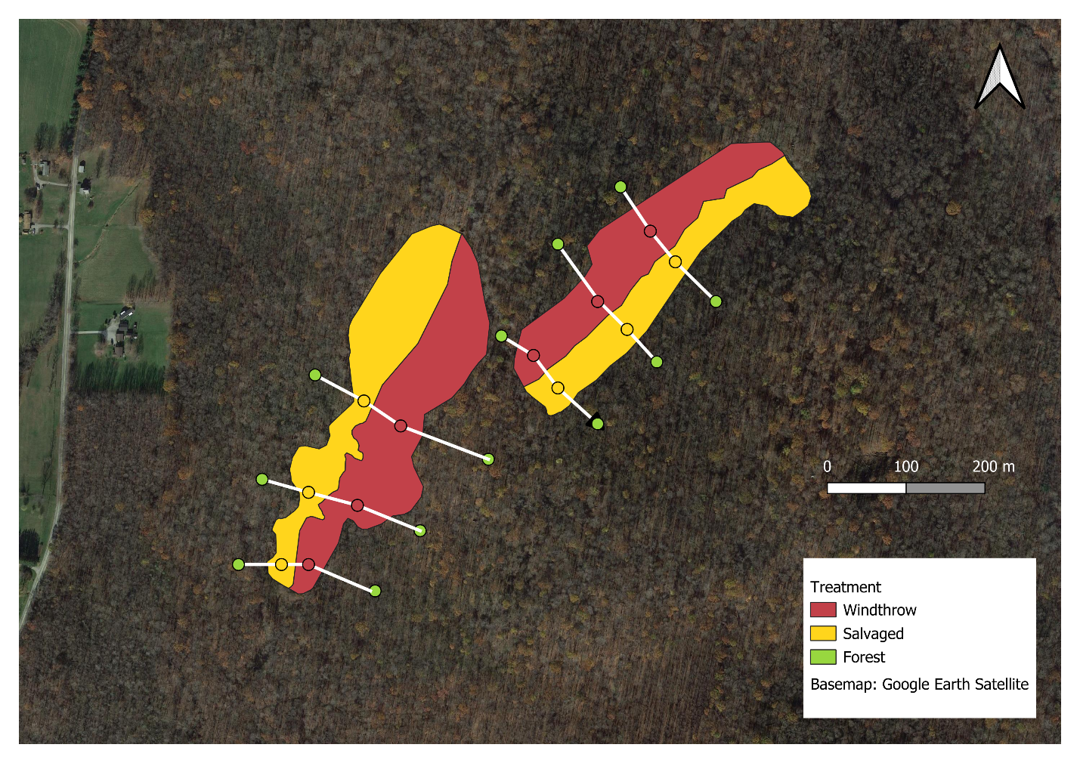

**Figure 2.1.** Map of the study area. The study was located at Powdermill Nature Reserve in Rector, Westmoreland County, Pennsylvania. Red shading represents forest affected by the tornado but left unsalvaged, whereas yellow shading represents forest affected by the tornado and subsequently salvage-logged. Colored dots are drawn in the plot locations where pitfall traps were installed. Locations of plots have been slightly adjusted on this map to coincide with shapefiles of the shaded areas. White lines connecting the plots indicate the transects, which span the disturbances and extend into the undisturbed forest.

From mid-summer through winter of 2013, half of each wind-disturbed area was salvage-logged using intensive practices that included heavy machinery, roads, and skid trails to remove both fallen and residual standing trees. In 2015, three transects were established across each area of forest impacted by the tornado (total 6 transects) (Figure 2.1). Transects were established across the windthrow and salvaged disturbances and extended ≥50 m into the surrounding undisturbed forest on each side. Along each transect, four plots were established: 1) one plot in the tornado-affected forest which was not salvage-logged (hereafter: windthrow); 2) one in the tornado-affected forest which was then salvage-logged (hereafter: salvaged), and two in the surrounding undisturbed forest (hereafter: forest). This resulted in a sample size of 24 plots, wherein all data collection occurred.

Ground beetle sampling and identification

Ground beetles were sampled using unbaited barrier pitfall traps in 2015 and 2022, representing three and ten years post-tornado (two and nine years post-salvage-logging). Pitfall traps preferentially collect insects that are more active and mobile, and consequently the number of ground beetles caught in pitfalls is reported as activity-abundance (Gandhi et al. 2008). Barrier pitfall traps consisted of two pairs of plastic cups (each pair having an inner 500 mL cup and an outer 1 L cup) which were placed into the ground so that the lip of the cup was flush with the ground surface. The two pairs of cups were placed 1 m from each other, and garden edging (Suncast® eco edge) was placed between them to create a barrier. Cups were filled with approximately 4 cm of propylene glycol (recreational vehicle and marine antifreeze, Peak Company Old World Industries, Clear Lake, Texas) with a few drops of detergent. Masonite board (100 cm2) was placed at 3 cm above each cup to prevent flooding from rain. Steel hardware cloth was secured over cups using 30 cm stakes to limit mammal disturbance.

Pitfall trap sampling was conducted continuously over the growing seasons in 2015 and 2022. Trap catch was collected every two weeks, and cups were refilled with propylene glycol. In 2015, pitfall traps were installed on 27-28 May, and samples were collected on 9-10 June, 24-25 June, 8 July, 22 July, 5 August, and 17 August. In 2022, traps were installed on 1-2 June, and samples were collected on 15 June, 29 June, 13 July, 27 July, 11 August, and 23 August. Trap catch was collected by pouring the sample through a fine mesh strainer and storing the contents in a specimen cup with 70% ethanol until sorting and identification.

Ground beetles were identified to species using taxonomic keys (Lindroth 1961, Freitag 1969, Bousquet 2010, Bousquet and Messer 2010, Hunting 2013, Harden and Guarnieri 2017). Nomenclature followed Bousquet (2012). Species vouchers were deposited at the C. A. Triplehorn Insect Collection (OSUC), Museum of Biological Diversity, The Ohio State University, Columbus, Ohio where each specimen was given a unique identifier label (Table B.1).

Trait measurements

We selected eight morphological traits that have previously been shown to relate to habitat preference (Table 2.1) (Fountain-Jones et al. 2015). These traits are body length, antenna length, eye protrusion, eye length, pronotum width, abdomen width, rear leg length, and rear trochanter length. Traits were measured under a dissecting microscope using an ocular micrometer to the nearest 0.1 mm. Some traits were calculated from the sum of multiple measurements. For example, body length was calculated as elytra length + pronotum length + head length (Table B.4). For each species, traits were measured on up to six individuals, three males and three females (Fountain-Jones et al. 2015), although we did not achieve this number for rare species. The six individuals were chosen in a way that attempted to encompass the intraspecific variation in body size observed for the species. Most (185/202) specimens used for trait measurement were collected at Powdermill Nature Reserve, but a few (17/202) measured specimens were collected in Erie and Cuyahoga counties, Ohio (Table B.1). These specimens were used to supplement the sample size when less than six measurable individuals were collected at Powdermill. To control for variation in beetle body size, relative measurements of all morphological traits were calculated as their ratio to body length for each individual (Ribera et al. 2001), and thus all results of morphological traits pertain to traits in relation to body length. Trait measurements were then averaged across individuals of a species to calculate species-specific means.

In addition to morphological traits, traits related to flight capability, water affinity, and forest affinity were collected from the literature (Larochelle and Larivière 2003). Flight capability was coded as 1 if the species is flight-capable, 0 if the species is flight-incapable, and 0.5 if the species exhibits wing dimorphism. Water affinity was coded as 0 for xerophilous species, 1 for hygrophilous species, and 0.5 for intermediate species. Water affinity was treated as a physiological trait because ground beetle species often have consistent humidity preferences in behavioral studies (Thiele 1977). Forest affinity was coded as forest-specialist, open-habitat, or generalist (meaning the species is found in forest clearings or in both forest and open habitats). Because only two species we found were recorded as open-habitat species in the literature, we pooled generalist and open-habitat species for the statistical analysis.

**Table 2.1.** Measured morphological traits and literature-based traits used in this study, and their connections to habitat variables that could be impacted by disturbance. The columns are trait, connection to habitat, and references.

|  |  |  |
| --- | --- | --- |
| **Trait** | **Connection to habitat** | **References** |
| Body length (mm) | Shorter body length was found for ground beetles caught in wind-disturbed forests, relative to undisturbed forests. Body length is correlated with many other morphological traits. | (Barton et al. 2011, Sklodowski and Garbalinska 2011) |
| Antenna length (mm) | Tactile hunter species, which rely on sense of touch more than vision, tend to have longer antennae. Longer antenna length relative to body length was found for ground beetles caught under a tree, versus in the open. | (Bauer and Kredler 1993, Barton et al. 2011) |
| Eye protrusion (mm) | A greater eye protrusion was found in a tree-climbing ground beetle, and it may allow partial overlap in the frontal visual field. However, greater eye protrusion might prevent a ground beetle from moving through thick vegetation or soil. | (Talarico et al. 2007) |
| Eye length (mm) | Diurnal ground beetle species and/or those adapted to open environments tend to rely on vision for predator avoidance or prey detection, and thus might have longer eyes. | (Talarico et al. 2007) |
| Pronotum width (mm) | A proportionally wider pronotum can be found in robust-bodied beetles, which tend to be found within open habitats. A narrow pronotum can be an adaptation to reaching prey within hard-to-reach soil crevices or snail shells. A narrow pronotum may also be related to the beetle having an unobstructed view behind its eyes. | (Thiele 1977, Forsythe 1991, Barton et al. 2011) |
| Abdomen width (mm) | Similar pattern to pronotum width, with species having proportionally wider abdomens tending to be found in open habitats. | (Barton et al. 2011) |
| Rear leg length (mm) | Open habitats seem to favor ground beetle species with shorter legs relative to body length. Ground beetles with longer legs may be weaker at pushing through dense substrates. | (Forsythe 1991, Barton et al. 2011) |
| Rear trochanter length (mm) | The rear trochanter connects to the femur of the rear leg. Ground beetles have a bean-shaped rear trochanter that allows them to move between narrow crevices between bark, leaf litter, or soil. The muscle in the rear trochanter allows the rear leg to create a force in the dorsal direction, which expands the space and allows the beetle to move through constricted areas. The trochanter is longer, on average, in species that push themselves through soil and underneath leaf litter. It is shorter in species that walk or run above the surface of the substrate. | (Forsythe 1991, Talarico et al. 2007) |
| Flight capability (range: 0-1) | Flight-capable species (macropterous and with fully developed flight musculature) can exploit patchy, temporary habitats. Conversely, flight incapable species may have higher fitness within stable habitats. | (Ribera et al. 2001, Venn 2016) |

Continued

Table 2.1 Continued

|  |  |  |
| --- | --- | --- |
| **Trait** | **Connection to habitat** | **References** |
| Water affinity (range: 0-1) | Habitats vary in the saturation of the substrate with water, and water preference varies between ground beetle species, with some species found near riverbanks or other bodies of water, others found in moist leaf litter, and others found in dry soil. A preference for low humidity may be related to overwintering within tree stumps and logs, versus in the soil. | (Thiele 1977) |
| Forest affinity (forest specialist, eurytopic, or open-habitat) | Some ground beetle species tend to be caught in forests, underneath trees, whereas other species tend to be caught in fields, prairies, pastures, and other open habitats. | (Silverman et al. 2008) |

Forest floor environment

Environmental variables on the forest floor were quantified to assess differences among windthrow, salvaged, and undisturbed forest. Percentage canopy openness was measured using a spherical crown densiometer directly above the pitfall traps to assess light availability on the forest floor. Canopy openness was measured on 9-10 June in 2015, and on 1-2 June in 2022. Percentage cover of ground-level vegetation and percentage cover of leaf litter were estimated in two randomly selected 1 m2 quadrats around each pitfall trap (1 m away from trap, in random directions). Ground cover estimates were collected on 9 June and 7 July in 2015 and on 1-2 June and 13 July in 2022. Values from the two quadrats around each pitfall trap were averaged together for a site-level mean. Soil moisture was measured at three locations adjacent to each pitfall trap using a Dynamax Inc. (Houston, Texas) TH20 portable soil moisture meter with a Theta Probe ML2x sensor in 2015. Soil moisture measurements were taken biweekly when pitfall samples were collected, for a total of six dates per year. The 18 soil moisture readings at each plot were averaged together for a single mean for the year.

Statistical analysis

All analyses were conducted in R version 4.4.1 (R Core Team 2024). All code and development history that support these findings can be found in the GitHub repository: https://github.com/KPerryLab/PNR_Beetles.

To determine if our sampling effort was adequate to characterize the ground beetle community, we used species accumulation curves (SACs) and Chao estimators. For each year and treatment, we created a SAC with number of sampled plots on the x-axis. This was implemented using the ‘specaccum’ function in the R package ‘vegan’ with the ‘random’ setting, which finds the mean SAC by permuting the order of the plots (Oksanen et al. 2024, R Core Team 2024). The Chao1 estimator was used to estimate a lower bound on the true species richness of ground beetles (Chao and Chiu 2016). This estimator incorporates the number of singletons and doubletons to estimate the number of undetected species and was implemented using the function ‘ChaoSpecies’ in the R package ‘SpadeR’ (Chao et al. 2016).

Before calculating abundance metrics, we accounted for occasional loss of trap catch due to animal disturbance (Perry et al. 2018). Trap catches were standardized to correspond to a sampling effort of six 14-day trapping intervals. Any plots where trap catch was lost for one interval were corrected by dividing the trap catch by $\frac{5}{6}.$ We calculated total activity-abundance of ground beetles as the sum of the activity-abundances of all species at a plot. Furthermore, we decomposed total activity-abundance into two groups: the contribution from forest specialist species and the contribution from species that are generalists or specialize in open-habitats (Larochelle and Larivière 2003). To investigate alpha-diversity at the plot level, we calculated species richness (number of species) and Shannon diversity using the package ‘HillR’ (Li 2018). Shannon diversity was calculated using the formula exp(-Σpiln(pi)), which is the same as the Hill number of order 1. This metric takes values between 1 and the species richness, depending on the degree to which the relative abundances are equal.

We conducted a principal components analysis (PCA) using morphological traits of ground beetles to identify key axes of variation (Swenson 2014). All continuous traits had already been standardized by dividing by body length. We centered each continuous trait to a mean of 0, scaled to a variance of 1, and ran the PCA using the function ‘prcomp’ in the R package ‘stats’ (R Core Team 2024). We removed the species *Notiophilus aeneus* (Herbst, 1806) from the PCA analysis because inclusion of this rare species, which has unusual morphology, noticeably changed the PC axes (Table B.3). After running the PCA, we added *Notiophilus* back into the analysis by centering and scaling its data using the previously-calculated scaling coefficients and then projecting the values onto the PC axes using the loading values.

We used trait data in combination with ground beetle counts to calculate functional alpha-diversity. We used the first four PC axes, which together explained 89% of the variance in the data, along with the categorical variables water affinity and flight capability, to calculate a Gower dissimilarity matrix between all ground beetle species in trait space using the package ‘FD’ (Laliberte et al. 2014). The categorical variables were treated as ordinal data and the ‘metric’ method was used to calculate dissimilarity, so that a wing dimorphic species would be counted as intermediate in its flight capability. After obtaining the dissimilarity matrix, we calculated functional alpha diversity for each plot by computing the intra-plot mean dissimilarity between pairs of species in trait space. Each calculation of dissimilarity between a pair of species was weighted by the product of the species’ relative abundances at the plot, so that more abundant species had a larger influence on functional alpha diversity (Swenson 2014). The calculation was carried out using the function ‘mpd’ in the R package ‘picante’ (Kembel et al. 2010).

To investigate the average traits of ground beetles at each plot, we calculated community-weighted mean (CWM) trait values. The CWM is the average trait value of all species found at a plot, weighted by the species’ relative abundances. These were calculated for all functional traits, including water affinity and flight capability, using the function ‘functcomp’ in the R package ‘FD’ (Laliberte et al. 2014).

We compared ground beetle communities among forest management treatments and years using linear mixed-effects models with the R package ‘lme4’ (Bates et al. 2015) and ‘lmerTest’ (Kuznetsova et al. 2017). Our response variables were total activity-abundance, activity-abundance of open-habitat and generalist species, activity-abundance of forest-specialist species, species richness, Shannon diversity, functional alpha diversity, and community-weighted mean (CWM) traits. In addition to the fixed effects treatment (windthrow, salvaged, undisturbed forest) and year (2015, 2022), we included a treatment*year interaction term in the models. Transect was included as a random effect to account for spatial structure in the data (Figure 2.1). For some models, the variance of the residuals differed based on the fitted value (heteroscedasticity), so we transformed these response variables using the function f(x)=ln(x) before rerunning the model. In one case, the function g(x)=ln(x+1) was used due to the presence of zeros in the response variable. In some models, a singular fit was obtained, so we removed the random effect term. Because species richness is a count response variable, we used a Poisson generalized linear model (GLM) with the package ‘stats’ (R Core Team 2024). Models were subjected to hypothesis testing using type III sums-of-squares using the package ‘stats’ (R Core Team 2024) or the package ‘car’ (Fox and Weisberg 2019). When the ANOVA showed a significant effect for treatment, pairwise comparisons between treatment groups were made using the package ‘emmeans’ (Lenth 2024).

A similar linear mixed effects model framework was used to assess changes in environmental conditions among forest management treatments over time. Response variables were canopy openness, percentage cover of ground-level vegetation, percentage cover of leaf litter, and soil moisture. Differences in soil moisture among treatments were investigated separately for 2015 and 2022 because a different meter was used for each year.

Measures of beta-diversity were used to investigate changes in taxonomic and functional composition of ground beetle communities among forest management treatments. Taxonomic beta-diversity was calculated using Bray-Curtis dissimilarities between the ground beetle species at each plot using the package ‘vegan’ (Oksanen et al. 2024). The species abundance matrix was first row-standardized to convert the data to relative abundances before the Bray-Curtis dissimilarity between pairs of plots was calculated. We visualized the dissimilarity matrix in two-dimensional space using nonmetric multidimensional scaling (NMDS). Next, we used a permutational multivariate analysis of variance (PERMANOVA) approach to determine if species composition varied by forest management treatment or by year, using 99,999 permutations. Treatment differences were investigated using the ‘pairwiseAdonis’ package (Martinez Arbizu 2017) and interactions were investigated by running separate PERMANOVAs for each year. Furthermore, we used an analysis of multivariate homogeneity of group dispersions with the ‘betadisper’ function in the ‘vegan’ package to test if the treatments differed in their dispersions. Mirroring taxonomic beta-diversity, we calculated functional beta-diversity. Distances between plots were calculated using inter-plot mean pairwise distance in trait space with the function ‘comdist’ in the R package ‘picante’ (Kembel et al. 2010). Using the previously calculated Gower dissimilarity matrix, the ‘comdist’ function calculates the expected distance in trait space between an individual beetle drawn randomly from the first plot and an individual beetle drawn randomly from the second plot. The NMDS, PERMANOVA and beta-dispersion analyses were performed in a similar manner.

## Results

Across 2015 and 2022 between the months of June and August, a total of 1537 individuals comprising 47 species of ground beetles were collected (Table 2.2). Of these 47 species, 27 were caught both in 2015 and in 2022, 10 species were caught only in 2015, and 10 species were caught only in 2022. The most abundant species were *Pterostichus moestus* Say (15.1% of individuals collected), *Chlaenius emarginatus* Say (10.5%), and *Sphaeroderus stenostomus lecontei* Dejean (10.3%). Of the 47 species caught, 2 were classified as open-habitat specialists, 24 were habitat generalists, 20 were forest-specialists, and one species had unknown habitat affinity. The Chao1 estimator for the true number of ground beetle species in 2015 was 47.1 species (95% conf. int. 39.3 - 82.2 species) while in 2022 the Chao1 estimator was 79.2 species (95% conf. int. 46.2 – 230.7 species). Thus, our sampling effort captured approximately 79% of the estimated species present in 2015, and 47% of the estimated species present in 2022. Species accumulation curves for each treatment and year showed that species richness had begun to reach an asymptote with increasing number of plots (Figure B.1).

Activity-abundance and species richness of ground beetles were affected by forest management treatment, and in some cases, year of sampling. Species richness of ground beetles was higher in salvaged plots than forest plots, while windthrow plots were intermediate (Fig. 2.2A, Tables 2.3-2.4). In 2015, activity-abundance was higher in salvaged plots relative to windthrow and forest, but this pattern disappeared in 2022, as total activity-abundance was similar among treatments (Fig. 2.2B). Activity-abundance of open-habitat and generalist species was higher in salvaged plots than forest plots (Fig. 2.3A). Activity-abundance of forest specialists (Fig. 2.3B) and Shannon diversity were similar among treatments and years.

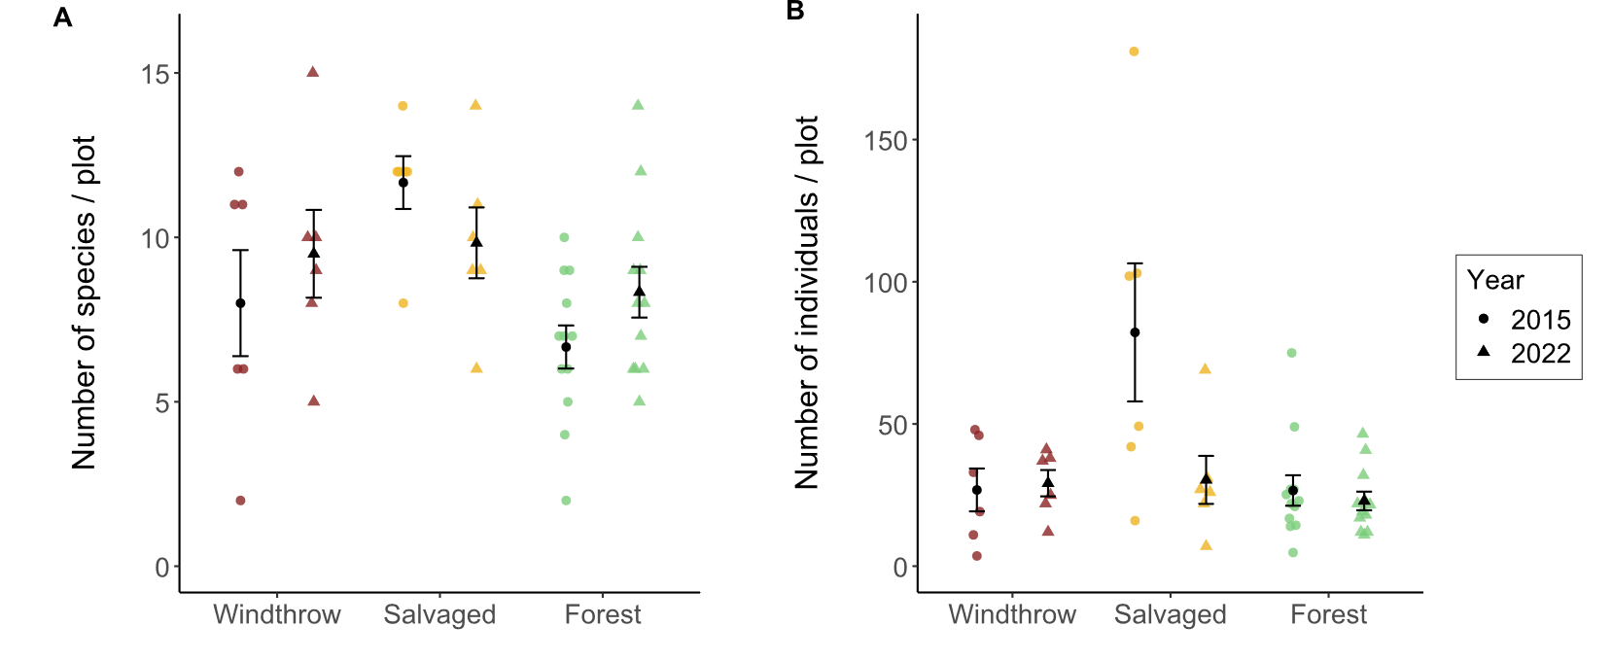

**Figure 2.2.** Total species richness (A) and activity-abundance (B) of ground beetles collected in windthrow, salvaged, and undisturbed forest in 2015 and 2022 at Powdermill Nature Reserve, Rector, Westmoreland County, Pennsylvania, USA. Bar height is the group mean, and whiskers indicate the standard error of the mean. Statistical results are provided in Table 2.3.

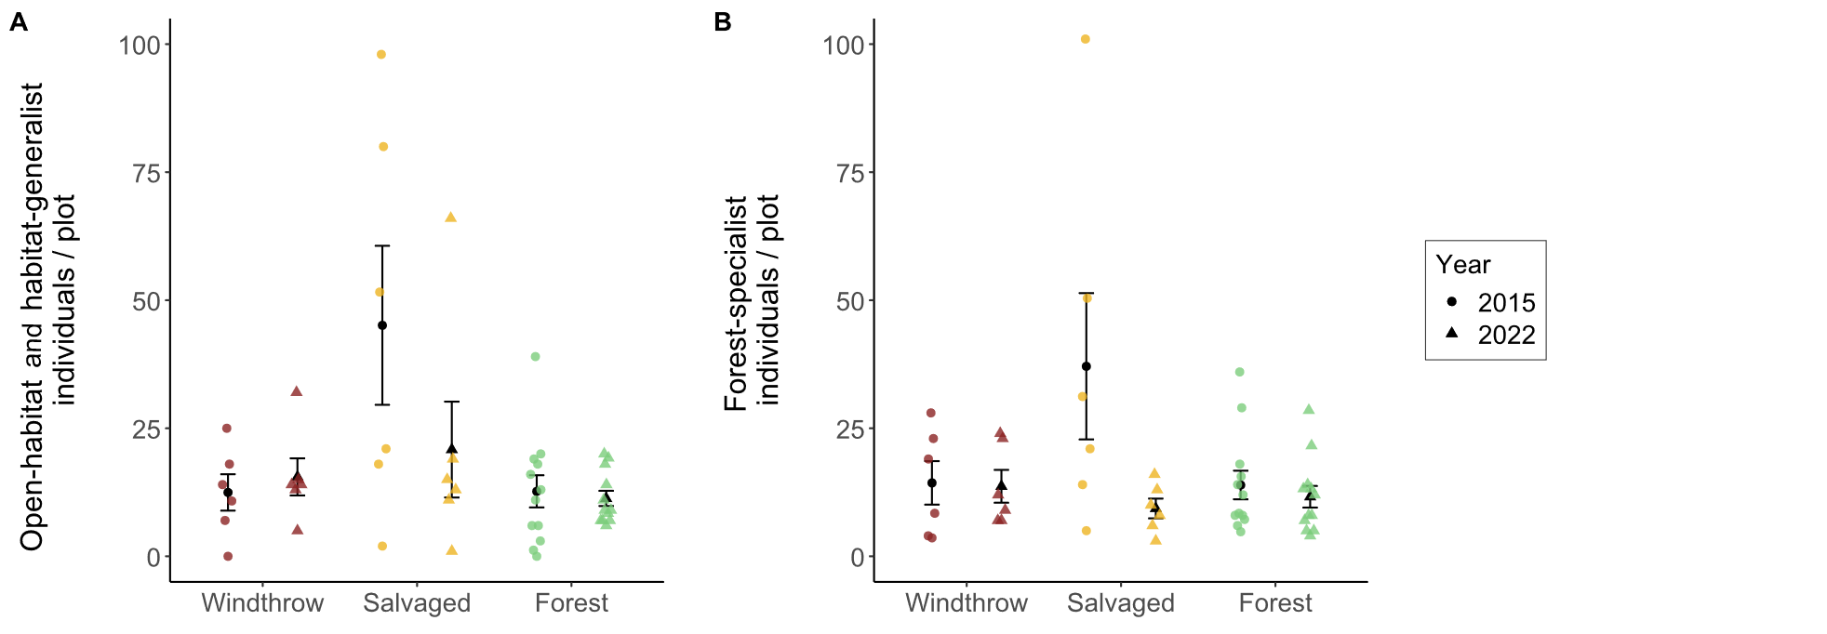

**Figure 2.3**. Activity-abundance of open-habitat and habitat-generalist ground beetle species (A) and forest-specialist species (B) collected in windthrow, salvaged, and undisturbed forest in 2015 and 2022 at Powdermill Nature Reserve, Rector, Westmoreland County, Pennsylvania, USA. The habitat affinity information was collected from Larochelle and Larivière (2003). Bar height is the group mean, and whiskers indicate the standard error of the mean. Statistical results are provided in Table 2.3

**Table 2.2.** Total trap catch of ground beetle species (Coleoptera: Carabidae) collected via pitfall traps at Powdermill Nature Reserve, Rector, Westmoreland County, Pennsylvania, USA. Sampling occurred from 27 May to 17 August, 2015, and from 1 June to 23 August, 2022. The columns of the table are tribe, species (including authority), code (referring to species codes in Figure B.2 and B.3), 2015 (counts), 2022 (counts), and total (counts). Nomenclature follows Bousquet (2012).

|  |  |  |  |  |  |
| --- | --- | --- | --- | --- | --- |
| Tribe | Species | Code | 2015 | 2022 | Total |
| Notiophilini |  |  |  |  |  |
|  | *Notiophilus aeneus* (Herbst) | No.ae | 2 | 1 | 3 |
| Cychrini |  |  |  |  |  |
|  | *Sphaeroderus canadensis canadensis* Chaudoir | Sp.ca | 35 | 7 | 42 |
|  | *Sphaeroderus stenostomus lecontei* Dejean | Sp.st | 76 | 82 | 158 |
|  | *Scaphinotus viduus*  (Dejean) | Sc.vi | 1 | 1 | 2 |
|  | *Scaphinotus imperfectus* (Horn) | Sc.im | 0 | 3 | 3 |
| Carabini |  |  |  |  |  |
|  | *Carabus goryi* Dejean | Ca.go | 66 | 33 | 99 |
| Pterostichini |  |  |  |  |  |
|  | *Lophoglossus scrutator* (LeConte) | Lo.sc | 0 | 1 | 1 |
|  | *Pterostichus mutus* (Say) | Pt.mu | 1 | 0 | 1 |
|  | *Pterostichus corvinus* (Dejean) | Pt.co | 6 | 0 | 6 |
|  | *Pterostichus sayanus* Csiki | Pt.sa | 0 | 1 | 1 |
|  | *Pterostichus coracinus* (Newman) | Pt.co | 28 | 14 | 42 |
|  | *Pterostichus melanarius* (Illiger) | Pt.me | 1 | 0 | 1 |
|  | *Pterostichus lachrymosus* (Newman) | Pt.la | 27 | 45 | 72 |
|  | *Pterostichus stygicus* (Say) | Pt.st | 62 | 70 | 132 |
|  | *Pterostichus hamiltoni* Horn | Pt.ha | 0 | 1 | 1 |
|  | | | | | |
|  |  |  |  |  | Continued |
| Table 2.2 Continued | |  |  |  |  |
|  |  |  |  |  |  |
| Tribe | Species | Code | 2015 | 2022 | Total |
| Pterostichini | *Pterostichus moestus* (Say) | Pt.mo | 185 | 47 | 232 |
|  | *Pterostichus diligendus* (Chaudoir) | Pt.di | 1 | 1 | 2 |
|  | *Pterostichus rostratus* (Newman) | Pt.ro | 36 | 22 | 58 |
|  | *Pterostichus adoxus* (Say) | Pt.ad | 19 | 80 | 99 |
|  | *Pterostichus tristis* (Dejean) | Pt.tr | 10 | 31 | 41 |
|  | *Cyclotrachelus fucatus*  (Freitag) | Cy.fu | 5 | 1 | 6 |
|  | *Cyclotrachelus convivus* (LeConte) | Cy.co | 1 | 0 | 1 |
|  | *Cyclotrachelus sigillatus* (Say) | Cy.si | 22 | 52 | 74 |
| Chlaeniini |  |  |  |  |  |
|  | *Chlaenius emarginatus* Say | Ch.em | 137 | 25 | 162 |
|  | *Chlaenius laticollis* Say | Ch.la | 2 | 0 | 2 |
| Licinini |  |  |  |  |  |
|  | *Dicaelus politus* Dejean | Di.po | 54 | 13 | 67 |
|  | *Dicaelus teter* Bonelli | Di.te | 68 | 10 | 78 |
| Harpalini |  |  |  |  |  |
|  | *Notiobia nitidipennis* (LeConte) | No.ni | 6 | 0 | 6 |
|  | *Anisodactylus harrisii* LeConte | An.ha | 2 | 1 | 3 |
|  | *Anisodactylus melanopus* (Haldeman) | An.me | 1 | 0 | 1 |
|  | *Anisodactylus nigerrimus* (Dejean) | An.ni | 3 | 5 | 8 |
|  | *Amphasia interstitialis* (Say) | Am.in | 6 | 0 | 6 |
|  | *Agonoleptus thoracicus* (Casey) | Ag.th | 0 | 1 | 1 |
|  |  |  |  |  |  |
|  |  |  |  |  | Continued |
|  |  |  |  |  |  |
|  |  |  |  |  |  |
| Table 2.2 Continued | |  |  |  |  |
|  |  |  |  |  |  |
| Harpalini | *Harpalus spadiceus* Dejean | Ha.sp | 1 | 11 | 12 |
|  | *Trichotichnus autumnalis* (Say) | Tr.au | 10 | 2 | 12 |
| Zabrini& |  |  |  |  |  |
|  | *Pseudamara arenaria* (LeConte) | Ps.ar | 2 | 1 | 3 |
| Platynini |  |  |  |  |  |
|  | *Olisthopus parmatus*  (Say) | Ol.pa | 3 | 2 | 5 |
|  | *Agonum ferreum* Haldeman | Ag.fe | 1 | 0 | 1 |
|  | *Agonum fidele* Casey | Ag.fi | 31 | 3 | 34 |
|  | *Agonum retractum* LeConte | Ag.re | 1 | 0 | 1 |
|  | *Platynus decentis* (Say) | Pl.de | 0 | 1 | 1 |
|  | *Platynus tenuicollis* (LeConte) | Pl.te | 3 | 5 | 8 |
|  | *Platynus angustatus* Dejean | Pl.an | 19 | 17 | 36 |
| Lebiini |  |  |  |  |  |
|  | *Cymindis limbata* Dejean | Cy.li | 0 | 1 | 1 |
|  | *Cymindis platicollis* (Say) | Cy.pl | 0 | 1 | 1 |
|  | *Apenes lucidula* (Dejean) | Ap.lu | 0 | 8 | 8 |
| Galeritini |  |  |  |  |  |
|  | *Galerita bicolor* (Drury) | Ga.bi | 0 | 3 | 3 |
| Total |  |  | 934 | 603 | 1537 |

&: Although Bousquet (2012) lists *Pseudamara arenaria* in Sphodrini, a recent paper (Gomez et al. 2016) places the species in the tribe Zabrini.

The principal components analysis (PCA) of the eight numerical traits generated a set of axes, of which the first four axes together explained 89% of the variance (Table B.2). The first PC axis (39% of the variance) was associated with proportionally shorter antennae, shorter rear legs, and wider pronotum (Figure B.2). The second axis (26% of the variance) was associated with proportionally longer eyes, higher eye protrusion, and shorter body length. The third axis (14% of the variance) was associated with proportionally shorter rear trochanter and wider abdomen (Figure S4). The fourth axis (11% of the variance) was associated with proportionally wider abdomen and longer body length.

A subset of functional traits showed differences among treatments, but functional alpha-diversity was similar among forest management treatments and across years (Tables 2.3-2.4). The CWM body length was greater for forest plots than salvaged plots, while windthrow plots were intermediate (Fig. 2.4A). This indicates that species of larger body length made up a higher proportion of trap captures in forest plots than salvaged plots. When we examined morphological traits of the eyes and antenna relative to body length, we found that CWM eye length was greater for salvaged plots than windthrow or forest plots (Fig. 5C). Thus, species abundant in salvaged plots had longer eyes. However, we did not detect differences in CWM antenna length (Fig. 2.4E). When considering the morphological traits associated with locomotion strategy, we found that CWM trochanter length was greater for salvaged plots than windthrow or forest (Fig. 2.4D). This means species common in salvaged plots tended to have longer rear trochanters than species common in windthrow or forest plots. Flight capable species were more common in salvaged plots in 2015, but this pattern disappeared by 2022 (Fig. 2.4B). No patterns were detected for water affinity (Fig. 2.4F).

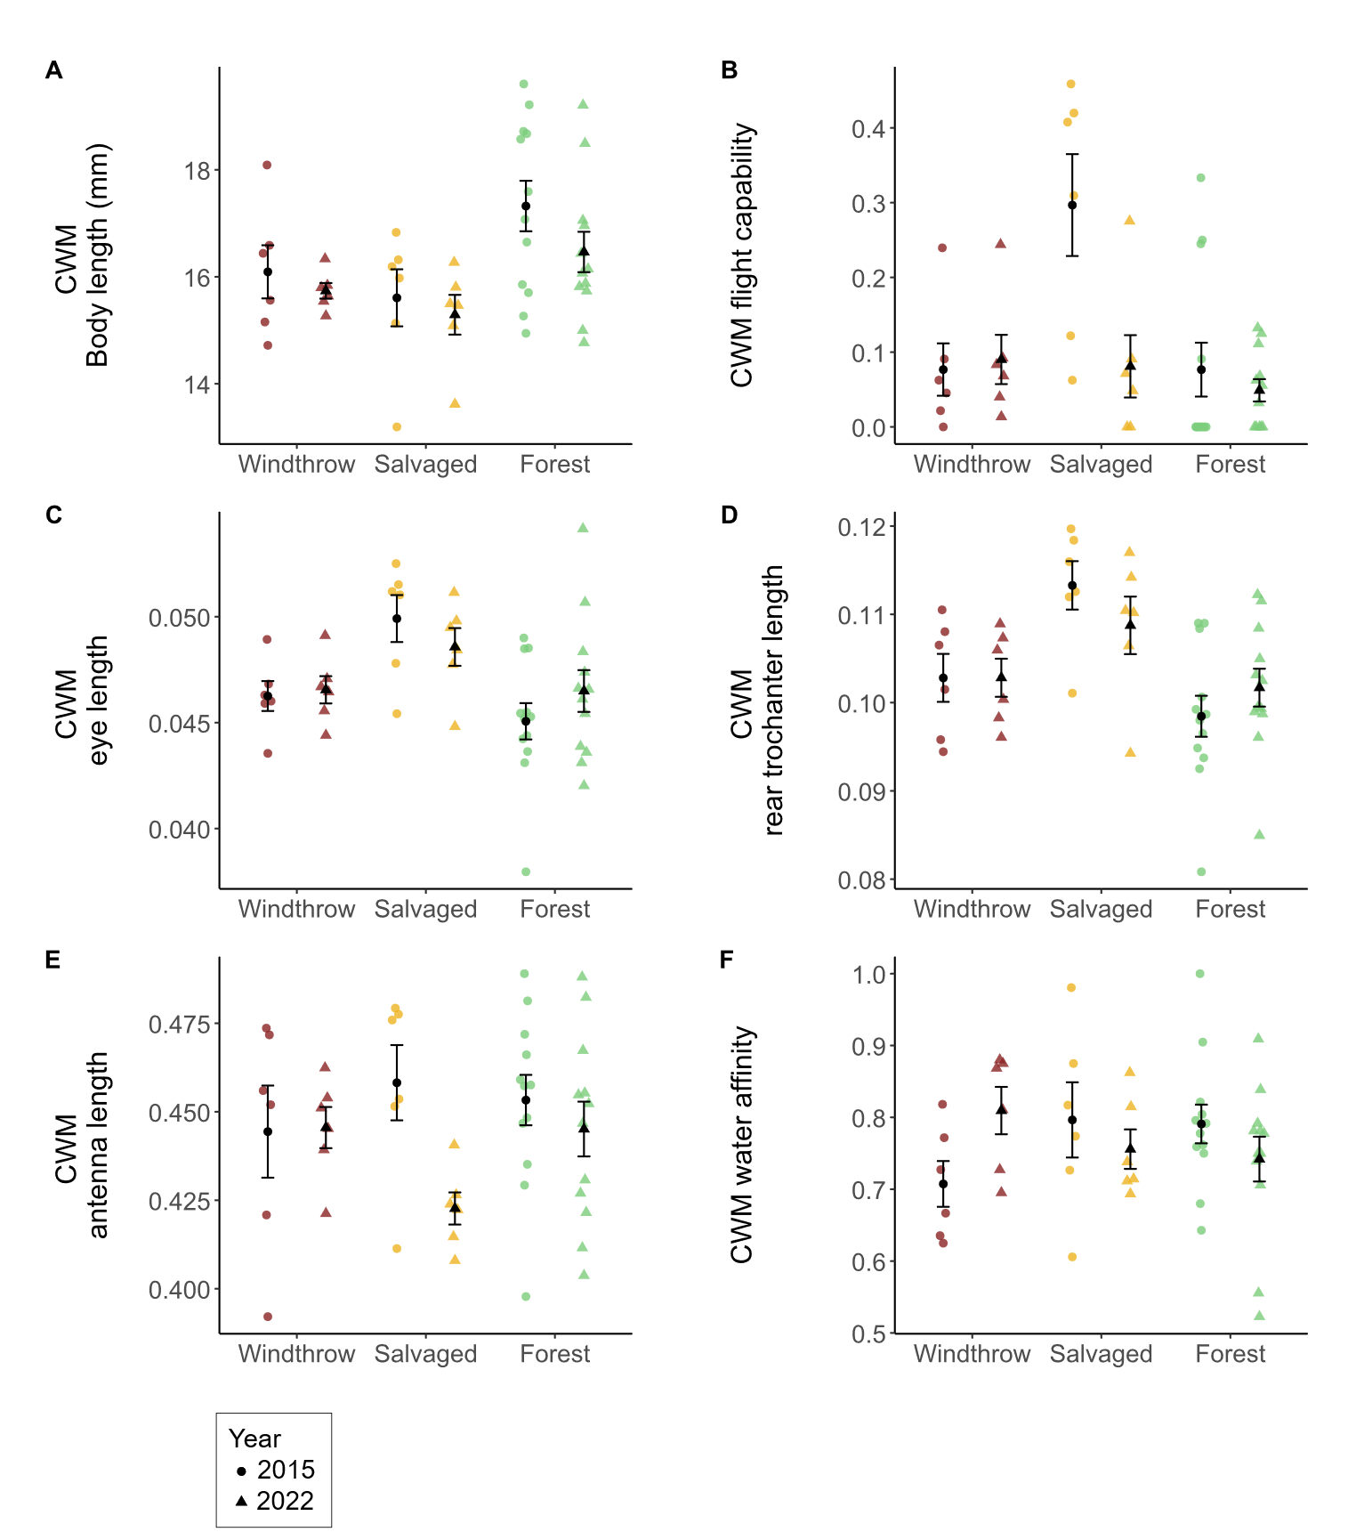

**Figure 2.4.** Community-weighted mean (CWM) traits of ground beetles collected in windthrow, salvaged, and undisturbed forest plots in 2015 and 2022. Circular points are observations from 2015, while triangles are observations from 2022. (A) CWM body length, measured as the sum of head length, pronotum length, and elytron length. (B) CWM flight capability, as indicated in the literature (Larochelle and Larivière 2003). Values closer to 1 indicate that a higher proportion of individuals collected were identified as flight-capable species. (C) CWM eye length (posterior to anterior edge of eye) standardized to body length. (D) CWM meta-trochanter length standardized to body length. (E) CWM antenna length standardized to body length. (F) CWM water affinity, as indicated in the literature (Larochelle and Larivière 2003). Values closer to 1 indicate that a higher proportion of individuals collected belonged to species which prefer wet soil or live near water. Statistical results are provided in Table 2.3.

**Table 2.3.** Main effects of forest management treatments (windthrow, salvaged, undisturbed forest) and year (2015, 2022) on activity-abundance, species richness, species diversity, community-weighted means (CWM) for individual traits, and functional diversity for ground beetles collected at Powdermill Nature Reserve, Rector, Westmoreland County, Pennsylvania, USA. The model type column indicates if the model was a standard linear model (LM), a linear mixed-effects model with transect included as a random effect (LMM), or a generalized linear model with Poisson errors (GLM). Dashes indicate that the p-value is above 0.10. Patterns with a p-value below 0.05 are bolded. Beetles were collected between 27 May to 17 August, 2015, and from 1 June to 23 August, 2022.

|  |  |  |  |  |  |  |  |
| --- | --- | --- | --- | --- | --- | --- | --- |
| Response variable | Model  type | Treatment  (Windthrow, Salvaged, Forest) | | Year (2015, 2022) | | Treatment*Year interaction | |
|  |  |  | |  | |  |  |
|  |  | Statistic | p | Statistic | p | Statistic | p |
|  |  |  |  |  |  |  |  |
| Total activity-abundance | LMM* | **F= 5.7** | **0.007** | F=1.9 | - | **F=4.5** | **0.018** |
|  |  |  |  |  |  |  |  |
| Activity abundance of open-habitat and habitat-generalist species | LMM* | **F=3.6** | **0.037** | F=0.01 | - | F=2.4 | - |
|  |  |  |  |  |  |  |  |
| Activity abundance of forest-specialist species | LMM* | F=0.7 | - | F=3.4 | 0.075 | F=2.7 | 0.079 |
|  |  |  |  |  |  |  |  |
| Species richness | GLM | **X2=11.5** | **0.003** | X2=2.2 | - | X2=3.2 | - |
|  |  |  |  |  |  |  |  |
| Shannon diversity | LMM | F= 1.0 | - | F= 1.3 | - | F= 0.2 | - |

*: a log transformation was done on the response variable to improve the model’s satisfaction of assumptions

Continued

Table 2.3 Continued

|  |  |  |  |  |  |  |  |
| --- | --- | --- | --- | --- | --- | --- | --- |
| Response variable | Model  type | Treatment  (Windthrow, Salvaged, Forest) | | Year (2015, 2022) | | Treatment*Year interaction | |
|  |  |  |  |  |  |  |  |
|  |  | Statistic | p | Statistic | p | Statistic | p |
| Functional alpha-diversity | LM | F=0.4 | - | F= 0.001 | - | F= 1.5 | - |
|  |  |  |  |  |  |  |  |
| CWM Body length | LM | **F=5.8** | **0.006** | F=2.6 | - | F=0.3 | - |
|  |  |  |  |  |  |  |  |
| CWM Standardized antenna length | LMM | F=0.6 | - | F=3.9 | 0.056 | F=2.0 | - |
|  |  |  |  |  |  |  |  |
| CWM Standardized rear leg length | LMM | F=0.4 | - | F=1.6 | - | F=1.9 | - |
|  |  |  |  |  |  |  |  |
| CWM Standardized eye length | LMM | **F=8.1** | **0.001** | F=0.03 | - | F=1.3 | - |
|  |  |  |  |  |  |  |  |
| CWM Standardized eye protrusion | LMM | F= 1.9 | - | F= 0.3 | - | F= 0.9 | - |
|  |  |  |  |  |  |  |  |
| CWM Standardized pronotum width | LMM | F= 1.2 | - | F= 1.2 | - | F= 0.05 | - |

Continued

Table 2.3 Continued

|  |  |  |  |  |  |  |  |
| --- | --- | --- | --- | --- | --- | --- | --- |
| Response variable | Model  type | Treatment  (Windthrow, Salvaged, Forest) | | Year (2015, 2022) | | Treatment*Year interaction | |
|  |  |  |  |  |  |  |  |
|  |  | Statistic | p | Statistic | p | Statistic | p |
| CWM Standardized abdomen width | LMM | F= 0.4 | - | F= 0.6 | - | F= 0.6 | - |
|  |  |  |  |  |  |  |  |
| CWM Standardized rear trochanter length | LMM | **F= 11.4** | **<0.001** | F= 0.05 | - | F= 1.4 | - |
|  |  |  |  |  |  |  |  |
| CWM Water affinity | LM | F=0.1 | - | F= 0.1 | - | F= 2.7 | 0.082 |
|  |  |  |  |  |  |  |  |
| CWM Flight capability | LMM* | **F= 5.7** | **0.007** | F= 3.5 | 0.068 | **F= 3.9** | **0.028** |

*: a log transformation was done on the response variable to improve the model’s satisfaction of assumptions

**Table 2.4.** Means (± standard errors) of the response variables for ground beetle biodiversity. The columns list the response variable, the unit, the year, and then columns for the group means for windthrow, salvaged, and forest.

|  |  |  |  |  |  |  |  |
| --- | --- | --- | --- | --- | --- | --- | --- |
|  |  | Unit |  | Year | Windthrow | Salvaged | Forest |
| Sample size |  | Plots |  | 2015 | n=6 | n=6 | n=12 |
|  |  |  |  | 2022 | n=6 | n=6 | n=12 |
|  |  |  |  |  |  |  |  |
| Total activity- |  | Beetles per 84 trap days |  | 2015 | 26.8 ± 7.5 | 82.2 ± 24.3 | 26.6 ± 5.4 |
| abundance |  |  |  | 2022 | 29.2 ± 4.6 | 30.3 ± 8.4 | 22.9 ± 3.3 |
|  |  |  |  |  |  |  |  |
| Activity abundance of |  | Beetles per 84 trap days |  | 2015 | 0 ± 0 | 0.90 ± 0.32 | 0 ± 0 |
| open-habitat species |  |  |  | 2022 | 0 ± 0 | 0.67 ± 0.67 | 0.23 ± 0.15 |
|  |  |  |  |  |  |  |  |
| Activity abundance of |  | Beetles per 84 trap days |  | 2015 | 12.4 ± 3.6 | 44.2 ± 15.4 | 12.7 ± 3.1 |
| eurytopic species |  |  |  | 2022 | 15.5 ± 3.6 | 20.2 ± 8.7 | 11.1 ± 1.4 |
|  |  |  |  |  |  |  |  |
| Activity abundance of |  | Beetles per 84 trap days |  | 2015 | 14.3 ± 4.2 | 37.1 ± 14.3 | 13.9 ± 2.8 |
| forest-specialist species |  |  |  | 2022 | 13.7 ± 3.2 | 9.3 ± 1.9 | 11.6 ± 2.1 |
|  |  |  |  |  |  |  |  |
| Species richness |  | Number of species |  | 2015 | 8.0 ± 1.6 | 11.7 ± 0.8 | 6.7 ± 0.7 |
|  |  |  |  | 2022 | 9.5 ± 1.3 | 9.8 ± 1.1 | 8.3 ± 0.8 |
|  |  |  |  |  |  |  |  |
| Shannon diversity |  | Effective number of species |  | 2015 | 6.5 ± 1.2 | 6.3 ± 1.0 | 5.1 ± 0.5 |
|  |  |  |  | 2022 | 7.0 ± 0.9 | 6.7 ± 1.0 | 6.4 ± 0.6 |

Continued

Table 2.4 Continued

|  |  |  |  |  |  |  |  |
| --- | --- | --- | --- | --- | --- | --- | --- |
|  |  | Unit |  | Year | Windthrow | Salvaged | Forest |
| Functional alpha- |  | Within-plot mean pairwise |  | 2015 | 0.16 ± 0.02 | 0.18 ± 0.01 | 0.15 ± 0.01 |
| diversity |  | distance in trait space |  | 2022 | 0.17 ± 0.01 | 0.16 ± 0.01 | 0.17 ± 0.01 |
|  |  |  |  |  |  |  |  |
| CWM Body length |  | mm |  | 2015 | 16.09 ± 0.50 | 15.61 ± 0.53 | 17.32 ± 0.47 |
|  |  |  |  | 2022 | 15.74 ± 0.15 | 15.29 ± 0.37 | 16.46 ± 0.38 |
|  |  |  |  |  |  |  |  |
| CWM |  | Fraction of body length |  | 2015 | 0.444 ± 0.013 | 0.458 ± 0.011 | 0.453 ± 0.007 |
| antenna length |  |  |  | 2022 | 0.446 ± 0.006 | 0.423 ± 0.005 | 0.445 ± 0.008 |
|  |  |  |  |  |  |  |  |
| CWM |  | Fraction of body length |  | 2015 | 0.731 ± 0.014 | 0.752 ± 0.013 | 0.744 ± 0.013 |
| rear leg length |  |  |  | 2022 | 0.740 ± 0.006 | 0.712 ± 0.008 | 0.739 ± 0.009 |
|  |  |  |  |  |  |  |  |
| CWM eye |  | Fraction of body length |  | 2015 | 0.046 ± 0.001 | 0.05 ± 0.001 | 0.045 ± 0.001 |
| length |  |  |  | 2022 | 0.047 ± 0.001 | 0.049 ± 0.001 | 0.046 ± 0.001 |
|  |  |  |  |  |  |  |  |
| CWM eye |  | Fraction of body length |  | 2015 | 0.052 ± 0.001 | 0.054 ± 0.001 | 0.051 ± 0.001 |
| protrusion |  |  |  | 2022 | 0.052 ± 0.000 | 0.053 ± 0.001 | 0.052 ± 0.001 |
|  |  |  |  |  |  |  |  |
| CWM |  | Fraction of body length |  | 2015 | 0.263 ± 0.002 | 0.265 ± 0.002 | 0.262 ± 0.003 |
| pronotum width |  |  |  | 2022 | 0.265 ± 0.001 | 0.268 ± 0.002 | 0.264 ± 0.001 |

Continued

Table 2.4 Continued

|  |  |  |  |  |  |  |  |
| --- | --- | --- | --- | --- | --- | --- | --- |
|  |  | Unit |  | Year | Windthrow | Salvaged | Forest |
| CWM |  | Fraction of body length |  | 2015 | 0.349 ± 0.006 | 0.351 ± 0.005 | 0.353 ± 0.004 |
| abdomen width |  |  |  | 2022 | 0.357 ± 0.003 | 0.349 ± 0.003 | 0.354 ± 0.003 |
|  |  |  |  |  |  |  |  |
| CWM rear |  | Fraction of body length |  | 2015 | 0.103 ± 0.003 | 0.113 ± 0.003 | 0.098 ± 0.002 |
| trochanter length |  |  |  | 2022 | 0.103 ± 0.002 | 0.109 ± 0.003 | 0.102 ± 0.002 |
|  |  |  |  |  |  |  |  |
| CWM Water affinity |  | 0, 0.5, or 1 |  | 2015 | 0.71 ± 0.03 | 0.80 ± 0.05 | 0.79 ± 0.03 |
|  |  |  |  | 2022 | 0.81 ± 0.03 | 0.76 ± 0.03 | 0.74 ± 0.03 |
|  |  |  |  |  |  |  |  |
| CWM Flight capability |  | 0, 0.5, or 1 |  | 2015 | 0.08 ± 0.04 | 0.30 ± 0.07 | 0.08 ± 0.04 |
|  |  |  |  | 2022 | 0.09 ± 0.03 | 0.08 ± 0.04 | 0.05 ± 0.01 |

The taxonomic and functional composition of ground beetle communities differed among forest management treatments. Ground beetle communities in salvaged plots were taxonomically distinct from undisturbed forest, and taxonomic composition changed over time from 2015 to 2022 (F=3.8, p<0.001; Fig. 2.5A). Functional composition showed an interaction between treatment and year, whereby salvaged plots differed from windthrow and undisturbed forest in 2015, but these differences were not detected in 2022 (F=1.3, p=0.046; Fig. 2.5B). Neither treatment groups nor years differed significantly in dispersion from their spatial medians (p>0.10 in all cases).

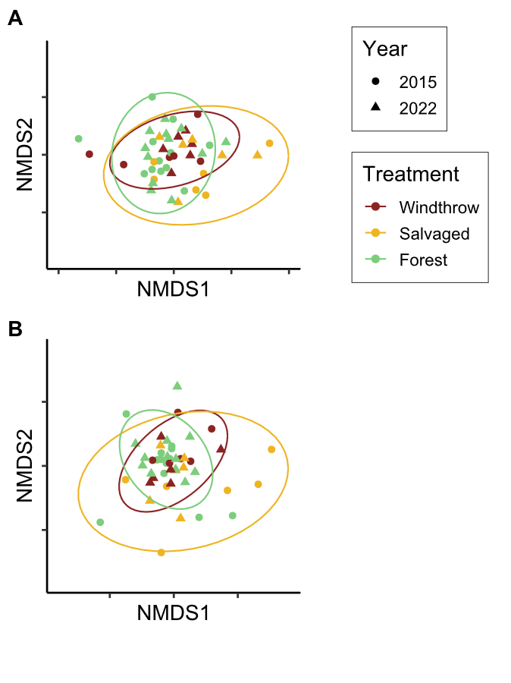

**Figure 2.5.** Nonmetric multidimensional scaling (NMDS) ordinations of ground beetle communities in taxonomic space (A) and functional trait space (B). Each point is a plot in a given year; shape of the point indicates the year the community was sampled, while color indicates the forest management treatment. Ellipses are drawn at the 95% level. The NMDS ordinations resulted in stress values of 0.224 for taxonomic beta-diversity and 0.181 for functional beta-diversity.

The forest floor environment changed among the forest management treatments over time (Table 2.5). The effects of forest management on canopy openness changed over time such that canopy openness was higher in salvaged plots than in windthrow or undisturbed forest in 2015, but the magnitude of these treatment differences decreased in 2022 (F=19.9, p<0.001). In 2022, one salvaged plot

In 2015, percentage cover of understory vegetation was higher in salvaged plots than windthrow, and windthrow had higher vegetation cover than forest, but these differences became less pronounced by 2022 (F=5.7, p=0.007). Meanwhile, percentage cover of leaf litter showed the opposite pattern. In 2015, salvaged plots had the lowest leaf litter cover, followed by windthrow plots and then forest with the highest leaf litter cover, but these differences lessened in magnitude in 2022 (F=8.8, p=0.001). Soil moisture was similar among forest management treatments in 2015 (F=0.08, p>0.10) and in 2022 (F=0.2, p>0.10).

**Table 2.5.** Means (± standard errors) of the environmental variables in the understory. The columns list the environmental variable, followed by the unit, then the year, and then there are columns for the group means for windthrow, salvaged, and forest.

|  |  |  |  |  |  |  |  |
| --- | --- | --- | --- | --- | --- | --- | --- |
| Environmental variable |  | Unit |  | Year | Forest | Salvaged | Windthrow |
| Canopy openness |  | 0-100% |  | 2015 | 9.1 ± 0.4 | 82.3 ± 3.4 | 13.7 ± 2.5 |
|  |  |  |  | 2022 | 7.7 ± 0.5 | 19.7 ± 10.8 | 9.1 ± 1.3 |
|  |  |  |  |  |  |  |  |
| Ground-level vegetation |  | 0-100% |  | 2015 | 21.6 ± 2.8 | 73.0 ± 6.0 | 42.1 ± 10.4 |
| percentage cover |  |  |  | 2022 | 35.1 ± 4.2 | 47.7 ± 11.3 | 41.9 ± 6.7 |
|  |  |  |  |  |  |  |  |
| Leaf litter percentage cover |  | 0-100% |  | 2015 | 61.2 ± 3.6 | 5.2 ± 3.5 | 35.4 ± 7.3 |
|  |  |  |  | 2022 | 43.1 ± 4.5 | 31.5 ± 9.5 | 39.6 ± 5.8 |
|  |  |  |  |  |  |  |  |
| Soil moisture$ |  | 0-1.129 |  | 2015 | 0.59 ± 0.04 | 0.61 ± 0.07 | 0.60 ± 0.04 |
|  |  | 0-100% |  | 2022 | 44.8 ± 3.5 | 47.6 ± 2.5 | 48.7 ± 7.4 |

$: A different soil sensor was used in 2022 than was used in 2015, so readings are only comparable between treatments within a year.

## Discussion

This study investigated the effects of disturbance caused by wind and subsequent salvage logging on ground beetle communities over time. We found that ground beetles differed both taxonomically and functionally between windthrow and salvaged forest, consistent with other studies (Koivula and Spence 2006, Gandhi et al. 2008). Salvage-logging, which removed all standing and downed trees, supported ground beetle communities that were distinct in species and trait composition, compared to windthrow and undisturbed forest which were more similar to one another. Although differences between treatments were largest two years after salvaging in 2015, some differences in species and traits persisted in 2022, nine years after salvaging. These findings suggest that the impacts of salvage logging after a natural disturbance continue to affect forest invertebrates for more than a decade, even as tree regeneration occurs.

Ground beetle activity-abundance, species richness, and community composition were similar among windthrow and undisturbed forest in 2015 and 2022. This finding was inconsistent with our hypothesis that ground beetle alpha-diversity would increase in unsalvaged windthrow relative to undisturbed forest. Other studies have found slightly elevated ground beetle alpha-diversity and altered community composition in windthrow relative to reference forest (Gandhi et al. 2008, Sklodowski and Garbalinska 2011, Barber and Widick 2017). Wind from strong storms increases standing and downed woody debris, changes abiotic conditions on the soil surface, and stimulates the growth of ground-level vegetation, all of which can alter the structure and composition of arthropod communities (Urbanovicova et al. 2014, Wermelinger et al. 2017). Some of these environmental changes were observed in our study, including increased cover of ground level vegetation and decreased cover of leaf litter. However, instead of a complete reorganization of the ground beetle community, windthrows commonly supported many of the same species found in undisturbed forest (Lee et al. 2017). Similarly, our study documented the persistence of forest-specialists in unsalvaged windthrows rather than a pronounced influx of generalists or open-habitat species.

Windthrow followed by salvage-logging resulted in distinct ground beetle communities and elevated species richness relative to undisturbed forest. Habitat-generalists increased in abundance two years after salvaging, altering ground beetle community composition, which supports our initial hypothesis. At nine years after salvaging, ground beetle communities remained taxonomically distinct, suggesting that legacies of windthrow were altered by the logging process. Our results align with many studies of salvage-logging and green-logging, where complete canopy removal resulted in an initial influx of flight-capable species (Pearce et al. 2003, Niemelä et al. 2007, Silverman et al. 2008, Gandhi et al. 2008). We observed an influx of habitat generalists such as *C. emarginatus*, but open-habitat specialists from the genera *Amara* and *Harpalus* were not present, in contrast to other studies (Pearce et al. 2003, Silverman et al. 2008, Riley and Browne 2011). This finding may reflect the surrounding landscape, which is mostly forested and likely did not support source populations of open-habitat species. We also found some forest-specialists, such as *P. moestus*, thrived initially in salvage-logged habitat, which may indicate their ability to tolerate altered abiotic conditions (Riley and Browne 2011), adopt new food sources (Lee et al. 2017), utilize any rapidly decomposing branches left by salvaging (Hamilton 1884, Thorn et al. 2014), or move between salvaged and unsalvaged habitat during different times of the year (Ohwaki et al. 2015). However, salvaged habitat after nine years supported mostly habitat-generalists such as *P. stygicus*, suggesting that logging may have reduced the woody debris resources necessary for certain species (Gore and Patterson III 1986, Larochelle and Larivière 2003, Pearce et al. 2003).

Contrary to our hypothesis, we found that functional alpha-diversity was similar among forest management treatments and across years, despite the increase in species richness after salvaging. We expected that the influx of open-habitat species and habitat-generalists following windthrow and salvage-logging would increase functional diversity due to the presence of novel traits such as flight capability or traits associated with specialized modes of feeding (Lee et al. 2017, Nardi et al. 2022). While functional alpha-diversity did not differ, functional beta-diversity between forest management treatments supported our hypothesis. Ground beetle communities in salvage-logged forest were functionally distinct from windthrow and undisturbed forest in 2015. The environmental conditions within salvaged plots, including higher light levels, lower leaf litter depth (Greenberg and Forrest 2003), temperature extremes (Urbanovicova et al. 2014), altered vegetation (Spicer et al. 2023), and changes in prey types (Wermelinger et al. 2017) can act as filters that select for a different suite of functional traits (Bauer and Kredler 1993, Inward et al. 2011, Ng et al. 2018, Sultaire et al. 2021). Species common in salvaged forests had proportionally longer eyes and rear trochanters in both years, and were more flight capable in 2015, partially supporting our hypothesis. Larger eye size can relate to open habitat preference, diurnal activity, and visual-hunting strategy (Bauer and Kredler 1993, Ribera et al. 1999, Talarico et al. 2007). Species with larger rear trochanters can expand crevices between layers of substrate, whereas species with shorter rear trochanters tend to walk or run on the surface (Evans 1977, Forsythe 1981). Further research could investigate why salvage-logging favored species with longer trochanters, even though salvaged forest tended to have lower leaf litter cover and higher vegetation cover. The abundance of flight-capable species often increases in the first few years after disturbance, then decreases over time with forest regeneration (Sklodowski and Garbalinska 2011, Riley and Browne 2011). We found that salvage-logging favored flight capable species in 2015, but not in 2022, which may reflect the rapid tree regeneration occurring in salvaged forest (Curtze et al. 2018). Finally, species common in undisturbed forest tended to have longer bodies, which may reflect that larger forest-specialists can decline in disturbed forests (Sklodowski and Garbalinska 2011).

The process of salvage-logging following a natural disturbance such as wind can alter important biological legacies that shape short- and long-term recovery in forests. These legacies include the size-distribution of tree seedlings (Slyder et al. 2020), the size, age, and microclimate around downed woody debris (Thorn et al. 2014), and the abundance and richness of herbaceous plants in the understory (Elliott et al. 2002, Spicer et al. 2023). Using ground beetles as environmental indicators, we documented shifts in community composition that occurred due to salvage-logging. Our results suggest that habitat generalists benefitted from salvaging, but some species with specialized modes of feeding were disadvantaged (Sultaire et al. 2021). Furthermore, we saw larger differences in community composition than we did in alpha-diversity, suggesting that species turnover occurred among windthrow, salvaged, and undisturbed forest patches, ultimately supporting increased landscape-level diversity. Finally, differences between disturbances (for example, in taxonomic composition and CWM meta-trochanter length) persisted even after nine years, highlighting the importance of maintaining biological legacies in the landscape following disturbance in forests. These findings suggest that conservation-minded land managers should leave a portion of windthrow stands unsalvaged to conserve insect biodiversity in the long term.

## References

Barber, N. A., and W. L. Widick. 2017. Localized Effects of Tornado Damage on Ground Beetle Communities and Vegetation in a Forested Preserve. Natural Areas Journal 37:489–496.

Barton, P. S., H. Gibb, A. D. Manning, D. B. Lindenmayer, and S. A. Cunningham. 2011. Morphological traits as predictors of diet and microhabitat use in a diverse beetle assemblage. Biological Journal of the Linnean Society 102:301–310.

Bates, D., M. Mächler, B. Bolker, and S. Walker. 2015. Fitting Linear Mixed-Effects Models Using lme4. Journal of Statistical Software 67.

Bauer, T., and M. Kredler. 1993. Morphology of the compound eyes as an indicator of life-style in carabid beetles. Canadian Journal of Zoology 71:799–810.

Baulechner, D., F. Jauker, T. A. Neubauer, and V. Wolters. 2020. Convergent evolution of specialized generalists: Implications for phylogenetic and functional diversity of carabid feeding groups. Ecology and Evolution 10:11100–11110.

Bousquet, Y. 2010. Illustrated identification guide to adults and larvae of northeastern North American ground beetles: Coleoptera : Carabidae. Pensoft, Sofia.

Bousquet, Y. 2012. Catalogue of Geadephaga (Coleoptera: Adephaga) of America, north of Mexico. ZooKeys 245:1–1722.

Bousquet, Y., and P. Messer. 2010. Redescription of *Stenolophus thoracicus* Casey (Coleoptera, Carabidae, Harpalini), a valid species. ZooKeys 53:25–31.

Browne, R., S. Maveety, L. Cooper, and K. Riley. 2014. Ground Beetle (Coleoptera: Carabidae) Species Composition in the Southern Appalachian Mountains. Southeastern Naturalist 13:407–422.

Calinger, K., E. Calhoon, H. Chang, J. Whitacre, J. Wenzel, L. Comita, and S. Queenborough. 2015. Historic Mining and Agriculture as Indicators of Occurrence and Abundance of Widespread Invasive Plant Species. PLOS ONE 10:e0128161.

Chao, A., and C. Chiu. 2016. Species Richness: Estimation and Comparison. Pages 1–26 *in* R. S. Kenett, N. T. Longford, W. W. Piegorsch, and F. Ruggeri, editors. Wiley StatsRef: Statistics Reference Online. First edition. Wiley.

Chao, A., K. H. Ma, T. C. Hsieh, and C. Chiu. 2016. SpadeR: Species-Richness Prediction and Diversity Estimation with R.

Curtze, A. C., T. A. Carlo, and J. W. Wenzel. 2018. The Effects of a Tornado Disturbance and a Salvaged Timber Extraction on the Seed-Rain and Recruitment Community of an Eastern Temperate Deciduous Forest. Northeastern Naturalist 25:627.

Elliott, K. J., S. L. Hitchcock, and L. Krueger. 2002. Vegetation Response to Large Scale Disturbance in a Southern Appalachian Forest: Hurricane Opal and Salvage Logging. Journal of the Torrey Botanical Society 129:48.

Erwin, T. L. 1979. Thoughts on the Evolutionary History of Ground Beetles: Hypotheses Generated from Comparative Faunal Analyses of Lowland Forest Sites in Temperate and Tropical Regions. Pages 539–592 *in* T. L. Erwin, G. E. Ball, D. R. Whitehead, and A. L. Halpern, editors. Carabid Beetles: Their Evolution, Natural History, and Classification. Springer Netherlands, Dordrecht.

Evans, M. E. G. 1977. Locomotion in the Coleoptera Adephaga, especially Carabidae. Journal of Zoology 181:189–226.

Fischer, A., P. Marshall, and A. Camp. 2013. Disturbances in deciduous temperate forest ecosystems of the northern hemisphere: their effects on both recent and future forest development. Biodiversity and Conservation 22:1863–1893.

Forsythe, T. G. 1981. Running and Pushing in Relationship to Hind Leg Structure in Some Carabidae (Coleoptera). The Coleopterists Bulletin 35:353–378.

Forsythe, T. G. 1991. Feeding and locomotory functions in relation to body form in five species of ground beetle (Coleoptera: Carabidae). Journal of Zoology 223:233–263.

Fountain-Jones, N. M., S. C. Baker, and G. J. Jordan. 2015. Moving beyond the guild concept: developing a practical functional trait framework for terrestrial beetles. Ecological Entomology 40:1–13.

Fox, J., and S. Weisberg. 2019. An {R} Companion to Applied Regression. Sage, Thousand Oaks {CA}.

Freitag, R. 1969. A revision of the species of the genus Evarthrus LeConte (Coleoptera: Carabidae). Quaestiones Entomologicae 5:88–212.

Gandhi, K. J. K., D. W. Gilmore, S. A. Katovich, W. J. Mattson, J. C. Zasada, and S. J. Seybold. 2008. Catastrophic windstorm and fuel-reduction treatments alter ground beetle (Coleoptera: Carabidae) assemblages in a North American sub-boreal forest. Forest Ecology and Management 256:1104–1123.

Gomez, R. A., K. W. Will, and D. R. Maddison. 2016. Are *Miquihuana rhadiniformis* Barr, 1982 and *Pseudamara arenaria* (LeConte, 1847) (Coleoptera, Carabidae) sphodrines? Phylogenetic analysis of data from next-generation sequencing of museum specimens resolves the tribal-group relationships of these enigmatic taxa. Entomologische Blätter und Coleoptera 112:149–168.

Gore, J. A., and W. A. Patterson III. 1986. Mass of downed wood in northern hardwood forests in New Hampshire: potential effects of forest management. Canadian Journal of Forest Research 16:335–339.

Greenberg, C. H., and T. G. Forrest. 2003. Seasonal abundance of ground-occuring macroarthropods in forest and canopy gaps in the southern Appalachians. Southeastern Naturalist 2:591–608.

Hamilton, J. 1884. The survival of the fittest among certain species of *Pterostichus* as deduced from their habits. The Canadian Entomologist 16:73–77.

Harden, C. W., and F. G. Guarnieri. 2017. Illustrated Key and Photo Atlas of the Snail-eating Ground Beetles in the Genus *Scaphinotus* Dejean (Coleoptera: Carabidae: Cychrini) Occurring in the Mid-Atlantic Region. The Maryland Entomologist 7:16–34.

Hunting, W. 2013. A taxonomic revision of the *Cymindis* (*Pinacodera*) *limbata* species group (Coleoptera, Carabidae, Lebiini), including description of a new species from Florida, U.S.A. ZooKeys 259:1–73.

Inward, D. J. G., R. G. Davies, C. Pergande, A. J. Denham, and A. P. Vogler. 2011. Local and regional ecological morphology of dung beetle assemblages across four biogeographic regions: Ecological morphology of dung beetle assemblages. Journal of Biogeography 38:1668–1682.

Kembel, S. W., P. D. Cowan, M. R. Helmus, W. K. Cornwell, H. Morlon, D. D. Ackerly, S. P. Blomberg, and C. O. Webb. 2010. Picante: R tools for integrating phylogenies and ecology. Bioinformatics 26:1463–1464.

Koivula, M. 2011. Useful model organisms, indicators, or both? Ground beetles (Coleoptera, Carabidae) reflecting environmental conditions. ZooKeys 100:287–317.

Koivula, M., and J. R. Spence. 2006. Effects of post-fire salvage logging on boreal mixed-wood ground beetle assemblages (Coleoptera, Carabidae). Forest Ecology and Management 236:102–112.

Kuznetsova, A., P. B. Brockhoff, and R. H. B. Christensen. 2017. lmerTest Package: Tests in Linear Mixed Effects Models. Journal of Statistical Software 82.

Laliberte, E., P. Legendre, and B. Shipley. 2014. FD: measuring functional diversity from multiple traits, and other tools for functional ecology. R.

Langor, D. W., and J. R. Spence. 2006. Arthropods as ecological indicators of sustainability in Canadian forests. The Forestry Chronicle 82:344–350.

Larochelle, A., and M.-C. Larivière. 2003. A natural history of the ground-beetles (Coleoptera: Carabidae) of America north of Mexico. Pensoft Publ, Sofia.

Lee, C. M., T.-S. Kwon, and K. Cheon. 2017. Response of ground beetles (Coleoptera: Carabidae) to forest gaps formed by a typhoon in a red pine forest at Gwangneung Forest, Republic of Korea. Journal of Forestry Research 28:173–181.

Lenth, R. V. 2024. emmeans: Estimated Marginal Means, aka Least-Squares Means. R.

Li, D. 2018. hillR: taxonomic, functional, and phylogenetic diversity and similarity through Hill Numbers. Journal of Open Source Software 3:1041.

Lindenmayer, D., P. J. Burton, and J. F. Franklin. 2012. Salvage logging and its ecological consequences. Island Press, United States.

Lindroth, C. H. 1961. The Ground-beetles of Canada and Alaska. Entomologiska Sallskapet, Lund, Sweden.

Lundgren, J., and K. McCravy. 2011. Carabid beetles (Coleoptera: Carabidae) of the Midwestern United States: a review and synthesis of recent research. Terrestrial Arthropod Reviews 4:63–94.

Martinez Arbizu, P. 2017. pairwiseAdonis: Pairwise Multilevel Comparison using Adonis. R.

McNabb, D. H., A. D. Startsev, and H. Nguyen. 2001. Soil Wetness and Traffic Level Effects on Bulk Density and Air‐Filled Porosity of Compacted Boreal Forest Soils. Soil Science Society of America Journal 65:1238–1247.

Murphy, S. J., L. D. Audino, J. Whitacre, J. L. Eck, J. W. Wenzel, S. A. Queenborough, and L. S. Comita. 2015. Species associations structured by environment and land‐use history promote beta‐diversity in a temperate forest. Ecology 96:705–715.

Nardi, D., F. Giannone, and L. Marini. 2022. Short-term response of ground-dwelling arthropods to storm-related disturbances is mediated by topography and dispersal. Basic and Applied Ecology 65:86–95.

National Oceanic and Atmospheric Administration. 2012, 2022. Past Weather. https://www.ncei.noaa.gov/access/past-weather/40.31510524031136,-79.72542724948556,40.10676305409062,-79.22526387171922. Accessed November 2025.

Ng, K., P. S. Barton, W. Blanchard, M. J. Evans, D. B. Lindenmayer, S. Macfadyen, S. McIntyre, and D. A. Driscoll. 2018. Disentangling the effects of farmland use, habitat edges, and vegetation structure on ground beetle morphological traits. Oecologia 188:645–657.

Niemelä, J., M. Koivula, and D. J. Kotze. 2007. The effects of forestry on carabid beetles (Coleoptera: Carabidae) in boreal forests. Journal of Insect Conservation 11:5–18.

Ohwaki, A., Y. Kaneko, and H. Ikeda. 2015. Seasonal variability in the response of ground beetles (Coleoptera: Carabidae) to a forest edge in a heterogeneous agricultural landscape in Japan. European Journal of Entomology 112:135–144.

Oksanen, J., G. Simpson, F. Blanchet, R. Kindt, P. Legendre, P. Minchin, R. O’Hara, P. Solymos, M. Stevens, E. Szoecs, Wagner H., Barbour M., Bedward M., Bolker B., Borcard D., Carvalho G., Chirico M., De Caceres, M., Durand S., Evangelista H., FitzJohn R., Friendly M., Furneaux B., Hannigan G., Hill M., Lahti L., McGlinn D., Ouellette M., Ribeiro, Cunha E., Smith T., Stier A., Ter Braak C., and J. Weedon. 2024. _vegan: Community Ecology Package_. R.

Pearce, J. L., L. A. Venier, J. McKee, J. Pedlar, and D. McKenney. 2003. Influence of habitat and microhabitat on carabid (Coleoptera: Carabidae) assemblages in four stand types. The Canadian Entomologist 135:337–357.

Perry, K., and D. Herms. 2019. Dynamic Responses of Ground-Dwelling Invertebrate Communities to Disturbance in Forest Ecosystems. Insects 10:61.

Perry, K. I., K. F. Wallin, J. W. Wenzel, and D. A. Herms. 2018. Forest disturbance and arthropods: Small‐scale canopy gaps drive invertebrate community structure and composition. Ecosphere 9:e02463.

Peterson, C. J., and A. D. Leach. 2008. Salvage logging after windthrow alters microsite diversity, abundance and environment, but not vegetation. Forestry 81:361–376.

Phillips, I. D., and T. P. Cobb. 2005. Effects of Habitat Structure and Lid Transparency on Pitfall Catches. Environmental Entomology 34:875–882.

R Core Team. 2024. R: A Language and Environment for Statistical Computing. R Foundation for Statistical Computing, Vienna, Austria.

Ribera, I., S. Dolédec, I. S. Downie, and G. N. Foster. 2001. Effect of Land Disturbance and Stress on Species Traits of Ground Beetle Assemblages. Ecology 82:1112–1129.

Ribera, I., G. N. Foster, I. S. Downie, D. I. McCracken, and V. J. Abernethy. 1999. A comparative study of the morphology and life traits of Scottish ground beetles (Coleoptera, Carabidae). Annales Zoologici Fennici 36:21–37.

Riley, K., and R. Browne. 2011. Changes in ground beetle diversity and community composition in age structured forests (Coleoptera, Carabidae). ZooKeys 147:601–621.

Ritter, E., L. Dalsgaard, and K. S. Einhorn. 2005. Light, temperature and soil moisture regimes following gap formation in a semi-natural beech-dominated forest in Denmark. Forest Ecology and Management 206:15–33.

Schammel, L. A., E. J. Holzmueller, J. W. Groninger, C. M. Ruffner, and J. L. Nelson. 2025. Recovering of Biodiversity in Bottomland Hardwood Forests After a Tornado and Salvage Logging in Southern Illinois (USA). Ecologies 6:27.

Seidl, R., D. Thom, M. Kautz, D. Martin-Benito, M. Peltoniemi, G. Vacchiano, J. Wild, D. Ascoli, M. Petr, J. Honkaniemi, M. J. Lexer, V. Trotsiuk, P. Mairota, M. Svoboda, M. Fabrika, T. A. Nagel, and C. P. O. Reyer. 2017. Forest disturbances under climate change. Nature Climate Change 7:395–402.

Silverman, B., D. J. Horn, F. F. Purrington, and K. J. K. Gandhi. 2008. Oil Pipeline Corridor Through an Intact Forest Alters Ground Beetle (Coleoptera: Carabidae) Assemblages in Southeastern Ohio. Environmental Entomology 37:725–733.

Sklodowski, J., and P. Garbalinska. 2011. Ground beetle (Coleoptera, Carabidae) assemblages inhabiting Scots pine stands of Puszcza Piska Forest: six-year responses to a tornado impact. ZooKeys 100:371–392.

Slesak, R. A., C. F. Lenhart, K. N. Brooks, A. W. D’Amato, and B. J. Palik. 2014. Water table response to harvesting and simulated emerald ash borer mortality in black ash wetlands in Minnesota, USA. Canadian Journal of Forest Research 44:961–968.

Slyder, J. B., J. W. Wenzel, A. A. Royo, M. E. Spicer, and W. P. Carson. 2020. Post-windthrow salvage logging increases seedling and understory diversity with little impact on composition immediately after logging. New Forests 51:409–420.

Spicer, M. E., A. A. Royo, J. W. Wenzel, and W. P. Carson. 2023. Understory plant growth forms respond independently to combined natural and anthropogenic disturbances. Forest Ecology and Management 543:121077.

Sultaire, S. M., A. J. Kroll, J. Verschuyl, D. A. Landis, and G. J. Roloff. 2021. Effects of varying retention tree patterns on ground beetle (Coleoptera: Carabidae) taxonomic and functional diversity. Ecosphere 12:e03641.

Swenson, N. G. 2014. Functional and Phylogenetic Ecology in R. Springer New York, New York, NY.

Talarico, F., P. Brandmayr, A. Giglio, A. Massolo, and T. Zetto Brandmayr. 2011. Morphometry of eyes, antennae and wings in three species of *Siagona* (Coleoptera, Carabidae). ZooKeys 100:203–214.

Talarico, F., M. Romeo, A. Massolo, P. Brandmayr, and T. Zetto. 2007. Morphometry and eye morphology in three species of *Carabus* (Coleoptera: Carabidae) in relation to habitat demands. Journal of Zoological Systematics and Evolutionary Research 45:33–38.

Thiele, H.-U. 1977. Carabid Beetles in Their Environments. Springer, Berlin, Heidelberg.

Thorn, S., C. Bässler, R. Brandl, P. J. Burton, R. Cahall, J. L. Campbell, J. Castro, C.-Y. Choi, T. Cobb, D. C. Donato, E. Durska, J. B. Fontaine, S. Gauthier, C. Hebert, T. Hothorn, R. L. Hutto, E.-J. Lee, A. B. Leverkus, D. B. Lindenmayer, M. K. Obrist, J. Rost, S. Seibold, R. Seidl, D. Thom, K. Waldron, B. Wermelinger, M.-B. Winter, M. Zmihorski, and J. Müller. 2018. Impacts of salvage logging on biodiversity: A meta-analysis. Journal of Applied Ecology 55:279–289.

Thorn, S., C. Bässler, T. Gottschalk, T. Hothorn, H. Bussler, K. Raffa, and J. Müller. 2014. New Insights into the Consequences of Post-Windthrow Salvage Logging Revealed by Functional Structure of Saproxylic Beetles Assemblages. PLoS ONE 9:e101757.

Urbanovicova, V., D. Miklisová, and A. Mock. 2014. Activity of epigeic arthropods in differently managed windthrown forest stands in the High Tatra Mts. North-western Journal of Zoology 10:337–345.

Venn, S. 2016. To fly or not to fly: Factors influencing the flight capacity of carabid beetles (Coleoptera: Carabidae). European Journal of Entomology 113:587–600.

Wagner, D. L., E. M. Grames, M. L. Forister, M. R. Berenbaum, and D. Stopak. 2021. Insect decline in the Anthropocene: Death by a thousand cuts. Proceedings of the National Academy of Sciences 118:e2023989118.

Wermelinger, B., M. Moretti, P. Duelli, T. Lachat, G. B. Pezzatti, and M. K. Obrist. 2017. Impact of windthrow and salvage-logging on taxonomic and functional diversity of forest arthropods. Forest Ecology and Management 391:9–18.

Werner, S. M., and K. F. Raffa. 2000. Effects of forest management practices on the diversity of ground-occurring beetles in mixed northern hardwood forests of the Great Lakes Region. Forest Ecology and Management 139:135–155.

# Full References

Abell, K. J., L. S. Bauer, J. J. Duan, and R. Van Driesche. 2014. Long-term monitoring of the introduced emerald ash borer (Coleoptera: Buprestidae) egg parasitoid, *Oobius agrili* (Hymenoptera: Encyrtidae), in Michigan, USA and evaluation of a newly developed monitoring technique. Biological Control 79:36–42.

Abell, K. J., J. J. Duan, L. Bauer, J. P. Lelito, and R. G. Van Driesche. 2012. The effect of bark thickness on host partitioning between *Tetrastichus planipennisi* (Hymen: Eulophidae) and *Atanycolus* spp. (Hymen: Braconidae), two parasitoids of emerald ash borer (Coleop: Buprestidae). Biological Control 63:320–325.

Abella, S. R., C. E. Hausman, J. F. Jaeger, K. S. Menard, T. A. Schetter, and O. J. Rocha. 2019. Fourteen years of swamp forest change from the onset, during, and after invasion of emerald ash borer. Biological Invasions 21:3685–3696.

Abella, S. R., K. S. Menard, T. A. Schetter, and C. E. Hausman. 2024. Species and landscape variation in tree regeneration and 17 years of change in forested wetlands invaded by emerald ash borer. Forest Ecology and Management 557:121750.

Aker, S. A., R. B. De Andrade, J. J. Duan, and D. S. Gruner. 2022. Rapid Spread of an Introduced Parasitoid for Biological Control of Emerald Ash Borer (Coleoptera: Buprestidae) in Maryland. Journal of Economic Entomology 115:381–386.

Aubin, I., F. Cardou, K. Ryall, D. Kreutzweiser, and T. Scarr. 2015. Ash regeneration capacity after emerald ash borer (EAB) outbreaks: Some early results. The Forestry Chronicle 91:291–298.

Barber, N. A., and W. L. Widick. 2017. Localized Effects of Tornado Damage on Ground Beetle Communities and Vegetation in a Forested Preserve. Natural Areas Journal 37:489–496.

Barnes, B. V. 1976. Succession in deciduous swamp communities of southeastern Michigan formerly dominated by American elm. Canadian Journal of Botany 54:19–24.

Barton, P. S., H. Gibb, A. D. Manning, D. B. Lindenmayer, and S. A. Cunningham. 2011. Morphological traits as predictors of diet and microhabitat use in a diverse beetle assemblage. Biological Journal of the Linnean Society 102:301–310.

Bates, D., M. Mächler, B. Bolker, and S. Walker. 2015. Fitting Linear Mixed-Effects Models Using lme4. Journal of Statistical Software 67.

Bauer, T., and M. Kredler. 1993. Morphology of the compound eyes as an indicator of life-style in carabid beetles. Canadian Journal of Zoology 71:799–810.

Baulechner, D., F. Jauker, T. A. Neubauer, and V. Wolters. 2020. Convergent evolution of specialized generalists: Implications for phylogenetic and functional diversity of carabid feeding groups. Ecology and Evolution 10:11100–11110.

Benedict, L., and R. David. 2003. Propagation Protocol for Black Ash (Fraxinus nigra Marsh.). Native Plants Journal 4:100–103.

Bolen, A. 2020. A Silent Killer: Black Ash Basket Makers are Battling a Voracious Beetle to Keep Their Heritage Alive. National Museum of the American Indian 21.

Bolton, N., J. Shannon, J. Davis, M. Grinsven, N. Noh, S. Schooler, R. Kolka, T. Pypker, and J. Wagenbrenner. 2018. Methods to Improve Survival and Growth of Planted Alternative Species Seedlings in Black Ash Ecosystems Threatened by Emerald Ash Borer. Forests 9:146.

Bousquet, Y. 2010. Illustrated identification guide to adults and larvae of northeastern North American ground beetles: Coleoptera : Carabidae. Pensoft, Sofia.

Bousquet, Y. 2012. Catalogue of Geadephaga (Coleoptera: Adephaga) of America, north of Mexico. ZooKeys 245:1–1722.

Bousquet, Y., and P. Messer. 2010. Redescription of *Stenolophus thoracicus* Casey (Coleoptera, Carabidae, Harpalini), a valid species. ZooKeys 53:25–31.

Braun, E. L. 1989. The woody plants of Ohio: trees, shrubs and woody climbers, native, naturalized, and escaped. Ohio State University Press, Columbus, Ohio.

Browne, R., S. Maveety, L. Cooper, and K. Riley. 2014. Ground Beetle (Coleoptera: Carabidae) Species Composition in the Southern Appalachian Mountains. Southeastern Naturalist 13:407–422.

Burns, R., and B. Honkala. 1990. Silvics of North America: Volume 2, Hardwoods.

Calinger, K., E. Calhoon, H. Chang, J. Whitacre, J. Wenzel, L. Comita, and S. Queenborough. 2015. Historic Mining and Agriculture as Indicators of Occurrence and Abundance of Widespread Invasive Plant Species. PLOS ONE 10:e0128161.

Canadian Food Inspection Agency. 2025. Regulated areas and items: Emerald ash borer. https://inspection.canada.ca/en/plant-health/invasive-pests-and-plants/directives/forest-products/03-08/regulated-areas.

Chao, A., and C. Chiu. 2016. Species Richness: Estimation and Comparison. Pages 1–26 *in* R. S. Kenett, N. T. Longford, W. W. Piegorsch, and F. Ruggeri, editors. Wiley StatsRef: Statistics Reference Online. First edition. Wiley.

Chao, A., K. H. Ma, T. C. Hsieh, and C. Chiu. 2016. SpadeR: Species-Richness Prediction and Diversity Estimation with R.

Chen, Y., M. D. Ulyshen, and T. M. Poland. 2016. Abundance of volatile organic compounds in white ash phloem and emerald ash borer larval frass does not attract *Tetrastichus planipennisi* in a Y‐tube olfactometer. Insect Science 23:712–719.

Costilow, K. C., K. S. Knight, and C. E. Flower. 2017. Disturbance severity and canopy position control the radial growth response of maple trees (*Acer* spp.) in forests of northwest Ohio impacted by emerald ash borer (*Agrilus planipennis*). Annals of Forest Science 74:10.

Curtze, A. C., T. A. Carlo, and J. W. Wenzel. 2018. The Effects of a Tornado Disturbance and a Salvaged Timber Extraction on the Seed-Rain and Recruitment Community of an Eastern Temperate Deciduous Forest. Northeastern Naturalist 25:627.

Davis, J. C., J. P. Shannon, N. W. Bolton, R. K. Kolka, and T. G. Pypker. 2017. Vegetation responses to simulated emerald ash borer infestation in *Fraxinus nigra* dominated wetlands of Upper Michigan, USA. Canadian Journal of Forest Research 47:319–330.

Duan, J. J., L. S. Bauer, K. J. Abell, M. D. Ulyshen, and R. G. Van Driesche. 2015. Population dynamics of an invasive forest insect and associated natural enemies in the aftermath of invasion: implications for biological control. Journal of Applied Ecology 52:1246–1254.

Duan, J. J., L. S. Bauer, and R. G. Van Driesche. 2017. Emerald ash borer biocontrol in ash saplings: The potential for early stage recovery of North American ash trees. Forest Ecology and Management 394:64–72.

Duan, J. J., J. R. Gould, N. F. Quinn, T. R. Petrice, B. H. Slager, T. M. Poland, L. S. Bauer, C. E. Rutledge, J. S. Elkinton, and R. G. Van Driesche. 2023. Protection of North American ash against emerald ash borer with biological control: ecological premises and progress toward success. BioControl 68:87–100.

Duan, J. J., C. B. Oppel, M. D. Ulyshen, L. S. Bauer, and J. LeLito. 2011. Biology and Life History of *Tetrastichus planipennisi* (Hymenoptera: Eulophidae), a Larval Endoparasitoid of the Emerald Ash Borer (Coleoptera: Buprestidae). Florida Entomologist 94:933–940.

Duan, J. J., R. G. Van Driesche, J. M. Schmude, N. F. Quinn, T. R. Petrice, C. E. Rutledge, T. M. Poland, L. S. Bauer, and J. S. Elkinton. 2021. Niche partitioning and coexistence of parasitoids of the same feeding guild introduced for biological control of an invasive forest pest. Biological Control 160:104698.

Elliott, K. J., S. L. Hitchcock, and L. Krueger. 2002. Vegetation Response to Large Scale Disturbance in a Southern Appalachian Forest: Hurricane Opal and Salvage Logging. Journal of the Torrey Botanical Society 129:48.

Engelken, P. J., M. E. Benbow, and D. G. McCullough. 2020. Legacy effects of emerald ash borer on riparian forest vegetation and structure. Forest Ecology and Management 457:117684.

Erwin, T. L. 1979. Thoughts on the Evolutionary History of Ground Beetles: Hypotheses Generated from Comparative Faunal Analyses of Lowland Forest Sites in Temperate and Tropical Regions. Pages 539–592 *in* T. L. Erwin, G. E. Ball, D. R. Whitehead, and A. L. Halpern, editors. Carabid Beetles: Their Evolution, Natural History, and Classification. Springer Netherlands, Dordrecht.

Evans, M. E. G. 1977. Locomotion in the Coleoptera Adephaga, especially Carabidae. Journal of Zoology 181:189–226.

Fahrner, S. J., J. P. Lelito, K. Blaedow, G. E. Heimpel, and B. H. Aukema. 2014. Factors Affecting the Flight Capacity of *Tetrastichus planipennisi* (Hymenoptera: Eulophidae), a Classical Biological Control Agent of *Agrilus planipennis* (Coleoptera: Buprestidae). Environmental Entomology 43:1603–1612.

Fischer, A., P. Marshall, and A. Camp. 2013. Disturbances in deciduous temperate forest ecosystems of the northern hemisphere: their effects on both recent and future forest development. Biodiversity and Conservation 22:1863–1893.

Forsythe, T. G. 1981. Running and Pushing in Relationship to Hind Leg Structure in Some Carabidae (Coleoptera). The Coleopterists Bulletin 35:353–378.

Forsythe, T. G. 1991. Feeding and locomotory functions in relation to body form in five species of ground beetle (Coleoptera: Carabidae). Journal of Zoology 223:233–263.

Fountain-Jones, N. M., S. C. Baker, and G. J. Jordan. 2015. Moving beyond the guild concept: developing a practical functional trait framework for terrestrial beetles. Ecological Entomology 40:1–13.

Fox, J., and S. Weisberg. 2019. An {R} Companion to Applied Regression. Sage, Thousand Oaks {CA}.

Freitag, R. 1969. A revision of the species of the genus Evarthrus LeConte (Coleoptera: Carabidae). Quaestiones Entomologicae 5:88–212.

Gandhi, K. J. K., D. W. Gilmore, S. A. Katovich, W. J. Mattson, J. C. Zasada, and S. J. Seybold. 2008. Catastrophic windstorm and fuel-reduction treatments alter ground beetle (Coleoptera: Carabidae) assemblages in a North American sub-boreal forest. Forest Ecology and Management 256:1104–1123.

Gandhi, K. J. K., and D. A. Herms. 2010. Direct and indirect effects of alien insect herbivores on ecological processes and interactions in forests of eastern North America. Biological Invasions 12:389–405.

Gandhi, K. J. K., A. Smith, D. M. Hartzler, and D. A. Herms. 2014. Indirect Effects of Emerald Ash Borer-Induced Ash Mortality and Canopy Gap Formation on Epigaeic Beetles. Environmental Entomology 43:546–555.

Golet, F. C., J. A. Allen, U. S. Fish, and W. Service. 1993. Ecology of Red Maple Swamps in the Glaciated Northeast: A Community Profile. U.S. Department of the Interior, Fish and Wildlife Service.

Gomez, R. A., K. W. Will, and D. R. Maddison. 2016. Are *Miquihuana rhadiniformis* Barr, 1982 and *Pseudamara arenaria* (LeConte, 1847) (Coleoptera, Carabidae) sphodrines? Phylogenetic analysis of data from next-generation sequencing of museum specimens resolves the tribal-group relationships of these enigmatic taxa. Entomologische Blätter und Coleoptera 112:149–168.

Gore, J. A., and W. A. Patterson III. 1986. Mass of downed wood in northern hardwood forests in New Hampshire: potential effects of forest management. Canadian Journal of Forest Research 16:335–339.

Greenberg, C. H., and T. G. Forrest. 2003. Seasonal abundance of ground-occuring macroarthropods in forest and canopy gaps in the southern Appalachians. Southeastern Naturalist 2:591–608.

Hamilton, J. 1884. The survival of the fittest among certain species of *Pterostichus* as deduced from their habits. The Canadian Entomologist 16:73–77.

Harden, C. W., and F. G. Guarnieri. 2017. Illustrated Key and Photo Atlas of the Snail-eating Ground Beetles in the Genus *Scaphinotus* Dejean (Coleoptera: Carabidae: Cychrini) Occurring in the Mid-Atlantic Region. The Maryland Entomologist 7:16–34.

Hartig, F. 2024. DHARMa: Residual Diagnostics for Hierarchical (Multi-Level / Mixed) Regression Models. R.

Hoven, B. M., K. S. Knight, V. E. Peters, and D. L. Gorchov. 2020. Release and suppression: forest layer responses to emerald ash borer (*Agrilus planipennis*)-caused ash death. Annals of Forest Science 77:10.

Hunting, W. 2013. A taxonomic revision of the *Cymindis* (*Pinacodera*) *limbata* species group (Coleoptera, Carabidae, Lebiini), including description of a new species from Florida, U.S.A. ZooKeys 259:1–73.

Inward, D. J. G., R. G. Davies, C. Pergande, A. J. Denham, and A. P. Vogler. 2011. Local and regional ecological morphology of dung beetle assemblages across four biogeographic regions: Ecological morphology of dung beetle assemblages. Journal of Biogeography 38:1668–1682.

Johnson, T. D., J. P. Lelito, and K. F. Raffa. 2014. Responses of two parasitoids, the exotic *Spathius agrili* Yang and the native *Spathius floridanus* Ashmead, to volatile cues associated with the emerald ash borer, *Agrilus planipennis* Fairmaire. Biological Control 79:110–117.

Jones, M. I., J. R. Gould, H. J. Mahon, and M. K. Fierke. 2020. Phenology of Emerald Ash Borer (Coleoptera: Buprestidae) and Its Introduced Larval Parasitoids in the Northeastern United States. Journal of Economic Entomology 113:622–632.

Jones, M. I., J. R. Gould, M. L. Warden, and M. K. Fierke. 2019. Dispersal of emerald ash borer (Coleoptera: Buprestidae) parasitoids along an ash corridor in western New York. Biological Control 128:94–101.

Kartesz, J. T. 2015. The Biota of North America Program (BONAP). North American Plant Atlas. (http://bonap.net/napa), Chapel Hill, N.C.

Kashian, D. M. 2016. Sprouting and seed production may promote persistence of green ash in the presence of the emerald ash borer. Ecosphere 7:e01332.

Kashian, D. M., L. S. Bauer, B. A. Spei, J. J. Duan, and J. R. Gould. 2018. Potential Impacts of Emerald Ash Borer Biocontrol on Ash Health and Recovery in Southern Michigan. Forests 9:296.

Kembel, S. W., P. D. Cowan, M. R. Helmus, W. K. Cornwell, H. Morlon, D. D. Ackerly, S. P. Blomberg, and C. O. Webb. 2010. Picante: R tools for integrating phylogenies and ecology. Bioinformatics 26:1463–1464.

Klooster, W., K. Gandhi, L. Long, K. Perry, K. Rice, and D. Herms. 2018. Ecological Impacts of Emerald Ash Borer in Forests at the Epicenter of the Invasion in North America. Forests 9:250.

Klooster, W. S. 2012. Forest Responses to Emerald Ash Borer-Induced Ash Mortality. PhD Thesis, The Ohio State University.

Klooster, W. S., D. A. Herms, K. S. Knight, C. P. Herms, D. G. McCullough, A. Smith, K. J. K. Gandhi, and J. Cardina. 2013. Ash (*Fraxinus* spp.) mortality, regeneration, and seed bank dynamics in mixed hardwood forests following invasion by emerald ash borer (*Agrilus planipennis*). Biological Invasions 16:859–873.

Knight, K. S., J. P. Brown, and R. P. Long. 2013. Factors affecting the survival of ash (*Fraxinus* spp.) trees infested by emerald ash borer (*Agrilus planipennis*). Biological Invasions 15:371–383.

Knight, K. S., B. P. Flash, R. H. Kappler, J. A. Throckmorton, B. Grafton, and C. E. Flower. 2014. Monitoring Ash (*Fraxinus* spp.) Decline and Emerald Ash Borer (*Agrilus planipennis*) Symptoms in Infested Areas. General Technical Report, U.S. Department of Agriculture, Forest Service, Northern Research Station.

Koch, J. L., D. W. Carey, M. E. Mason, T. M. Poland, and K. S. Knight. 2015. Intraspecific variation in *Fraxinus pennsylvanica* responses to emerald ash borer (*Agrilus planipennis*). New Forests 46:995–1011.

Koivula, M. 2011. Useful model organisms, indicators, or both? Ground beetles (Coleoptera, Carabidae) reflecting environmental conditions. ZooKeys 100:287–317.

Koivula, M., and J. R. Spence. 2006. Effects of post-fire salvage logging on boreal mixed-wood ground beetle assemblages (Coleoptera, Carabidae). Forest Ecology and Management 236:102–112.

Kolka, R., A. D’Amato, J. Wagenbrenner, R. Slesak, T. Pypker, M. Youngquist, A. Grinde, and B. Palik. 2018. Review of Ecosystem Level Impacts of Emerald Ash Borer on Black Ash Wetlands: What Does the Future Hold? Forests 9:179.

Kost, M. A., and R. P. O’Connor. 2003. Natural Features Inventory and Management Recommendations for Kensington and Oakwoods Metroparks. Michigan Natural Features Inventory, Huron-Clinton Metropolitan Authority.

Kuznetsova, A., P. B. Brockhoff, and R. H. B. Christensen. 2017. lmerTest Package: Tests in Linear Mixed Effects Models. Journal of Statistical Software 82.

Laliberte, E., P. Legendre, and B. Shipley. 2014. FD: measuring functional diversity from multiple traits, and other tools for functional ecology. R.

Langor, D. W., and J. R. Spence. 2006. Arthropods as ecological indicators of sustainability in Canadian forests. The Forestry Chronicle 82:344–350.

Larochelle, A., and M.-C. Larivière. 2003. A natural history of the ground-beetles (Coleoptera: Carabidae) of America north of Mexico. Pensoft Publ, Sofia.

Lee, C. M., T.-S. Kwon, and K. Cheon. 2017. Response of ground beetles (Coleoptera: Carabidae) to forest gaps formed by a typhoon in a red pine forest at Gwangneung Forest, Republic of Korea. Journal of Forestry Research 28:173–181.

Lenth, R. V. 2024. emmeans: Estimated Marginal Means, aka Least-Squares Means. R.

Li, D. 2018. hillR: taxonomic, functional, and phylogenetic diversity and similarity through Hill Numbers. Journal of Open Source Software 3:1041.

Lindenmayer, D., P. J. Burton, and J. F. Franklin. 2012. Salvage logging and its ecological consequences. Island Press, United States.

Lindroth, C. H. 1961. The Ground-beetles of Canada and Alaska. Entomologiska Sallskapet, Lund, Sweden.

Lovett, G. M., C. D. Canham, M. A. Arthur, K. C. Weathers, and R. D. Fitzhugh. 2006. Forest Ecosystem Responses to Exotic Pests and Pathogens in Eastern North America. BioScience 56:395.

Lundgren, J., and K. McCravy. 2011. Carabid beetles (Coleoptera: Carabidae) of the Midwestern United States: a review and synthesis of recent research. Terrestrial Arthropod Reviews 4:63–94.

mapBioControl (Midwest Invasive Species Information Network). 2024. . https://www.mapbiocontrol.org/.

Martinez Arbizu, P. 2017. pairwiseAdonis: Pairwise Multilevel Comparison using Adonis. R.

McCormick, J. F., and R. B. Platt. 1980. Recovery of an Appalachian Forest Following the Chestnut Blight or Catherine Keever-You Were Right! American Midland Naturalist 104:264.

McCullough, D. G. 2019. Challenges, tactics and integrated management of emerald ash borer in North America. Forestry: An International Journal of Forest Research 93:197–211.

McNabb, D. H., A. D. Startsev, and H. Nguyen. 2001. Soil Wetness and Traffic Level Effects on Bulk Density and Air‐Filled Porosity of Compacted Boreal Forest Soils. Soil Science Society of America Journal 65:1238–1247.

Mech, A. M., K. A. Thomas, T. D. Marsico, D. A. Herms, C. R. Allen, M. P. Ayres, K. J. K. Gandhi, J. Gurevitch, N. P. Havill, R. A. Hufbauer, A. M. Liebhold, K. F. Raffa, A. N. Schulz, D. R. Uden, and P. C. Tobin. 2019. Evolutionary history predicts high‐impact invasions by herbivorous insects. Ecology and Evolution 9:12216–12230.

Megonigal, J. P., W. H. Conner, S. Kroeger, and R. R. Sharitz. 1997. Aboveground Production in Southeastern Floodplain Forests: A Test of the Subsidy-Stress Hypothesis. Ecology 78:370–384.

Morris, T. D., J. R. Gould, J. Drake, and M. K. Fierke. 2023. Status of ash forests and regeneration a decade after first detection of emerald ash borer infestation in New York state. Forest Ecology and Management 549:121464.

Murphy, S. J., L. D. Audino, J. Whitacre, J. L. Eck, J. W. Wenzel, S. A. Queenborough, and L. S. Comita. 2015. Species associations structured by environment and land‐use history promote beta‐diversity in a temperate forest. Ecology 96:705–715.

Murphy, T. C., R. G. Van Driesche, J. R. Gould, and J. S. Elkinton. 2017. Can *Spathius galinae* attack emerald ash borer larvae feeding in large ash trees? Biological Control 114:8–13.

Nardi, D., F. Giannone, and L. Marini. 2022. Short-term response of ground-dwelling arthropods to storm-related disturbances is mediated by topography and dispersal. Basic and Applied Ecology 65:86–95.

National Oceanic and Atmospheric Administration. 2012, 2022. Past Weather. https://www.ncei.noaa.gov/access/past-weather/40.31510524031136,-79.72542724948556,40.10676305409062,-79.22526387171922.

Ng, K., P. S. Barton, W. Blanchard, M. J. Evans, D. B. Lindenmayer, S. Macfadyen, S. McIntyre, and D. A. Driscoll. 2018. Disentangling the effects of farmland use, habitat edges, and vegetation structure on ground beetle morphological traits. Oecologia 188:645–657.

Niemelä, J., M. Koivula, and D. J. Kotze. 2007. The effects of forestry on carabid beetles (Coleoptera: Carabidae) in boreal forests. Journal of Insect Conservation 11:5–18.

Niinemets, Ü., and F. Valladares. 2006. Tolerance to Shade, Drought, and Waterlogging of Temperate Northern Hemisphere Trees and Shrubs. Ecological Monographs 76:521–547.

Ohwaki, A., Y. Kaneko, and H. Ikeda. 2015. Seasonal variability in the response of ground beetles (Coleoptera: Carabidae) to a forest edge in a heterogeneous agricultural landscape in Japan. European Journal of Entomology 112:135–144.

Oksanen, J., G. Simpson, F. Blanchet, R. Kindt, P. Legendre, P. Minchin, R. O’Hara, P. Solymos, M. Stevens, E. Szoecs, Wagner H., Barbour M., Bedward M., Bolker B., Borcard D., Carvalho G., Chirico M., De Caceres, M., Durand S., Evangelista H., FitzJohn R., Friendly M., Furneaux B., Hannigan G., Hill M., Lahti L., McGlinn D., Ouellette M., Ribeiro, Cunha E., Smith T., Stier A., Ter Braak C., and J. Weedon. 2024. _vegan: Community Ecology Package_. R.

Olatinwo, R. O., S. W. Fraedrich, and A. E. Mayfield. 2021. Laurel Wilt: Current and Potential Impacts and Possibilities for Prevention and Management. Forests 12:181.

Oliver, C. D., and B. C. Larson. 1996. Forest stand dynamics. Update ed. Wiley, New York.

Oregon State University. 2022. Online Phenology and Degree-day Models. https://uspest.org/dd/model_app.

Palik, B. J., A. W. D’Amato, R. A. Slesak, D. Kastendick, C. Looney, and J. Kragthorpe. 2021. Eighth-year survival and growth of planted replacement tree species in black ash (*Fraxinus nigra*) wetlands threatened by emerald ash borer in Minnesota, USA. Forest Ecology and Management 484:118958.

Parsons, G. 2008. Emerald Ash Borer: A guide to identification and comparison to similar species. Michigan State University Department of Entomology.

Pearce, J. L., L. A. Venier, J. McKee, J. Pedlar, and D. McKenney. 2003. Influence of habitat and microhabitat on carabid (Coleoptera: Carabidae) assemblages in four stand types. The Canadian Entomologist 135:337–357.

Perry, K., and D. Herms. 2019. Dynamic Responses of Ground-Dwelling Invertebrate Communities to Disturbance in Forest Ecosystems. Insects 10:61.

Perry, K. I., K. F. Wallin, J. W. Wenzel, and D. A. Herms. 2018. Forest disturbance and arthropods: Small‐scale canopy gaps drive invertebrate community structure and composition. Ecosphere 9:e02463.

Peterson, C. J., and A. D. Leach. 2008. Salvage logging after windthrow alters microsite diversity, abundance and environment, but not vegetation. Forestry 81:361–376.

Petrice, T. R., L. S. Bauer, D. L. Miller, T. M. Poland, and F. W. Ravlin. 2021a. A Phenology Model for Simulating *Oobius agrili* (Hymenoptera: Encyrtidae) Seasonal Voltinism and Synchrony With Emerald Ash Borer Oviposition. Environmental Entomology 50:280–292.

Petrice, T. R., L. S. Bauer, D. L. Miller, J. S. Stanovick, T. M. Poland, and F. W. Ravlin. 2021b. Monitoring field establishment of the emerald ash borer biocontrol agent *Oobius agrili* Zhang and Huang (Hymenoptera: Encyrtidae): Sampling methods, sample size, and phenology. Biological Control 156:104535.

Phillips, I. D., and T. P. Cobb. 2005. Effects of Habitat Structure and Lid Transparency on Pitfall Catches. Environmental Entomology 34:875–882.

Quinn, N. F., J. J. Duan, and J. Elkinton. 2022a. Monitoring the impact of introduced emerald ash borer parasitoids: factors affecting *Oobius agrili* dispersal and parasitization of sentinel host eggs. BioControl 67:387–394.

Quinn, N. F., J. S. Gould, C. E. Rutledge, A. Fassler, J. S. Elkinton, and J. J. Duan. 2022b. Spread and phenology of *Spathius galinae* and *Tetrastichus planipennisi*, recently introduced for biocontrol of emerald ash borer (Coleoptera: Buprestidae) in the northeastern United States. Biological Control 165:104794.

Quinn, N. F., T. R. Petrice, J. M. Schmude, T. M. Poland, L. S. Bauer, C. E. Rutlege, R. G. Van Driesche, J. S. Elkinton, and J. J. Duan. 2023. Postrelease assessment of *Oobius agrili* (Hymenoptera: Encyrtidae) establishment and persistence in Michigan and the Northeastern United States. Journal of Economic Entomology 116:1165–1170.

R Core Team. 2024. R: A Language and Environment for Statistical Computing. R Foundation for Statistical Computing, Vienna, Austria.

Ribera, I., S. Dolédec, I. S. Downie, and G. N. Foster. 2001. Effect of Land Disturbance and Stress on Species Traits of Ground Beetle Assemblages. Ecology 82:1112–1129.

Ribera, I., G. N. Foster, I. S. Downie, D. I. McCracken, and V. J. Abernethy. 1999. A comparative study of the morphology and life traits of Scottish ground beetles (Coleoptera, Carabidae). Annales Zoologici Fennici 36:21–37.

Riley, K., and R. Browne. 2011. Changes in ground beetle diversity and community composition in age structured forests (Coleoptera, Carabidae). ZooKeys 147:601–621.

Ritter, E., L. Dalsgaard, and K. S. Einhorn. 2005. Light, temperature and soil moisture regimes following gap formation in a semi-natural beech-dominated forest in Denmark. Forest Ecology and Management 206:15–33.

Robinett, M. A., and D. G. McCullough. 2019. White ash (*Fraxinus americana*) survival in the core of the emerald ash borer (*Agrilus planipennis*) invasion. Canadian Journal of Forest Research 49:510–520.

Roy, H. E., L.-J. Lawson Handley, K. Schönrogge, R. L. Poland, and B. V. Purse. 2011. Can the enemy release hypothesis explain the success of invasive alien predators and parasitoids? BioControl 56:451–468.

Royo, A. A., and K. S. Knight. 2012. White ash (*Fraxinus americana*) decline and mortality: The role of site nutrition and stress history. Forest Ecology and Management 286:8–15.

Runkle, J. R., and T. C. Yetter. 1987. Treefalls Revisited: Gap Dynamics in the Southern Appalachians. Ecology 68:417–424.

Rutledge, C. E., R. G. Van Driesche, and J. J. Duan. 2021. Comparative efficacy of three techniques for monitoring the establishment and spread of larval parasitoids recently introduced for biological control of emerald ash borer, *Agrilus planipennis* (Coleoptera: Buprestidae). Biological Control 161:104704.

Schammel, L. A., E. J. Holzmueller, J. W. Groninger, C. M. Ruffner, and J. L. Nelson. 2025. Recovering of Biodiversity in Bottomland Hardwood Forests After a Tornado and Salvage Logging in Southern Illinois (USA). Ecologies 6:27.

Seidl, R., D. Thom, M. Kautz, D. Martin-Benito, M. Peltoniemi, G. Vacchiano, J. Wild, D. Ascoli, M. Petr, J. Honkaniemi, M. J. Lexer, V. Trotsiuk, P. Mairota, M. Svoboda, M. Fabrika, T. A. Nagel, and C. P. O. Reyer. 2017. Forest disturbances under climate change. Nature Climate Change 7:395–402.

Siegert, N. W., P. J. Engelken, and D. G. McCullough. 2021. Changes in demography and carrying capacity of green ash and black ash ten years after emerald ash borer invasion of two ash-dominant forests. Forest Ecology and Management 494:119335.

Siegert, N. W., D. G. McCullough, T. Luther, L. Benedict, S. Crocker, K. Church, and J. Banks. 2023. Biological invasion threatens keystone species indelibly entwined with Indigenous cultures. Frontiers in Ecology and the Environment 21:310–316.

Silverman, B., D. J. Horn, F. F. Purrington, and K. J. K. Gandhi. 2008. Oil Pipeline Corridor Through an Intact Forest Alters Ground Beetle (Coleoptera: Carabidae) Assemblages in Southeastern Ohio. Environmental Entomology 37:725–733.

Sklodowski, J., and P. Garbalinska. 2011. Ground beetle (Coleoptera, Carabidae) assemblages inhabiting Scots pine stands of Puszcza Piska Forest: six-year responses to a tornado impact. ZooKeys 100:371–392.

Slesak, R. A., C. F. Lenhart, K. N. Brooks, A. W. D’Amato, and B. J. Palik. 2014. Water table response to harvesting and simulated emerald ash borer mortality in black ash wetlands in Minnesota, USA. Canadian Journal of Forest Research 44:961–968.

Slyder, J. B., J. W. Wenzel, A. A. Royo, M. E. Spicer, and W. P. Carson. 2020. Post-windthrow salvage logging increases seedling and understory diversity with little impact on composition immediately after logging. New Forests 51:409–420.

Smith, A. 2006. Effects of Community Structure on Forest susceptibility and Response to the Emerald Ash Borer Invasion of the Huron River Watershed in Southeast Michigan. Master’s Thesis, The Ohio State University.

Spicer, M. E., A. A. Royo, J. W. Wenzel, and W. P. Carson. 2023. Understory plant growth forms respond independently to combined natural and anthropogenic disturbances. Forest Ecology and Management 543:121077.

Sultaire, S. M., A. J. Kroll, J. Verschuyl, D. A. Landis, and G. J. Roloff. 2021. Effects of varying retention tree patterns on ground beetle (Coleoptera: Carabidae) taxonomic and functional diversity. Ecosphere 12:e03641.

Swenson, N. G. 2014. Functional and Phylogenetic Ecology in R. Springer New York, New York, NY.

Talarico, F., P. Brandmayr, A. Giglio, A. Massolo, and T. Zetto Brandmayr. 2011. Morphometry of eyes, antennae and wings in three species of *Siagona* (Coleoptera, Carabidae). ZooKeys 100:203–214.

Talarico, F., M. Romeo, A. Massolo, P. Brandmayr, and T. Zetto. 2007. Morphometry and eye morphology in three species of *Carabus* (Coleoptera: Carabidae) in relation to habitat demands. Journal of Zoological Systematics and Evolutionary Research 45:33–38.

Telander, A. C., R. A. Slesak, A. W. D’Amato, B. J. Palik, K. N. Brooks, and C. F. Lenhart. 2015. Sap flow of black ash in wetland forests of northern Minnesota, USA: Hydrologic implications of tree mortality due to emerald ash borer. Agricultural and Forest Meteorology 206:4–11.

Thiele, H.-U. 1977. Carabid Beetles in Their Environments. Springer, Berlin, Heidelberg.

Thorn, S., C. Bässler, R. Brandl, P. J. Burton, R. Cahall, J. L. Campbell, J. Castro, C.-Y. Choi, T. Cobb, D. C. Donato, E. Durska, J. B. Fontaine, S. Gauthier, C. Hebert, T. Hothorn, R. L. Hutto, E.-J. Lee, A. B. Leverkus, D. B. Lindenmayer, M. K. Obrist, J. Rost, S. Seibold, R. Seidl, D. Thom, K. Waldron, B. Wermelinger, M.-B. Winter, M. Zmihorski, and J. Müller. 2018. Impacts of salvage logging on biodiversity: A meta-analysis. Journal of Applied Ecology 55:279–289.

Thorn, S., C. Bässler, T. Gottschalk, T. Hothorn, H. Bussler, K. Raffa, and J. Müller. 2014. New Insights into the Consequences of Post-Windthrow Salvage Logging Revealed by Functional Structure of Saproxylic Beetles Assemblages. PLoS ONE 9:e101757.

Timms, L. L., S. M. Smith, and P. De Groot. 2006. Patterns in the within‐tree distribution of the emerald ash borer *Agrilus planipennis* (Fairmaire) in young, green‐ash plantations of south‐western Ontario, Canada. Agricultural and Forest Entomology 8:313–321.

Urbanovicova, V., D. Miklisová, and A. Mock. 2014. Activity of epigeic arthropods in differently managed windthrown forest stands in the High Tatra Mts. North-western Journal of Zoology 10:337–345.

USDA–APHIS. 2025. Emerald ash borer (EAB) known infested counties. https://www.aphis.usda.gov/plant-pests-diseases/eab/eab-infestation-map.

USDA–APHIS/ARS/FS. 2021. Emerald Ash Borer Biological Control Release and Recovery Guidelines. USDA–APHIS–ARS–FS, Riverdale, Maryland.

Van Driesche, R., and R. Reardon. 2016. The Use of Classical Biological Control to Preserve Forests in North America. USDA Forest Service, Morgantown, WV.

Venables, W. N., B. D. Ripley, and W. N. Venables. 2002. Modern applied statistics with S. 4th ed. Springer, New York.

Venn, S. 2016. To fly or not to fly: Factors influencing the flight capacity of carabid beetles (Coleoptera: Carabidae). European Journal of Entomology 113:587–600.

Villari, C., D. A. Herms, J. G. A. Whitehill, D. Cipollini, and P. Bonello. 2016. Progress and gaps in understanding mechanisms of ash tree resistance to emerald ash borer, a model for wood‐boring insects that kill angiosperms. New Phytologist 209:63–79.

Wagner, D. L., E. M. Grames, M. L. Forister, M. R. Berenbaum, and D. Stopak. 2021. Insect decline in the Anthropocene: Death by a thousand cuts. Proceedings of the National Academy of Sciences 118:e2023989118.

Wagner, D. L., and K. J. Todd. 2015. Chapter 2: Ecological Impacts of Emerald Ash Borer. Pages 15-63. Biology and Control of Emerald Ash Borer. US Forest Service, Morgantown, WV.

Ward, S. F., S. Fei, and A. M. Liebhold. 2020. Temporal dynamics and drivers of landscape‐level spread by emerald ash borer. Journal of Applied Ecology 57:1020–1030.

Ward, S. F., A. M. Liebhold, R. S. Morin, and S. Fei. 2021. Population dynamics of ash across the eastern USA following invasion by emerald ash borer. Forest Ecology and Management 479:1–8.

Wermelinger, B., M. Moretti, P. Duelli, T. Lachat, G. B. Pezzatti, and M. K. Obrist. 2017. Impact of windthrow and salvage-logging on taxonomic and functional diversity of forest arthropods. Forest Ecology and Management 391:9–18.

Werner, S. M., and K. F. Raffa. 2000. Effects of forest management practices on the diversity of ground-occurring beetles in mixed northern hardwood forests of the Great Lakes Region. Forest Ecology and Management 139:135–155.

Wilson, C. J., T. R. Petrice, T. M. Poland, and D. G. McCullough. 2024. Tree species richness and ash density have variable effects on emerald ash borer biological control by woodpeckers and parasitoid wasps in post-invasion white ash stands. Environmental Entomology 53:544–560.

Youngquist, M. B., S. L. Eggert, A. W. D’Amato, B. J. Palik, and R. A. Slesak. 2017. Potential Effects of Foundation Species Loss on Wetland Communities: A Case Study of Black Ash Wetlands Threatened by Emerald Ash Borer. Wetlands 37:787–799.

Zhang, Y.-Z., D.-W. Huang, T.-H. Zho, H.-P. Liu, and L. S. Bauer. 2005. Two new species of egg parasitoids (Hymenoptera: Encyrtidae) of wood-boring beetle pests from China. Phytoparasitica 33:253–260.

# 

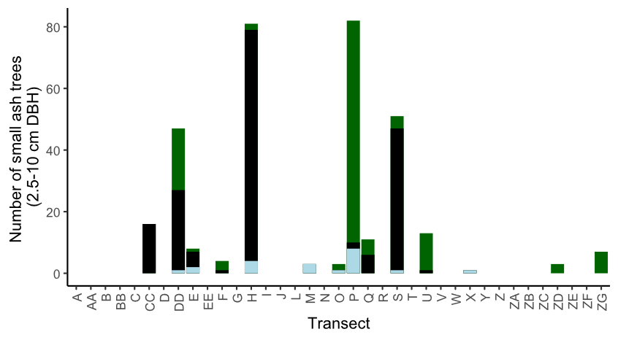

**Figure A.1.** The total number of understory ash trees (2.5 – 10 cm DBH) found in 37 transects in the Upper Huron River Watershed. Understory ash of all canopy conditions are counted. Bars are shaded based on the proportion of each ash species that was found in a transect. Green represents green, white, and/or pumpkin ash; black represents black ash; light blue represents unknown ash species.

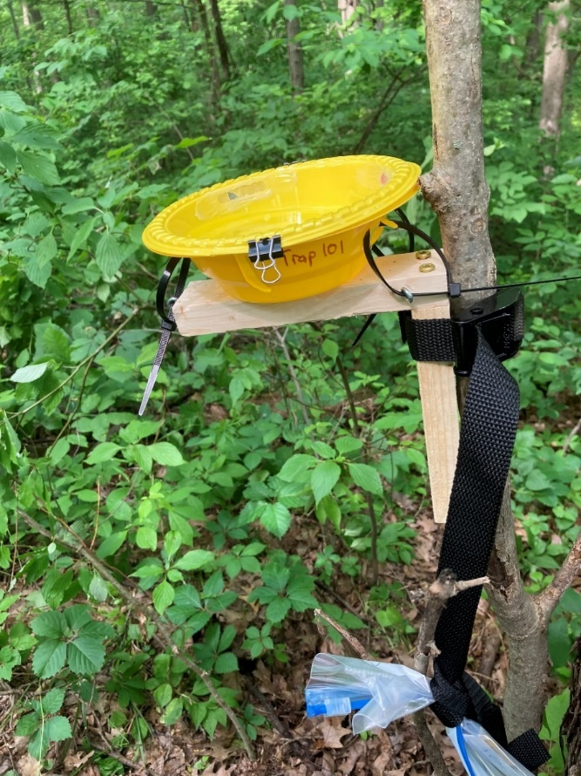

**Figure A.2.** Yellow pan trap design using nested yellow bowls attached to a wooden stand and strapped to an ash tree.

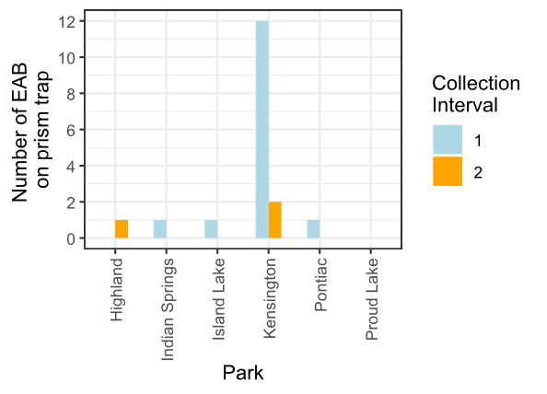

**Figure A.3.** Captures of EAB adults from Prism traps in 2024. Collection interval 1 corresponds to June, while collection interval 2 corresponds to July.

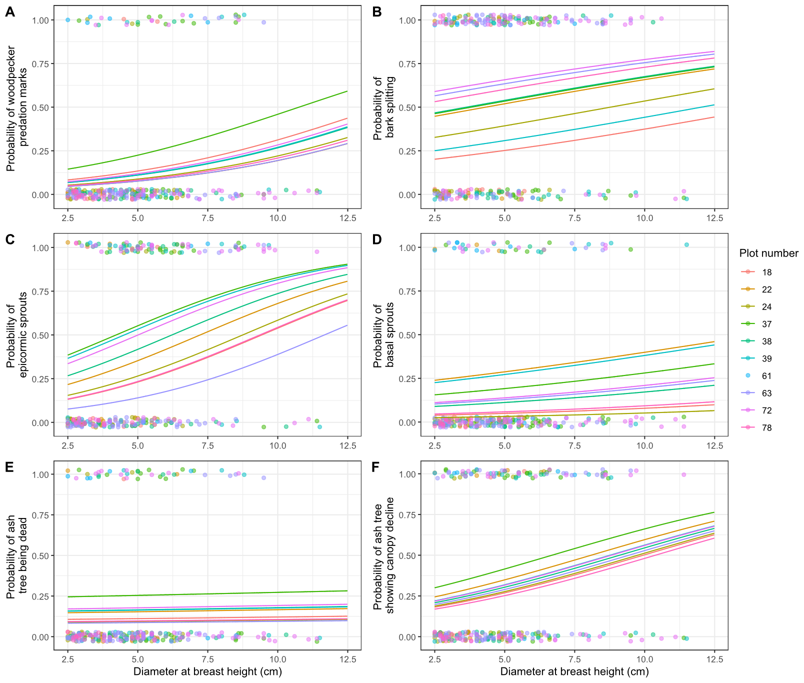

**Figure A.4.** Same as Figure 1.3, but here the regression lines are graphed separately for each random intercept. The presence or absence of symptoms of EAB plotted against tree diameter at breast height (DBH) for 283 trees in the 10 forest plots containing at least 10 trees. Colored points are individual trees, which are plotted as y=1 for presence or y=0 for absence (points were vertically jittered slightly). Points are colored based on the plot they belong to. Colored lines show the models for each estimated random intercept corresponding to each plot.

**Table A.1.** Plot locations for the 111 plots visited in this study. Each set of three plots makes up a transect. Each transect was given a hydrological class of xeric (19 transects), mesic (8 transects), or hydric (10 transects). The plot numbers go up to 114 because they skip 46-48, because transect K (Smith 2006) was not visited. The columns are plot number, plot name, park, transect, hydrological class, latitude, and longitude.

|  |  |  |  |  |  |  |
| --- | --- | --- | --- | --- | --- | --- |
| Plot  number | Plot name | Park | Transect | Hydrological  class | Latitude | Longitude |
| 1 | KENUPHD | Kensington | A | xeric | 42.53254195 | -83.6705388 |
| 2 | KENUPHD2 | Kensington | A | xeric | 42.53296724 | -83.67076505 |
| 3 | KENUPHD3 | Kensington | A | xeric | 42.53326356 | -83.67093244 |
| 4 | HMHD | Hudson Mills | AA | mesic | 42.37834666 | -83.91336117 |
| 5 | HMHD2 | Hudson Mills | AA | mesic | 42.3779638 | -83.91309216 |
| 6 | HMHD3 | Hudson Mills | AA | mesic | 42.37830402 | -83.91382332 |
| 7 | KENDRY | Kensington | B | xeric | 42.53544514 | -83.66722319 |
| 8 | KENDRY2 | Kensington | B | xeric | 42.53563361 | -83.66642756 |
| 9 | KENDRY3 | Kensington | B | xeric | 42.53588209 | -83.66709668 |
| 10 | HMDRY | Hudson Mills | BB | xeric | 42.37515735 | -83.91411337 |
| 11 | HMDRY2 | Hudson Mills | BB | xeric | 42.37474575 | -83.91429938 |
| 12 | HMDRY3 | Hudson Mills | BB | xeric | 42.37398156 | -83.91421887 |
| 13 | KENUP | Kensington | C | xeric | 42.53463699 | -83.66695495 |
| 14 | KENUP2 | Kensington | C | xeric | 42.53497995 | -83.66657034 |
| 15 | KENUP3 | Kensington | C | xeric | 42.53429542 | -83.66721965 |
| 16 | ILOPEN | Island Lake | CC | mesic | 42.49941418 | -83.7165664 |
| 17 | ILOPEN2 | Island Lake | CC | mesic | 42.50011316 | -83.71690408 |
| 18 | ILOPEN3 | Island Lake | CC | mesic | 42.49984426 | -83.71729405 |

Continued

Table A.1 Continued

|  |  |  |  |  |  |  |
| --- | --- | --- | --- | --- | --- | --- |
| Plot  number | Plot name | Park | Transect | Hydrological  class | Latitude | Longitude |
| 19 | KENDRY3 | Kensington | D | xeric | 42.53784433 | -83.66665362 |
| 20 | KENDRY3A | Kensington | D | xeric | 42.53794168 | -83.66596685 |
| 21 | KENDRY3B | Kensington | D | xeric | 42.53727952 | -83.66639485 |
| 22 | ILLOW | Island Lake | DD | hydric | 42.49971912 | -83.71630958 |
| 23 | ILLOW2 | Island Lake | DD | hydric | 42.50085549 | -83.7166848 |
| 24 | ILLOW3 | Island Lake | DD | hydric | 42.49794685 | -83.71775494 |
| 25 | PLINT | Proud Lake | E | xeric | 42.5759159 | -83.52099242 |
| 26 | PLINT2 | Proud Lake | E | xeric | 42.57601569 | -83.52054316 |
| 27 | PLINT3 | Proud Lake | E | xeric | 42.57637225 | -83.52026922 |
| 28 | HLMAT | Highland | EE | xeric | 42.64473456 | -83.56669535 |
| 29 | HLMAT2 | Highland | EE | xeric | 42.64590976 | -83.56680506 |
| 30 | HLMAT3 | Highland | EE | xeric | 42.64686284 | -83.56915982 |
| 31 | PLDRYMAT | Proud Lake | F | xeric | 42.57578816 | -83.52318352 |
| 32 | PLDRYMAT2 | Proud Lake | F | xeric | 42.57577574 | -83.52399007 |
| 33 | PLDRYMAT2A | Proud Lake | F | xeric | 42.57635459 | -83.52182426 |
| 34 | PLCONF | Proud Lake | G | xeric | 42.57571524 | -83.52814029 |
| 35 | PLDRYMAT3 | Proud Lake | G | xeric | 42.57581763 | -83.52740826 |
| 36 | PLDRYMAT3A | Proud Lake | G | xeric | 42.57607392 | -83.52668128 |

Continued

Table A.1 Continued

|  |  |  |  |  |  |  |
| --- | --- | --- | --- | --- | --- | --- |
| Plot  number | Plot name | Park | Transect | Hydrological  class | Latitude | Longitude |
| 37 | PLWET | Proud Lake | H | hydric | 42.5747667 | -83.54598723 |
| 38 | PLWET2 | Proud Lake | H | hydric | 42.57474279 | -83.54632682 |
| 39 | PLWET3 | Proud Lake | H | hydric | 42.57428658 | -83.54708265 |
| 40 | KENWET | Kensington | I | hydric | 42.53043348 | -83.67041583 |
| 41 | KENWET2 | Kensington | I | hydric | 42.53110591 | -83.66746124 |
| 42 | KENWET4 | Kensington | I | hydric | 42.53118814 | -83.66648081 |
| 43 | KENWET3 | Kensington | J | hydric | 42.53124676 | -83.66897599 |
| 44 | KENWET3A | Kensington | J | hydric | 42.53101609 | -83.66944111 |
| 45 | KENWET3B | Kensington | J | hydric | 42.53146534 | -83.6685188 |
| 49 | PONUP | Pontiac Lake | L | xeric | 42.67601991 | -83.48374379 |
| 50 | PONUP2 | Pontiac Lake | L | xeric | 42.67639534 | -83.48336561 |
| 51 | PONUP3 | Pontiac Lake | L | xeric | 42.67695181 | -83.48354417 |
| 52 | PONHD | Pontiac Lake | M | mesic | 42.67737591 | -83.4842027 |
| 53 | PONHD2 | Pontiac Lake | M | mesic | 42.67763539 | -83.48494077 |
| 54 | PONHD3 | Pontiac Lake | M | mesic | 42.67619344 | -83.48458083 |
| 55 | PONEAST | Pontiac Lake | N | xeric | 42.67628637 | -83.48161802 |
| 56 | PONEAST2 | Pontiac Lake | N | xeric | 42.67644003 | -83.48223133 |
| 57 | PONEAST3 | Pontiac Lake | N | xeric | 42.67655527 | -83.4827693 |
| 58 | PONRT | Pontiac Lake | O | xeric | 42.67697644 | -83.48225793 |
| 59 | PONRT2 | Pontiac Lake | O | xeric | 42.67847161 | -83.4821571 |
| 60 | PONRT3 | Pontiac Lake | O | xeric | 42.67796779 | -83.48337831 |

Continued

Table A.1 Continued

|  |  |  |  |  |  |  |
| --- | --- | --- | --- | --- | --- | --- |
| Plot  number | Plot name | Park | Transect | Hydrological  class | Latitude | Longitude |
| 61 | ILRIP | Island Lake | P | hydric | 42.50511387 | -83.711563 |
| 62 | ILRIP2 | Island Lake | P | hydric | 42.50548015 | -83.71130397 |
| 63 | ILRIP3 | Island Lake | P | hydric | 42.50506543 | -83.71105671 |
| 64 | ILCC | Island Lake | Q | hydric | 42.49871458 | -83.71880034 |
| 65 | ILCC2 | Island Lake | Q | hydric | 42.49826164 | -83.71911588 |
| 66 | ILCC3 | Island Lake | Q | hydric | 42.49755544 | -83.7194028 |
| 67 | ISMATDRY | Indian Springs | R | mesic | 42.70259786 | -83.49652337 |
| 68 | ISMATDRY2 | Indian Springs | R | mesic | 42.70213825 | -83.49648848 |
| 69 | ISMATDRY3 | Indian Springs | R | mesic | 42.70223513 | -83.49584728 |
| 70 | ISLD | Indian Springs | S | hydric | 42.7016922 | -83.49741597 |
| 71 | ISLD2 | Indian Springs | S | hydric | 42.70129243 | -83.49740698 |
| 72 | ISLD3 | Indian Springs | S | hydric | 42.70142849 | -83.49779967 |
| 73 | ISMATDE | Indian Springs | T | xeric | 42.7035437 | -83.49463936 |
| 74 | ISMATDE2 | Indian Springs | T | xeric | 42.70375308 | -83.49415138 |
| 75 | ISMATDE3 | Indian Springs | T | xeric | 42.70278921 | -83.49360562 |
| 76 | ISRIP | Indian Springs | U | hydric | 42.70463303 | -83.49570897 |
| 77 | ISRIP2 | Indian Springs | U | hydric | 42.70481219 | -83.494821 |
| 78 | ISRIP3 | Indian Springs | U | hydric | 42.70487822 | -83.4940807 |
| 79 | ISOPEN | Indian Springs | V | mesic | 42.70480262 | -83.49706373 |
| 80 | ISOPEN2 | Indian Springs | V | mesic | 42.70388702 | -83.49893342 |
| 81 | ISOPEN3 | Indian Springs | V | mesic | 42.7045196 | -83.49803841 |

Continued

Table A.1 Continued

|  |  |  |  |  |  |  |
| --- | --- | --- | --- | --- | --- | --- |
| Plot  number | Plot name | Park | Transect | Hydrological  class | Latitude | Longitude |
| 82 | HLMATFR | Highland | W | xeric | 42.6489291 | -83.55636056 |
| 83 | HLMATFR2 | Highland | W | xeric | 42.64858561 | -83.55689617 |
| 84 | HLMATFR3 | Highland | W | xeric | 42.64939898 | -83.55761483 |
| 85 | HLRIP | Highland | X | mesic | 42.64587606 | -83.55093888 |
| 86 | HLRIP2 | Highland | X | mesic | 42.64514371 | -83.55089568 |
| 87 | HLRIP3 | Highland | X | mesic | 42.64637211 | -83.55062169 |
| 88 | HLUP | Highland | Y | xeric | 42.6470476 | -83.55230573 |
| 89 | HLUP2 | Highland | Y | xeric | 42.64705538 | -83.55397741 |
| 90 | HLUP3 | Highland | Y | xeric | 42.6474566 | -83.55365762 |
| 91 | HMMAT | Hudson Mills | Z | xeric | 42.37824499 | -83.91166168 |
| 92 | HMMAT2 | Hudson Mills | Z | xeric | 42.37825474 | -83.91229145 |
| 93 | HMMAT3 | Hudson Mills | Z | xeric | 42.3787298 | -83.91267589 |
| 94 | PONNEW | Pontiac Lake | ZA | xeric | 42.67554541 | -83.48274071 |
| 95 | PONNEW2 | Pontiac Lake | ZA | xeric | 42.67584028 | -83.4830424 |
| 96 | PONNEW3 | Pontiac Lake | ZA | xeric | 42.67606664 | -83.48271281 |
| 97 | PONRD | Pontiac Lake | ZB | mesic | 42.67546355 | -83.4821069 |
| 98 | PONRD2 | Pontiac Lake | ZB | mesic | 42.67597751 | -83.48183457 |
| 99 | PONRD3 | Pontiac Lake | ZB | mesic | 42.67611495 | -83.4822095 |
| 100 | PONWH | Pontiac Lake | ZC | xeric | 42.67657235 | -83.48190157 |
| 101 | PONWH2 | Pontiac Lake | ZC | xeric | 42.67696268 | -83.48095924 |
| 102 | PONWH3 | Pontiac Lake | ZC | xeric | 42.67670871 | -83.48046038 |

Continued

Table A.1 Continued

|  |  |  |  |  |  |  |
| --- | --- | --- | --- | --- | --- | --- |
| Plot  number | Plot name | Park | Transect | Hydrological  class | Latitude | Longitude |
| 103 | ISBR | Indian Springs | ZD | hydric | 42.70640403 | -83.49342124 |
| 104 | ISBR2 | Indian Springs | ZD | hydric | 42.70623663 | -83.4938222 |
| 105 | ISBR3 | Indian Springs | ZD | hydric | 42.70670773 | -83.49360969 |
| 106 | ISBRS | Indian Springs | ZE | hydric | 42.70572744 | -83.49386673 |
| 107 | ISBRS2 | Indian Springs | ZE | hydric | 42.70535737 | -83.49412394 |
| 108 | ISBRS3 | Indian Springs | ZE | hydric | 42.70514295 | -83.49498565 |
| 109 | ISWH | Indian Springs | ZF | mesic | 42.70282112 | -83.49624363 |
| 110 | ISWH2 | Indian Springs | ZF | mesic | 42.70256049 | -83.49579452 |
| 111 | ISWH3 | Indian Springs | ZF | mesic | 42.70249606 | -83.49513887 |
| 112 | KENNEW | Kensington | ZG | xeric | 42.53359794 | -83.67122473 |
| 113 | KENNEW2 | Kensington | ZG | xeric | 42.53386003 | -83.67146597 |
| 114 | KENNEW3 | Kensington | ZG | xeric | 42.5343776 | -83.6712658 |

**Table A.2.** Trap locations for the 2024 purple-prism and multi-funnel traps installed to assess EAB presence. The columns are trap number, park, plot number of nearest plot, trap type, tree species trap is hung in, DBH of nearest ash, and canopy condition of nearest ash.

|  |  |  |  |  |  |  |
| --- | --- | --- | --- | --- | --- | --- |
| Trap number | Park | Plot number of nearest plot | Trap type | Tree species trap is hung in | DBH of nearest ash (cm) | Canopy condition of nearest ash (1-5) |
| 1 | Kensington | 3 | prism | green or white ash | 11.0 | 3 |
| 2 | Kensington | 45 | prism | black ash | 9.9 | 1 |
| 3 | Island Lake | 63 | prism | green or white ash | 3.7 | 1 |
| 4 | Island Lake | 63 | prism | green or white ash | 8.2 | 1 |
| 5 | Proud Lake | 39 | prism | elm (black ash nearby) | 4.5 | 1 |
| 6 | Proud Lake | 39 | prism | black ash | 11.5 | 1 |
| 7 | Highland | 86 | prism | shepard hook | NA | NA |
| 8 | Highland | 86 | prism | shepard hook | NA | NA |
| 9 | Pontiac | 53 | prism | elm | 7.2 | 1 |
| 10 | Pontiac | 53 | prism | red maple | 2.1 | 1 |
| 11 | Indian Springs | 78 | prism | maple | 2.8 | 1 |
| 12 | Indian Springs | 78 | prism | serviceberry | 9.3 | 1 |
| 13 | Pontiac | 53 | multifunnel | hickory | 7.0 | 1 |
| 14 | Pontiac | 53 | multifunnel | green or white ash | 4.4 | 1 |
| 15 | Pontiac | 53 | multifunnel | green or white ash | 10 | 2 |

**Table A.3.** Yellow pan trap information for 2024 parasitoid sampling effort. All traps were within ~30 meters of the center tree for Plot 53 at Pontiac Lake Recreation Area. The columns are trap number, DBH of ash, canopy condition, EAB exit holes, woodpecker marks, ash bark splitting, epicormic sprouts, and basal sprouts.

|  |  |  |  |  |  |  |  |
| --- | --- | --- | --- | --- | --- | --- | --- |
| Trap number | DBH of ash (cm) | Canopy condition  (1-5) | EAB exit holes? | Woodpecker marks? | Ash bark splitting? | Epicormic sprouts? | Basal sprouts? |
| 101 | 3.2 | 3 | n | n | y | y | y |
| 102 | 5.2 | 1 | n | n | y | n | n |
| 103 | 6.6 | 1 | n | n | y | y | n |
| 104 | 7.2 | 1 | n | n | y | y | n |
| 105 | 3.1 | 3 | y | n | y | y | y |
| 106 | 5.9 | 1 | n | n | y | n | n |
| 107 | 3.6 | 1 | n | n | n | y | n |
| 108 | 4.45 | 1 | n | n | y | n | n |
| 109 | 7.2 | 1 | n | n | y | y | n |
| 110 | 8.9 | 1 | n | n | n | n | n |
| 111 | 4.6 | 4 | n | n | y | y | y |
| 112 | 6.7 | 3 | n | n | y | y | n |
| 113 | 9.6 | 2 | n | n | n | n | n |
| 114 | 4.2 | 1 | n | n | y | y | n |
| 115 | 9.1 | 4 | n | y | y | y | y |

**Table A.4.** Waterlogging and shade tolerance (± SE) from (Niinemets and Valladares 2006) for the common tree species found in the 30 hydric plots. Species were included if three or more individual trees were found. Values range from 1 to 5, with 5 being the most tolerant to waterlogging or shade.

|  |  |  |
| --- | --- | --- |
| Species | Waterlogging tolerance | Shade  tolerance |
| *Acer rubrum* | 3.08±0.28 | 3.44±0.23 |
| *Acer saccharinum* | 3.37±0.22 | 3.6±0.31 |
| *Acer saccharum* | 1.09±0.08 | 4.76±0.11 |
| *Betula alleghaniensis* | 2 | 3.17±0.16 |
| *Carpinus caroliniana* | 2.3±0.5 | 4.58±0.21 |
| *Carya ovata* | 1.38±0.08 | 3.4±0.29 |
| *Fagus grandifolia* | 1.5±0.06 | 4.75±0.14 |
| *Frangula alnus* | 3.19±0 | 2.66±0 |
| *Fraxinus nigra* | 3.5 | 2.96±0.43 |
| *Fraxinus pennsylvanica* | 2.98±0.25 | 3.11±0.11 |
| *Larix laricina* | 3 | 0.98±0.09 |
| *Ostrya virginiana* | 1.07±0.06 | 4.58±0.21 |
| *Populus deltoides* | 3.03±0.27 | 1.76±0.38 |
| *Populus grandidentata* | 2 | 1.21±0.27 |
| *Prunus serotina* | 1.06±0.06 | 2.46±0.34 |
| *Quercus alba* | 1.43±0.14 | 2.85±0.17 |
| *Quercus bicolor* | 2.58±0.28 | 2.98±0.02 |
| *Quercus macrocarpa* | 1.82±0.15 | 2.71±0.27 |
| *Quercus rubra* | 1.12±0.06 | 2.75±0.18 |
| *Tilia americana* | 1.26±0.15 | 3.98±0.15 |
| *Ulmus americana* | 2.46±0.26 | 3.14±0.12 |
| *Ulmus rubra* | 1.73±0.24 | 3.31±0.19 |

# 

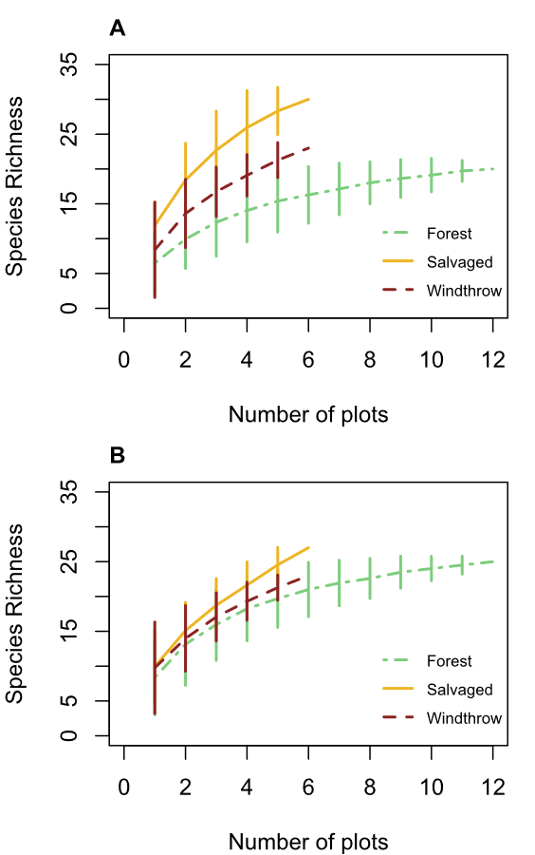

**Figure B.1.** Species accumulation curves for ground beetle communities sampled in A) 2015 and B) 2022. The x-axis shows the number of sampled plots, while the y-axis shows the species richness. The main line is the mean species richness at a given number of sampled plots, while the error bars are standard deviations based on random permutations of the order of sampling.

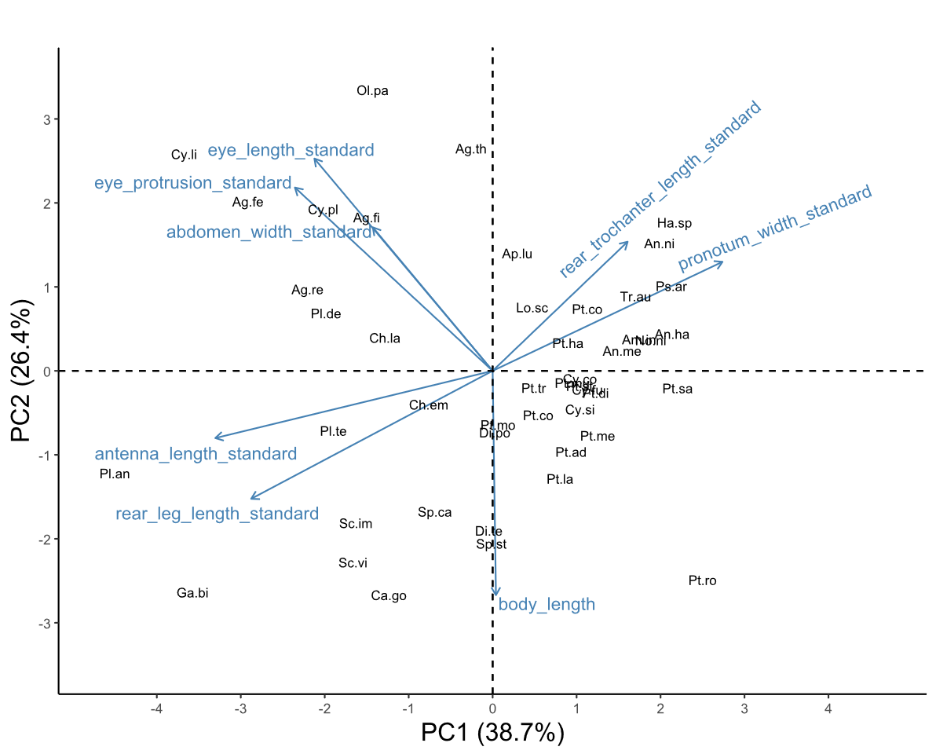

**Figure B.2.** Biplot of the first two principal component axes of the principal components analysis (PCA) of the eight numerical traits measured for 47 ground beetle species. Blue arrows with labels are the eight trait variables, which are explained in Table 1. Black text in the graph indicates the locations of each species in trait space, following the abbreviations in Table 2.2. The word “standard” after a variable name indicates that it has previously been divided by body length. The species *Notiophilus aeneus* was omitted from the PCA.

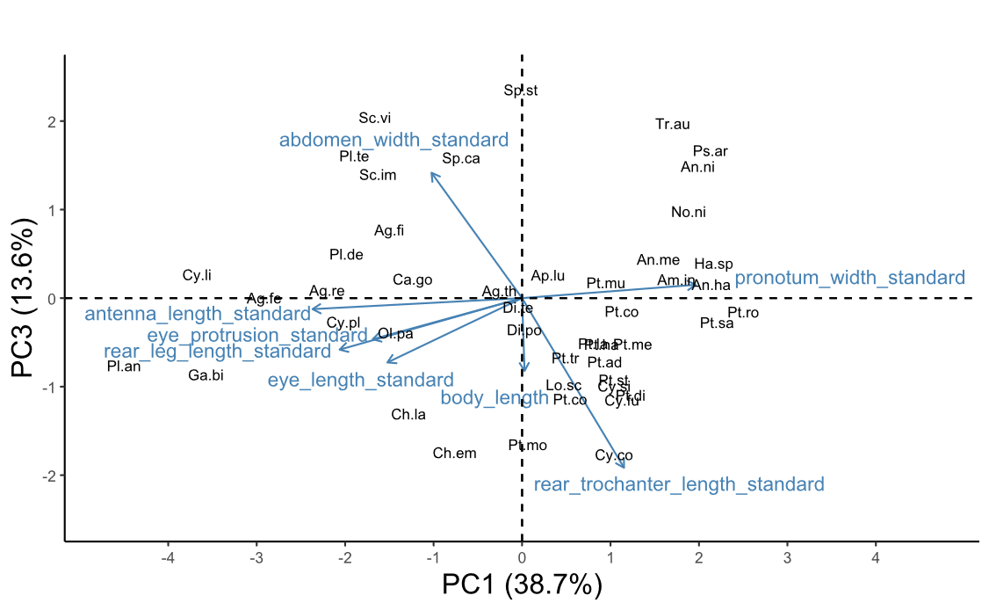

**Figure B.3.** Biplot of the third principal component axis (y-axis) against the first principal component axis (x-axis) of the principal components analysis (PCA) of the eight numerical traits measured for 47 ground beetle species. Blue arrows with labels are the eight trait variables, which are explained in Table 1. Black text in the graph indicates the locations of each species in trait space, following the abbreviations in Table 2. The word “standard” after a variable name indicates that it has previously been divided by body length to address high correlations with body length. The species *Notiophilus aeneus* was omitted from the PCA.

**Table B.1.** Voucher specimens used for trait measurements in this study. Vouchers were deposited at the Triplehorn Insect Collection at Ohio State University. The “Newly deposited?” column indicates whether the specimen was vouchered in 2025 as part of this thesis (y), or whether an existing specimen at the museum was used for trait measurement (n).

|  |  |  |  |  |
| --- | --- | --- | --- | --- |
| Species | Sex | Unique ID | Newly deposited? | Location of collection |
| *Agonoleptus thoracicus* | f | OSUC 819611 | y | Powdermill |
| *Agonum ferreum* | m | OSUC 671705 | n | Powdermill |
| *Agonum ferreum* | m | OSUC 671700 | n | Powdermill |
| *Agonum ferreum* | f | OSUC 671704 | n | Powdermill |
| *Agonum ferreum* | f | OSUC 671703 | n | Powdermill |
| *Agonum ferreum* | f | OSUC 671702 | n | Powdermill |
| *Agonum fidele* | f | OSUC 819619 | y | Powdermill |
| *Agonum fidele* | f | OSUC 819616 | y | Powdermill |
| *Agonum fidele* | f | OSUC 819613 | y | Powdermill |
| *Agonum retractum* | m | OSUC 671697 | n | Powdermill |
| *Agonum retractum* | f | OSUC 523212 | n | Erie Co. OH |
| *Agonum retractum* | f | OSUC 523213 | n | Erie Co. OH |
| *Agonum retractum* | f | OSUC 523214 | n | Erie Co. OH |
| *Amerizus sp.* | m | OSUC 819614 | y | Powdermill |
| *Amphasia interstitialis* | m | not vouchered | NA | Powdermill |
| *Amphasia interstitialis* | f | not vouchered | NA | Powdermill |
| *Amphasia interstitialis* | f | not vouchered | NA | Powdermill |
| *Amphasia interstitialis* | f | not vouchered | NA | Powdermill |
| *Anisodactylus harrisii* | m | OSUC 671671 | n | Powdermill |
| *Anisodactylus harrisii* | m | OSUC 740908 | n | Cuyahoga Co. OH |
| *Anisodactylus harrisii* | m | OSUC 740906 | n | Cuyahoga Co. OH |
| *Anisodactylus harrisii* | f | OSUC 819778 | y | Powdermill |
| *Anisodactylus harrisii* | f | OSUC 740902 | n | Cuyahoga Co. OH |
| *Anisodactylus harrisii* | f | OSUC 740900 | n | Cuyahoga Co. OH |
| *Anisodactylus melanopus* | m | OSUC 819699 | y | Powdermill |
| *Anisodactylus nigerrimus* | m | OSUC 819634 | y | Powdermill |
| *Anisodactylus nigerrimus* | m | OSUC 819631 | y | Powdermill |
| *Anisodactylus nigerrimus* | m | OSUC 819628 | y | Powdermill |
| *Anisodactylus nigerrimus* | f | OSUC 819625 | y | Powdermill |
| *Anisodactylus nigerrimus* | f | OSUC 819622 | y | Powdermill |
|  |  |  |  |  |
|  |  |  |  | Continued |
| Table B.1 Continued |  |  |  |  |
|  |  |  |  |  |
| Species | Sex | Unique ID | Newly deposited? | Location of collection |
| *Apenes lucidula* | m | OSUC 819706 | y | Powdermill |
| *Apenes lucidula* | m | OSUC 819715 | y | Powdermill |
| *Apenes lucidula* | f | OSUC 819707 | y | Powdermill |
| *Apenes lucidula* | f | OSUC 819716 | y | Powdermill |
| *Apenes lucidula* | f | OSUC 819724 | y | Powdermill |
| *Carabus goryi* | m | OSUC 819636 | y | Powdermill |
| *Carabus goryi* | m | OSUC 819639 | y | Powdermill |
| *Carabus goryi* | m | OSUC 819642 | y | Powdermill |
| *Carabus goryi* | f | OSUC 819645 | y | Powdermill |
| *Carabus goryi* | f | OSUC 819648 | y | Powdermill |
| *Carabus goryi* | f | OSUC 819651 | y | Powdermill |
| *Chlaenius emarginatus* | m | OSUC 819704 | y | Powdermill |
| *Chlaenius emarginatus* | m | OSUC 819713 | y | Powdermill |
| *Chlaenius emarginatus* | m | OSUC 819722 | y | Powdermill |
| *Chlaenius emarginatus* | f | OSUC 819705 | y | Powdermill |
| *Chlaenius emarginatus* | f | OSUC 819714 | y | Powdermill |
| *Chlaenius emarginatus* | f | OSUC 819723 | y | Powdermill |
| *Chlaenius laticollis* | f | OSUC 671794 | n | Powdermill |
| *Chlaenius laticollis* | f | OSUC 671795 | n | Powdermill |
| *Cyclotrachelus convivus* | m | OSUC 671699 | n | Powdermill |
| *Cyclotrachelus convivus* | m | OSUC 522517 | n | Erie Co. OH |
| *Cyclotrachelus convivus* | m | OSUC 740962 | n | Cuyahoga Co. OH |
| *Cyclotrachelus convivus* | f | OSUC 522528 | n | Erie Co. OH |
| *Cyclotrachelus convivus* | f | OSUC 522527 | n | Erie Co. OH |
| *Cyclotrachelus convivus* | f | OSUC 522525 | n | Erie Co. OH |
| *Cyclotrachelus fucatus* | m | OSUC 819782 | y | Powdermill |
| *Cyclotrachelus sigillatus* | m | OSUC 819753 | y | Powdermill |
| *Cyclotrachelus sigillatus* | m | OSUC 819763 | y | Powdermill |
| *Cyclotrachelus sigillatus* | m | OSUC 819773 | y | Powdermill |
| *Cyclotrachelus sigillatus* | f | OSUC 819754 | y | Powdermill |
| *Cyclotrachelus sigillatus* | f | OSUC 819764 | y | Powdermill |
| *Cyclotrachelus sigillatus* | f | OSUC 819774 | y | Powdermill |
| *Cymindis limbata* | ? | OSUC 819617 | y | Powdermill |
| *Cymindis platicollis* | ? | OSUC 819777 | y | Powdermill |
|  |  |  |  |  |
|  |  |  |  | Continued |
|  |  |  |  |  |
|  |  |  |  |  |
| Table B.1 Continued |  |  |  |  |
|  |  |  |  |  |
| Species | Sex | Unique ID | Newly deposited? | Location of collection |
| *Dicaelus politus* | m | OSUC 819708 | y | Powdermill |
| *Dicaelus politus* | m | OSUC 819717 | y | Powdermill |
| *Dicaelus politus* | m | OSUC 819725 | y | Powdermill |
| *Dicaelus politus* | f | OSUC 819709 | y | Powdermill |
| *Dicaelus politus* | f | OSUC 819718 | y | Powdermill |
| *Dicaelus politus* | f | OSUC 819726 | y | Powdermill |
| *Dicaelus teter* | m | OSUC 819604 | y | Powdermill |
| *Dicaelus teter* | m | OSUC 819719 | y | Powdermill |
| *Dicaelus teter* | m | OSUC 819727 | y | Powdermill |
| *Dicaelus teter* | f | OSUC 819710 | y | Powdermill |
| *Dicaelus teter* | f | OSUC 819720 | y | Powdermill |
| *Dicaelus teter* | f | OSUC 819728 | y | Powdermill |
| *Galerita bicolor* | f | OSUC 819640 | y | Powdermill |
| *Galerita bicolor* | f | OSUC 819637 | y | Powdermill |
| *Harpalus spadiceus* | m | OSUC 819658 | y | Powdermill |
| *Harpalus spadiceus* | m | OSUC 819655 | y | Powdermill |
| *Harpalus spadiceus* | m | OSUC 819652 | y | Powdermill |
| *Harpalus spadiceus* | f | OSUC 819649 | y | Powdermill |
| *Harpalus spadiceus* | f | OSUC 819646 | y | Powdermill |
| *Harpalus spadiceus* | f | OSUC 819643 | y | Powdermill |
| *Lophoglossus scrutator* | m | OSUC 819780 | y | Powdermill |
| *Myas coracinus* | m | OSUC 819733 | y | Powdermill |
| *Myas coracinus* | f | OSUC 819734 | y | Powdermill |
| *Notiobia nitidipennis* | m | OSUC 672665 | y | Powdermill |
| *Notiobia nitidipennis* | m | OSUC 672659 | y | Powdermill |
| *Notiobia nitidipennis* | m | OSUC 672651 | y | Powdermill |
| *Notiobia nitidipennis* | f | OSUC 672663 | y | Powdermill |
| *Notiobia nitidipennis* | f | OSUC 672662 | y | Powdermill |
| *Notiobia nitidipennis* | f | OSUC 672661 | y | Powdermill |
| *Notiophilus aeneus* | m | OSUC 819608 | y | Powdermill |
|  |  |  |  |  |
|  |  |  |  | Continued |
|  |  |  |  |  |
|  |  |  |  |  |
|  |  |  |  |  |
| Table B.1 Continued |  |  |  |  |
|  |  |  |  |  |
| Species | Sex | Unique ID | Newly deposited? | Location of collection |
| *Olisthopus parmatus* | f | OSUC 819630 | y | Powdermill |
| *Olisthopus parmatus* | f | OSUC 819633 | y | Powdermill |
| *Olisthopus parmatus* | f | OSUC 672763 | n | Powdermill |
| *Olisthopus parmatus* | m | OSUC 672759 | n | Powdermill |
| *Olisthopus parmatus* | m | OSUC 672760 | n | Powdermill |
| *Patrobus longicornis* | f | OSUC 819693 | y | Powdermill |
| *Platynus angustatus* | m | OSUC 819612 | y | Powdermill |
| *Platynus angustatus* | m | OSUC 819615 | y | Powdermill |
| *Platynus angustatus* | m | OSUC 819618 | y | Powdermill |
| *Platynus angustatus* | f | OSUC 819621 | y | Powdermill |
| *Platynus angustatus* | f | OSUC 819624 | y | Powdermill |
| *Platynus angustatus* | f | OSUC 819627 | y | Powdermill |
| *Platynus decentis* | m | OSUC 819687 | y | Powdermill |
| *Platynus hypolithos* | m | OSUC 819690 | y | Powdermill |
| *Platynus tenuicollis* | m | OSUC 819610 | y | Powdermill |
| *Platynus tenuicollis* | m | OSUC 819607 | y | Powdermill |
| *Platynus tenuicollis* | f | OSUC 819603 | y | Powdermill |
| *Platynus tenuicollis* | f | OSUC 819606 | y | Powdermill |
| *Platynus tenuicollis* | f | OSUC 819609 | y | Powdermill |
| *Pseudamara arenaria* | f | OSUC 819605 | y | Powdermill |
| *Pseudamara arenaria* | f | OSUC 671695 | n | Powdermill |
| *Pterostichus adoxus* | m | OSUC 819749 | y | Powdermill |
| *Pterostichus adoxus* | m | OSUC 819759 | y | Powdermill |
| *Pterostichus adoxus* | m | OSUC 819769 | y | Powdermill |
| *Pterostichus adoxus* | f | OSUC 819750 | y | Powdermill |
| *Pterostichus adoxus* | f | OSUC 819760 | y | Powdermill |
| *Pterostichus adoxus* | f | OSUC 819770 | y | Powdermill |
| *Pterostichus atratus* | m | OSUC 819735 | y | Powdermill |
| *Pterostichus atratus* | f | OSUC 819736 | y | Powdermill |
| *Pterostichus coracinus* | m | OSUC 819751 | y | Powdermill |
| *Pterostichus coracinus* | m | OSUC 819761 | y | Powdermill |
| *Pterostichus coracinus* | m | OSUC 819771 | y | Powdermill |
| *Pterostichus coracinus* | f | OSUC 819752 | y | Powdermill |
| *Pterostichus coracinus* | f | OSUC 819762 | y | Powdermill |
| *Pterostichus coracinus* | f | OSUC 819772 | y | Powdermill |
|  |  |  |  |  |
|  |  |  |  | Continued |
|  |  |  |  |  |
|  |  |  |  |  |
|  |  |  |  |  |
| Table B.1 Continued |  |  |  |  |
|  |  |  |  |  |
| Species | Sex | Unique ID | Newly deposited? | Location of collection |
| *Pterostichus corvinus* | m | OSUC 671808 | n | Powdermill |
| *Pterostichus corvinus* | f | OSUC 671807 | n | Powdermill |
| *Pterostichus corvinus* | f | OSUC 671809 | n | Powdermill |
| *Pterostichus corvinus* | f | OSUC 671810 | n | Powdermill |
| *Pterostichus diligendus* | m | OSUC 819781 | y | Powdermill |
| *Pterostichus hamiltoni* | m | OSUC 819779 | y | Powdermill |
| *Pterostichus lachrymosus* | m | OSUC 819682 | y | Powdermill |
| *Pterostichus lachrymosus* | m | OSUC 819679 | y | Powdermill |
| *Pterostichus lachrymosus* | m | OSUC 819676 | y | Powdermill |
| *Pterostichus lachrymosus* | f | OSUC 819673 | y | Powdermill |
| *Pterostichus lachrymosus* | f | OSUC 819670 | y | Powdermill |
| *Pterostichus lachrymosus* | f | OSUC 819667 | y | Powdermill |
| *Pterostichus melanarius* | m | OSUC 522968 | n | Erie Co. OH |
| *Pterostichus melanarius* | m | OSUC 522969 | n | Erie Co. OH |
| *Pterostichus melanarius* | m | OSUC 668451 | n | Powdermill |
| *Pterostichus melanarius* | f | OSUC 740950 | n | Cuyahoga Co. OH |
| *Pterostichus moestus* | m | OSUC 819737 | y | Powdermill |
| *Pterostichus moestus* | m | OSUC 819741 | y | Powdermill |
| *Pterostichus moestus* | m | OSUC 819745 | y | Powdermill |
| *Pterostichus moestus* | f | OSUC 819738 | y | Powdermill |
| *Pterostichus moestus* | f | OSUC 819742 | y | Powdermill |
| *Pterostichus moestus* | f | OSUC 819746 | y | Powdermill |
| *Pterostichus mutus* | m | OSUC 522813 | n | Erie Co. OH |
| *Pterostichus mutus* | m | OSUC 671803 | n | Powdermill |
| *Pterostichus mutus* | m | OSUC 671804 | n | Powdermill |
| *Pterostichus mutus* | f | OSUC 522811 | n | Erie Co. OH |
| *Pterostichus mutus* | f | OSUC 671805 | n | Powdermill |
| *Pterostichus mutus* | f | OSUC 671801 | n | Powdermill |
|  |  |  |  |  |
|  |  |  |  | Continued |
|  |  |  |  |  |
|  |  |  |  |  |
|  |  |  |  |  |
|  |  |  |  |  |
|  |  |  |  |  |
| Table B.1 Continued |  |  |  |  |
|  |  |  |  |  |
| Species | Sex | Unique ID | Newly deposited? | Location of collection |
| *Pterostichus rostratus* | m | OSUC 819729 | y | Powdermill |
| *Pterostichus rostratus* | m | OSUC 819739 | y | Powdermill |
| *Pterostichus rostratus* | m | OSUC 819743 | y | Powdermill |
| *Pterostichus rostratus* | f | OSUC 819730 | y | Powdermill |
| *Pterostichus rostratus* | f | OSUC 819740 | y | Powdermill |
| *Pterostichus rostratus* | f | OSUC 819744 | y | Powdermill |
| *Pterostichus sayanus* | m | OSUC 819731 | y | Powdermill |
| *Pterostichus sayanus* | f | OSUC 819732 | y | Powdermill |
| *Pterostichus stygicus* | m | OSUC 819755 | y | Powdermill |
| *Pterostichus stygicus* | m | OSUC 819765 | y | Powdermill |
| *Pterostichus stygicus* | m | OSUC 819775 | y | Powdermill |
| *Pterostichus stygicus* | f | OSUC 819756 | y | Powdermill |
| *Pterostichus stygicus* | f | OSUC 819766 | y | Powdermill |
| *Pterostichus stygicus* | f | OSUC 819776 | y | Powdermill |
| *Pterostichus tristis* | m | OSUC 819747 | y | Powdermill |
| *Pterostichus tristis* | m | OSUC 819757 | y | Powdermill |
| *Pterostichus tristis* | m | OSUC 819767 | y | Powdermill |
| *Pterostichus tristis* | f | OSUC 819748 | y | Powdermill |
| *Pterostichus tristis* | f | OSUC 819758 | y | Powdermill |
| *Pterostichus tristis* | f | OSUC 819768 | y | Powdermill |
| *Scaphinotus andrewsii* | m | OSUC 819660 | y | Powdermill |
| *Scaphinotus andrewsii* | f | OSUC 819663 | y | Powdermill |
| *Scaphinotus imperfectus* | m | OSUC 819672 | y | Powdermill |
| *Scaphinotus imperfectus* | m | OSUC 819675 | y | Powdermill |
| *Scaphinotus imperfectus* | m | OSUC 819678 | y | Powdermill |
| *Scaphinotus imperfectus* | f | OSUC 819681 | y | Powdermill |
| *Scaphinotus imperfectus* | f | OSUC 819684 | y | Powdermill |
| *Scaphinotus ridingsii* | m | OSUC 819666 | y | Powdermill |
| *Scaphinotus ridingsii* | m | OSUC 819669 | y | Powdermill |
| *Scaphinotus viduus* | m | OSUC 819654 | y | Powdermill |
| *Scaphinotus viduus* | m | OSUC 819657 | y | Powdermill |
|  |  |  |  |  |
|  |  |  |  | Continued |
|  |  |  |  |  |
|  |  |  |  |  |
|  |  |  |  |  |
| Table B.1 Continued |  |  |  |  |
|  |  |  |  |  |
| Species | Sex | Unique ID | Newly deposited? | Location of collection |
| *Sphaeroderus canadensis* | m | OSUC 819702 | y | Powdermill |
| *Sphaeroderus canadensis* | m | OSUC 819711 | y | Powdermill |
| *Sphaeroderus canadensis* | f | OSUC 819703 | y | Powdermill |
| *Sphaeroderus canadensis* | f | OSUC 819712 | y | Powdermill |
| *Sphaeroderus canadensis* | f | OSUC 819721 | y | Powdermill |
| *Sphaeroderus stenostomus* | m | OSUC 819700 | y | Powdermill |
| *Sphaeroderus stenostomus* | m | OSUC 819697 | y | Powdermill |
| *Sphaeroderus stenostomus* | m | OSUC 819694 | y | Powdermill |
| *Sphaeroderus stenostomus* | f | OSUC 819691 | y | Powdermill |
| *Sphaeroderus stenostomus* | f | OSUC 819688 | y | Powdermill |
| *Sphaeroderus stenostomus* | f | OSUC 819685 | y | Powdermill |
| *Synuchus impunctatus* | f | OSUC 819696 | y | Powdermill |
| *Trichotichnus autumnalis* | f | OSUC 819664 | y | Powdermill |
| *Trichotichnus autumnalis* | f | OSUC 819661 | y | Powdermill |

**Table B.2.** Loading values for the first four principal components of eight numerical traits. Percentages underneath each PC column indicate the percentage of variance explained by each axis. The word “standard” after a variable name indicates that it has previously been divided by body length.

|  |  |  |  |  |
| --- | --- | --- | --- | --- |
| Trait | PC1 (39%) | PC2 (26%) | PC3 (14%) | PC4 (11%) |
| body_length | 0.01 | -0.5 | -0.3 | 0.57 |
| antenna_length_standard | -0.51 | -0.15 | -0.05 | -0.05 |
| eye_protrusion_standard | -0.37 | 0.41 | -0.17 | 0.25 |
| eye_length_standard | -0.33 | 0.48 | -0.27 | -0.21 |
| pronotum_width_standard | 0.43 | 0.24 | 0.06 | 0.4 |
| abdomen_width_standard | -0.22 | 0.32 | 0.52 | 0.58 |
| rear_leg_length_standard | -0.45 | -0.29 | -0.21 | 0.21 |
| rear_trochanter_length_standard | 0.25 | 0.29 | -0.7 | 0.17 |

**Table B.3.** Comparison of the principal component analyses (PCA) run with and without *Notiophilus aeneus*, a species with unusual traits. Traits were listed under “Top loading values” if their loading value was ≥ 0.4. The word “standard” after each trait indicates that these values have been divided by body length prior to running the PCA.

|  |  |  |
| --- | --- | --- |
|  | **PCA with *Notiophilus aeneus*** | **PCA excluding *Notiophilus aeneus* (used in further analyses)** |
| Variance explained by PC1 | 33.1 % | 38.7 % |
| Variance explained by PC2 | 30.2 % | 26.4 % |
| Variance explained by PC3 | 14.0 % | 13.6 % |
| Top loading values for PC1 | antenna_length_standard (+0.53),  pronotum_width_standard  (-0.50),  rear_leg_length_standard (+0.54) | antenna_length_standard  (-0.51),  pronotum_width_standard (+0.43),  rear_leg_length_standard  (-0.45) |
| Top loading values for PC2 | body_length (-0.41),  eye_protrusion_standard (+0.58),  eye_length_standard (+0.59), | body_length (-0.50),  eye_protrusion_standard (+0.41),  eye_length_standard (+0.48) |
| Top loading values for PC3 | abdomen_width_standard  (-0.85) | abdomen_width_standard (+0.52)  rear_trochanter_length_standard (-0.70) |

**Table B.4.** Specific definitions of the traits measured for ground beetles in this study. Literature-based traits were assigned based on species descriptions in (Larochelle and Larivière 2003). Morphological traits were measured using an ocular micrometer. Sometimes multiple measurements were added to obtain a morphological trait. For example, body length was defined as elytron length + pronotum length + head length.

|  |  |  |  |
| --- | --- | --- | --- |
| Literature-based trait |  |  | Definition |
| Forest_affinity |  |  | Three options: forest specialist, open habitat, or eurytopic. Mark forest specialist if Larochelle and Lariviere (2003) only mention forested areas and/or shaded ground as a habitat. Mark open habitat if they only mention clearings, pastures, or fields, and/or if they only mention unshaded ground or open habitat. Mark eurytopic if both habitat affinities are mentioned, such as "forest clearings" or "shaded or open ground" or "roads and edges". |
| Water_affinity |  |  | Water affinity was coded as 0 for xerophilous species, 1 for hygrophilous species, and 0.5 for intermediate species. If the description mentions wet soil or proximity to waterway or lakes, then mark 1 (hygrophilous). If description mentions moist soil, then 0.5 (intermediate). If description mentions dry soil, then 0 (xerophilous). |
| Flight_capability |  |  | Flight capability was coded as 1 if the species is flight-capable, 0 if the species is flight-incapable, and 0.5 if the species exhibits wing dimorphism. Taken from Larochelle and Lariviere (2003) rather than from the specimens. |
|  |  |  |  |
|  |  |  | Continued |
|  |  |  |  |
|  |  |  |  |
| Table B.4 Continued |  |  |  |
|  |  |  |  |
| Morphological trait | Measured components | Unit | Definition |
| Body_length |  | mm | Elytra_length + Pronotum_length + Head_length |
|  | Elytra_length | mm | Distance, along 1st elytral interval, from posterior edge of pronotum to posterior edge of elytra - not including the abdomen if it extends past elytra. The anterior 1/2 of the elytra should be horizontal. |
|  | Pronotum_length | mm | Distance, along midline, from anterior to posterior end of pronotum |
|  | Head_length | mm | Distance from tip of mandibles to anterior end of pronotum (follows Bousquet 2010). If mandibles are unequal in length, take the distance from the longer one. Pitch beetle up so that mandibles are at roughly same height as the frons. |
| Antenna_length |  | mm | Distance from the base to tip of antenna. Choose the left or right antenna depending on which is less curved and which one is not missing any segments. If necessary, divide the antenna into parts and add up the lengths. |
| Eye_protrusion |  | mm | Outer_eye_distance - Inner_eye_distance |
|  | Outer_eye_distance | mm | Distance between apical sides of each compound eye, EVEN if the head behind or around the eyes is slightly wider than the measured distance (example: *Pterostichus rostratus*) |
|  | Inner_eye_distance | mm | Looking down at the dorsal surface of the beetle's head, find the minimum separation between the interior edges of the compound eyes |
|  |  |  |  |
|  |  |  | Continued |
|  |  |  |  |
| Table B.4 Continued |  |  |  |
| Morphological trait | Measured components | Unit | Definition |
| Eye_length |  | mm | Look at beetle in profile. Turn the beetle so the rounded part of the eye is pointing straight up towards the lens of the microscope. Then measure from the anterior to posterior of the part covered in ommatidia. Measure along the direction from lateral pronotal edge to mandibles |
| Pronotum_width |  | mm | Distance between marginal sides of pronotum at their widest point |
|  |  |  |  |
| Abdomen_width |  | mm | Distance between marginal sides of elytra or abdomen at widest point. If the elytra are widely separated, then measure width of one elytron and multiply by 2. |
|  |  |  |  |
| Rear_leg_length |  | mm | Rear_femur_length + Rear_tibia_length + Rear_tarsi_length |
|  | Rear_femur_length | mm |  |
|  | Rear_tibia_length | mm | Distance from (the center of the apex of the femur) to end of tibia, not including tibial spurs |
|  | Rear_tarsi_length | mm | If necessary, measure each tarsal segment and add them up. Do not include tarsal claws. |
|  |  |  |  |
| Rear_trochanter_length |  | mm | Length of the bean-shaped rear trochanter |